MUSIC THEORY UNIT 2
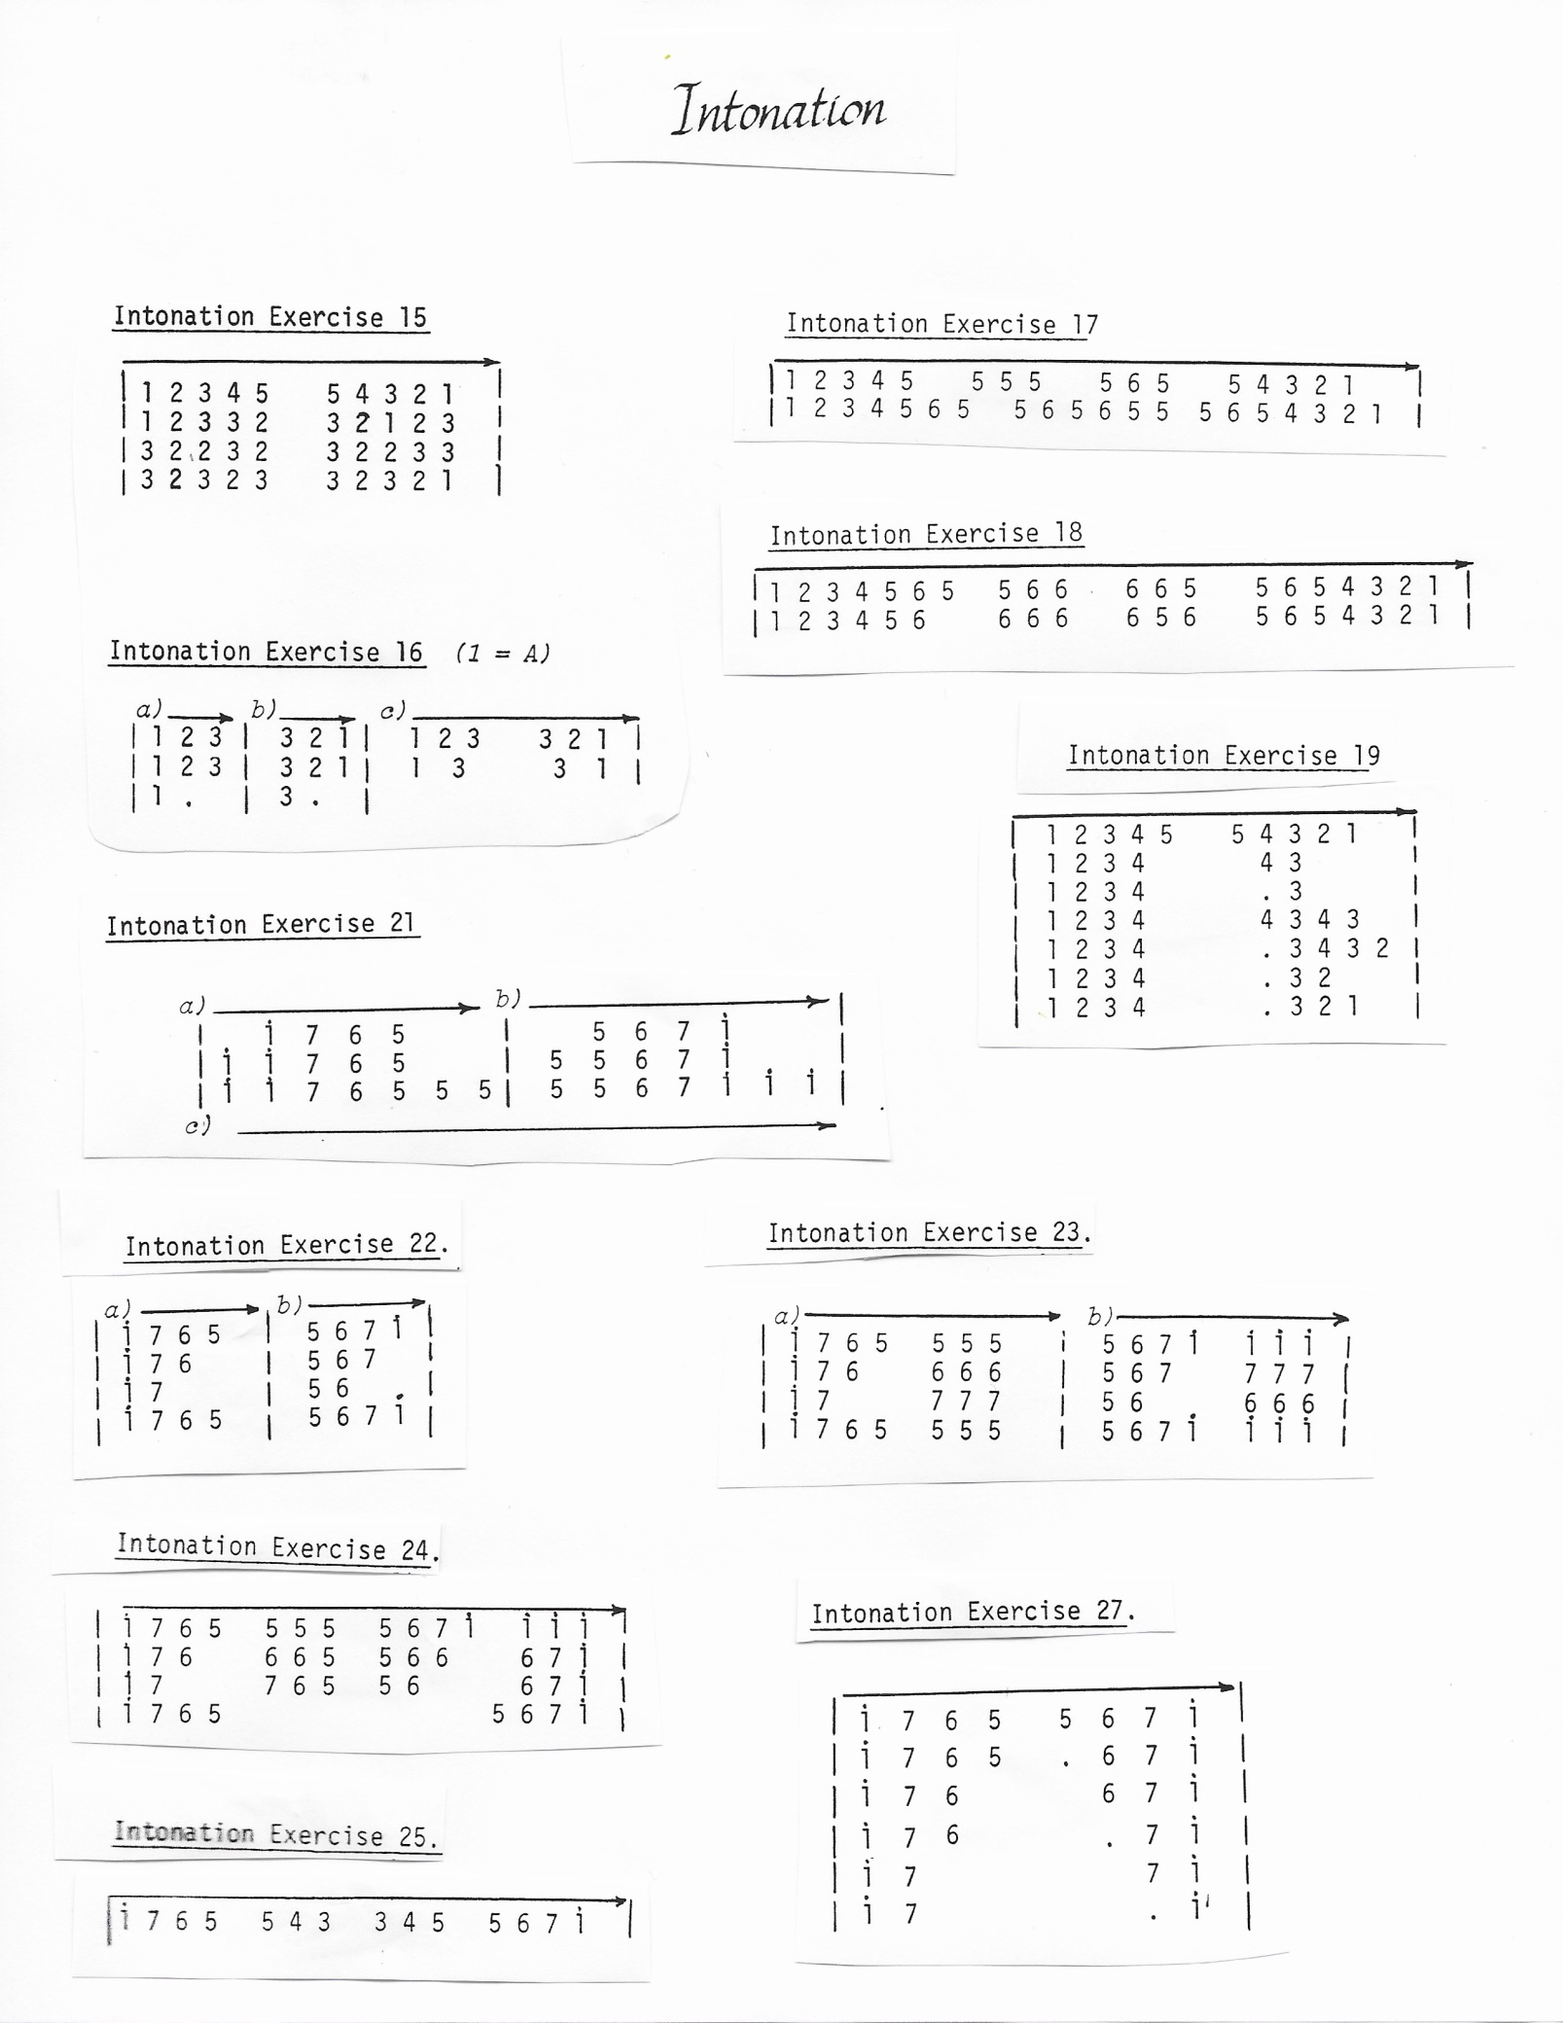
MUSIC THEORY: pg. 10

MUSIC THEORY: pg. 11

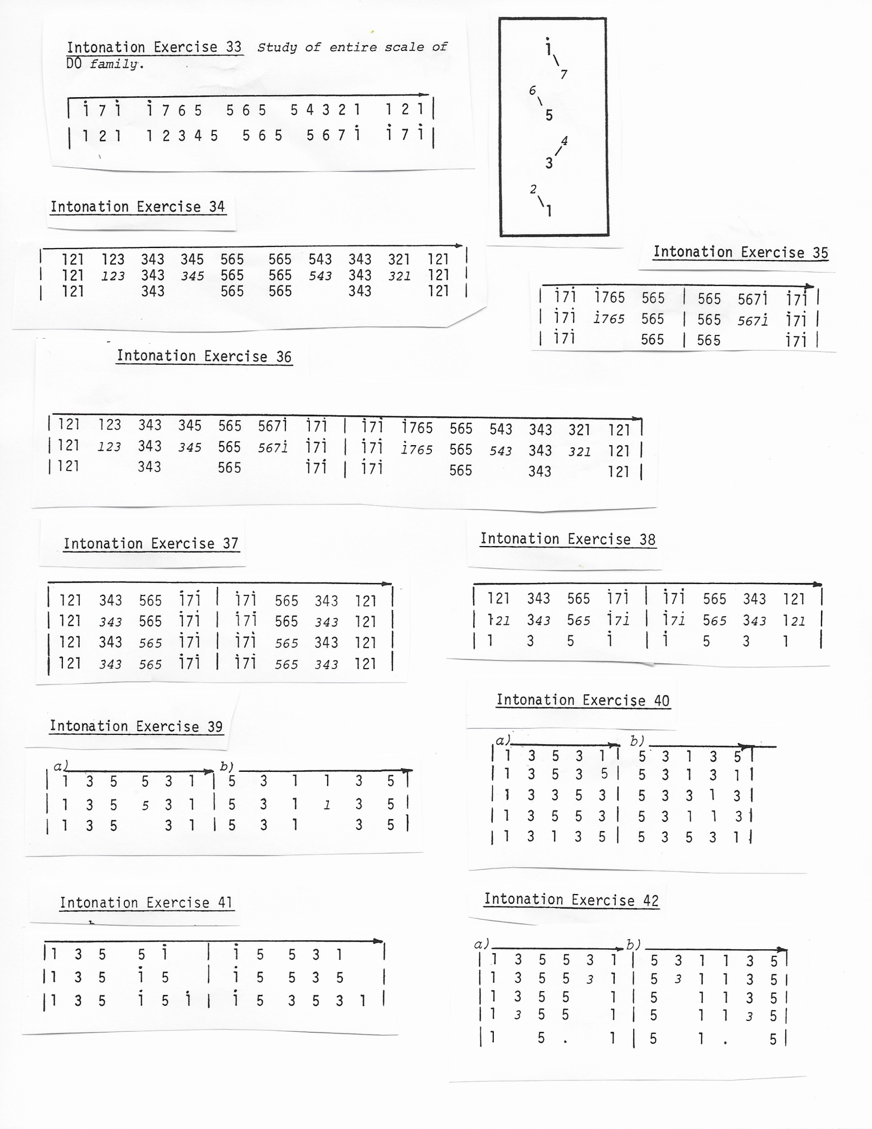

MUSIC THEORY: pg. 12

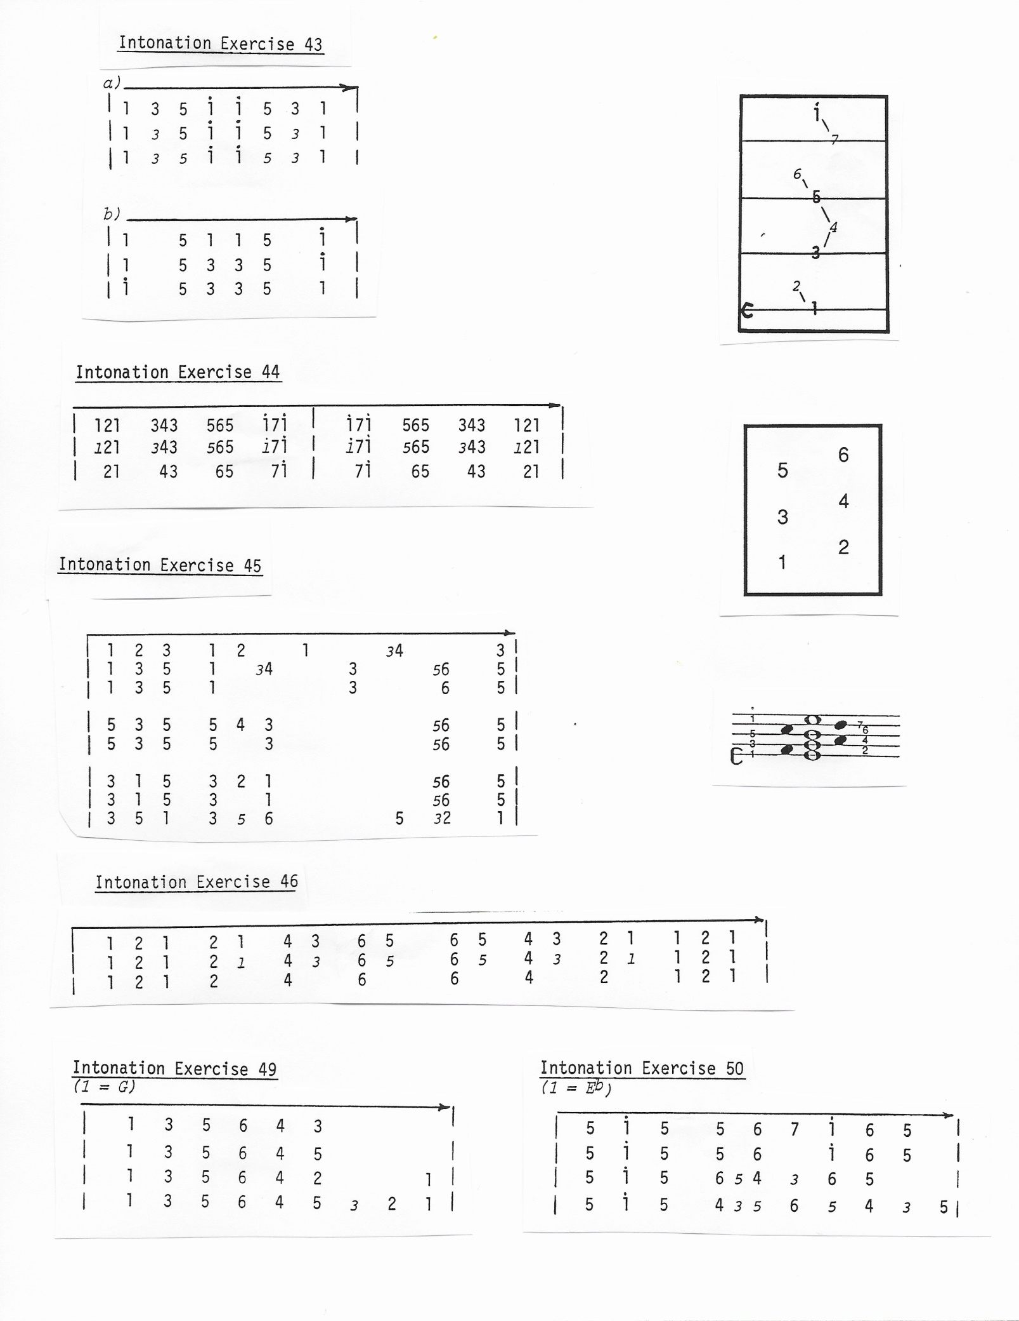

MUSIC THEORY: pg. 13

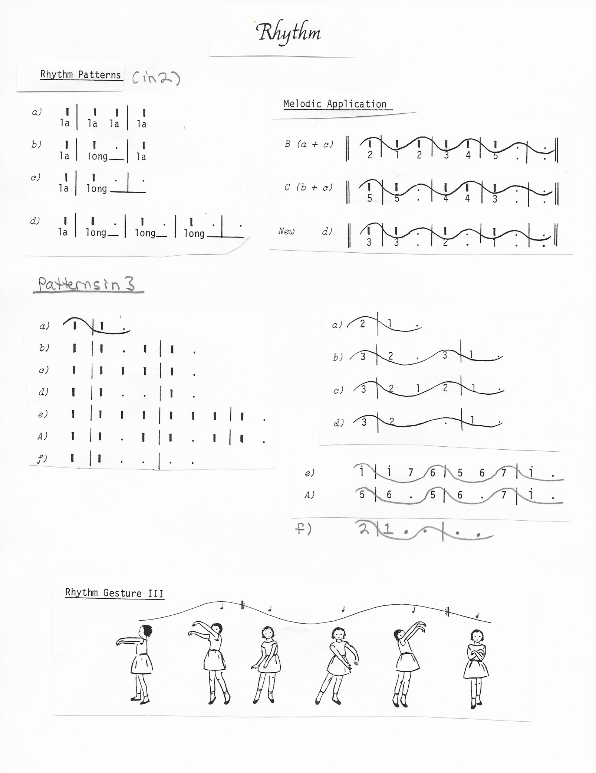

MUSIC THEORY: pg. 14

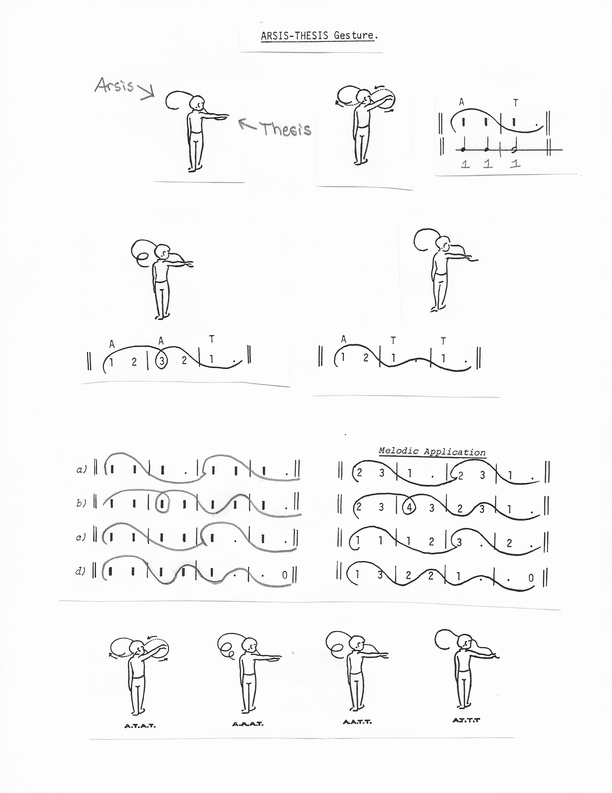

MUSIC THEORY: pg. 15

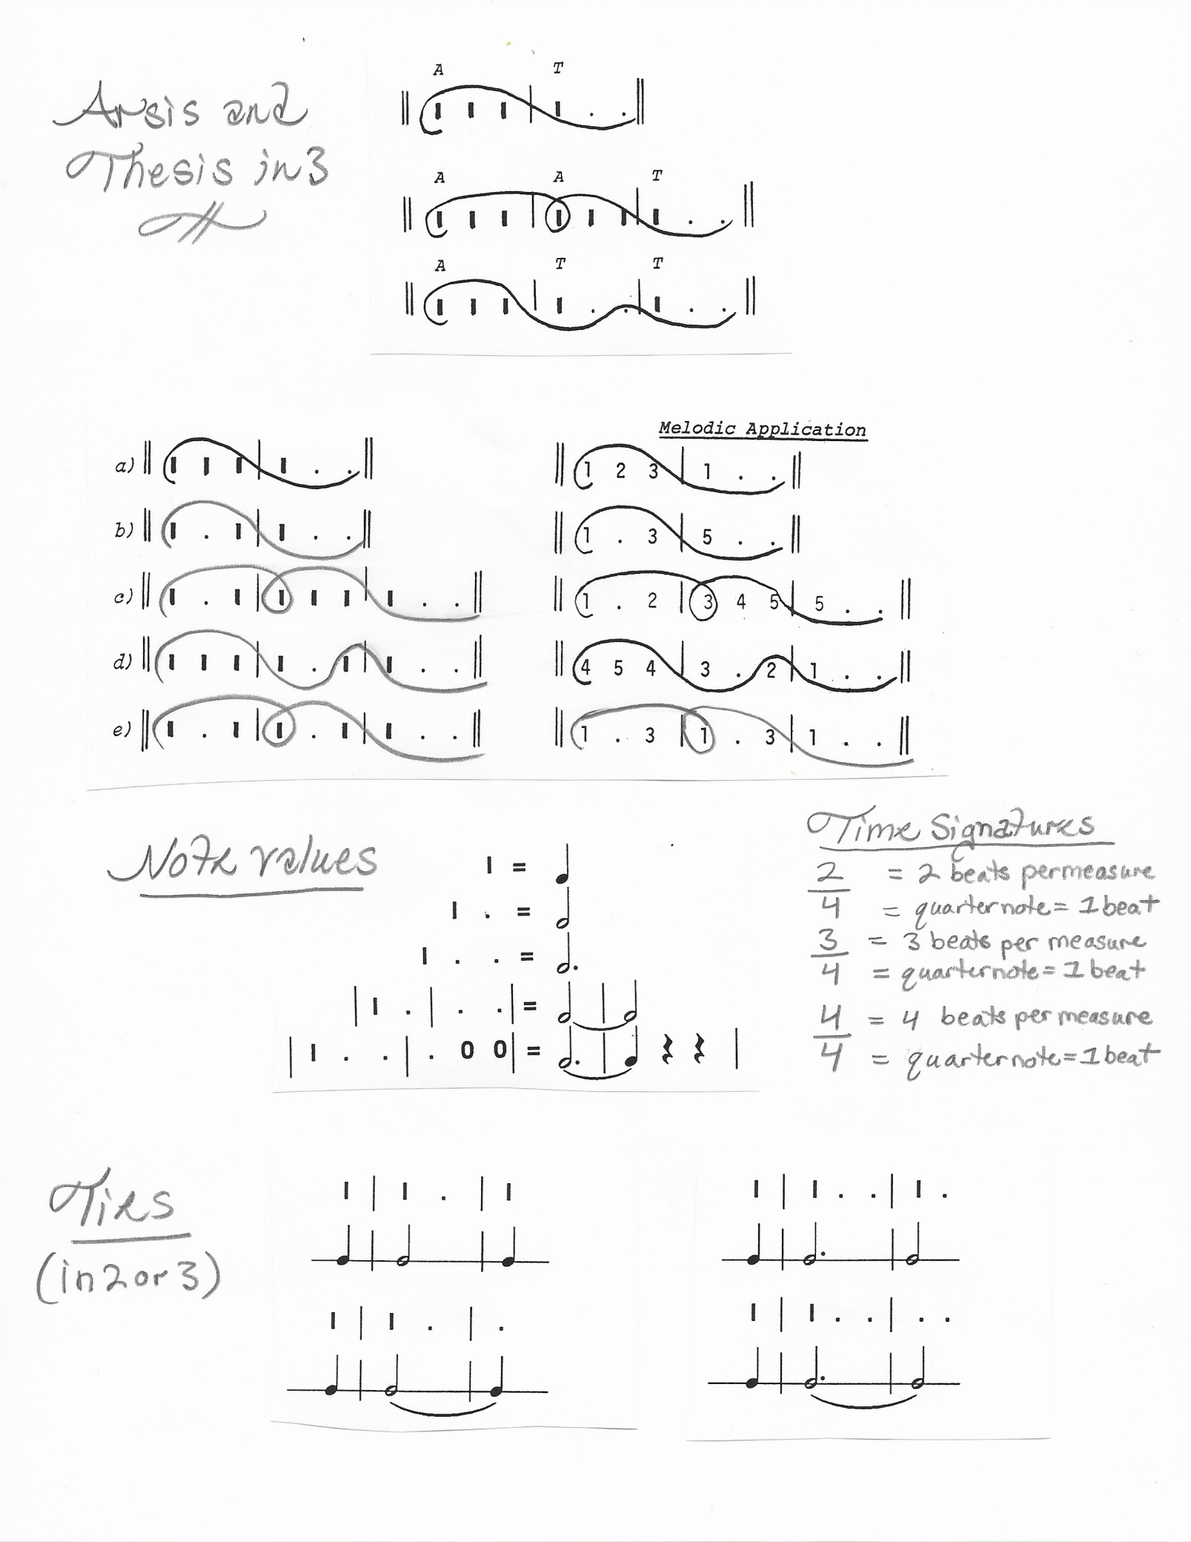

MUSIC THEORY: pg. 16

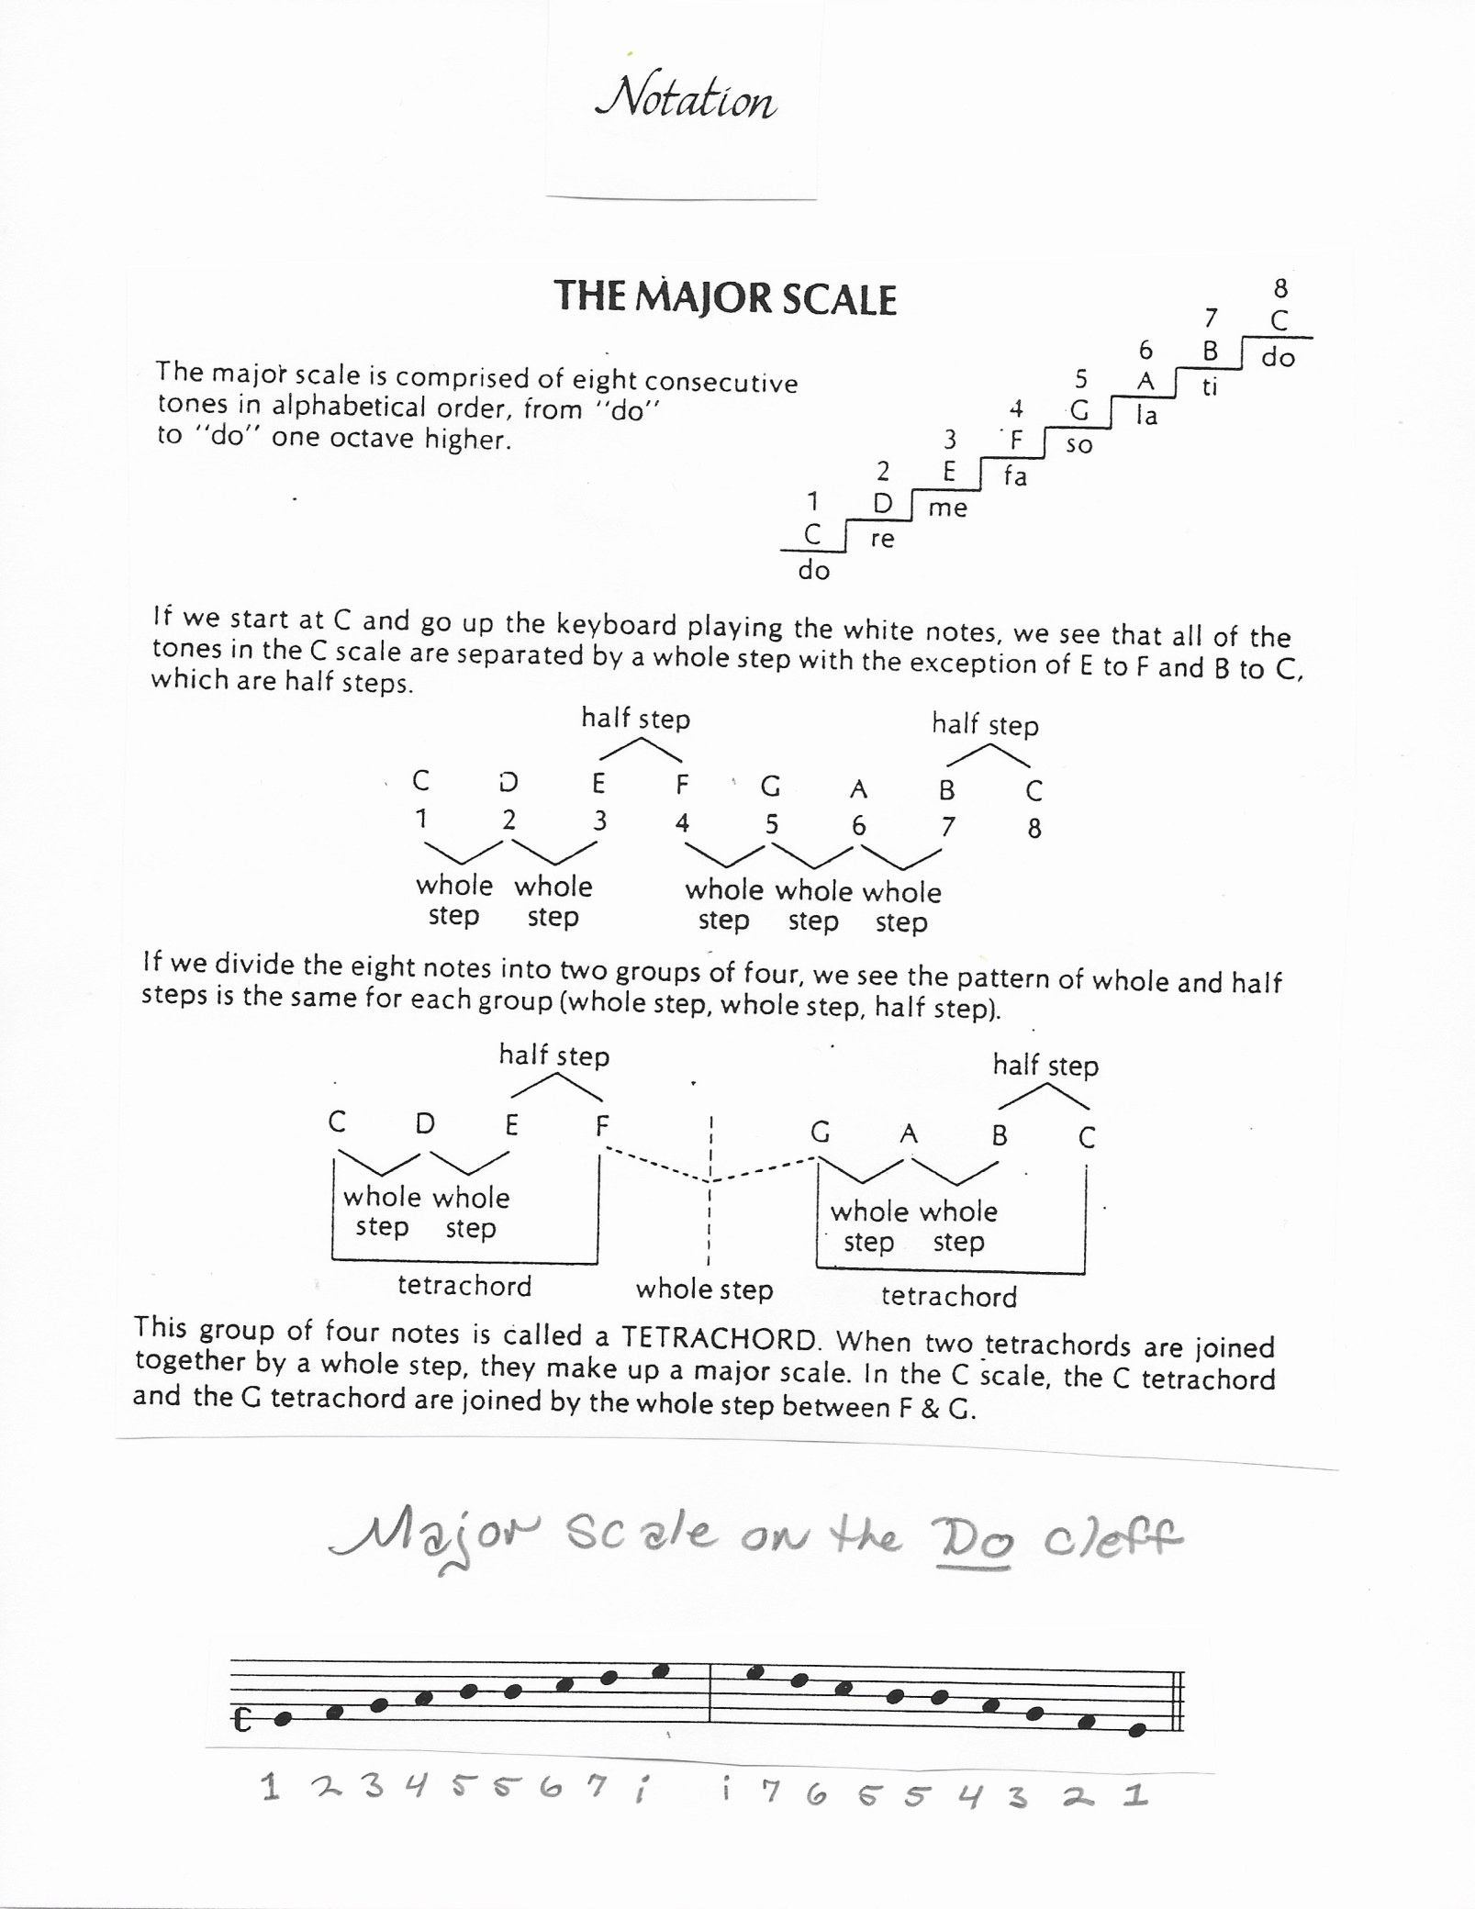

MUSIC THEORY: pg. 17

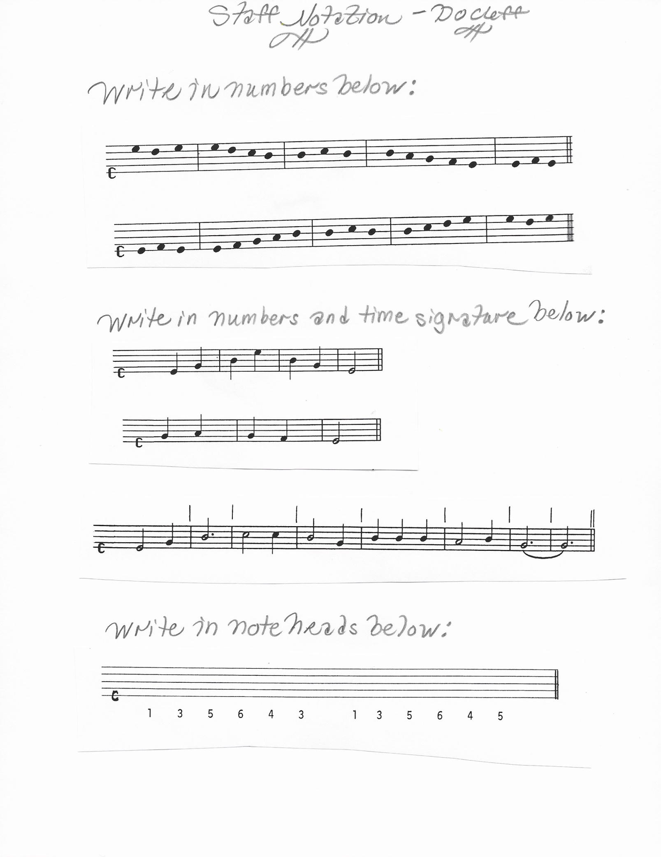

MUSIC THEORY: pg. 18

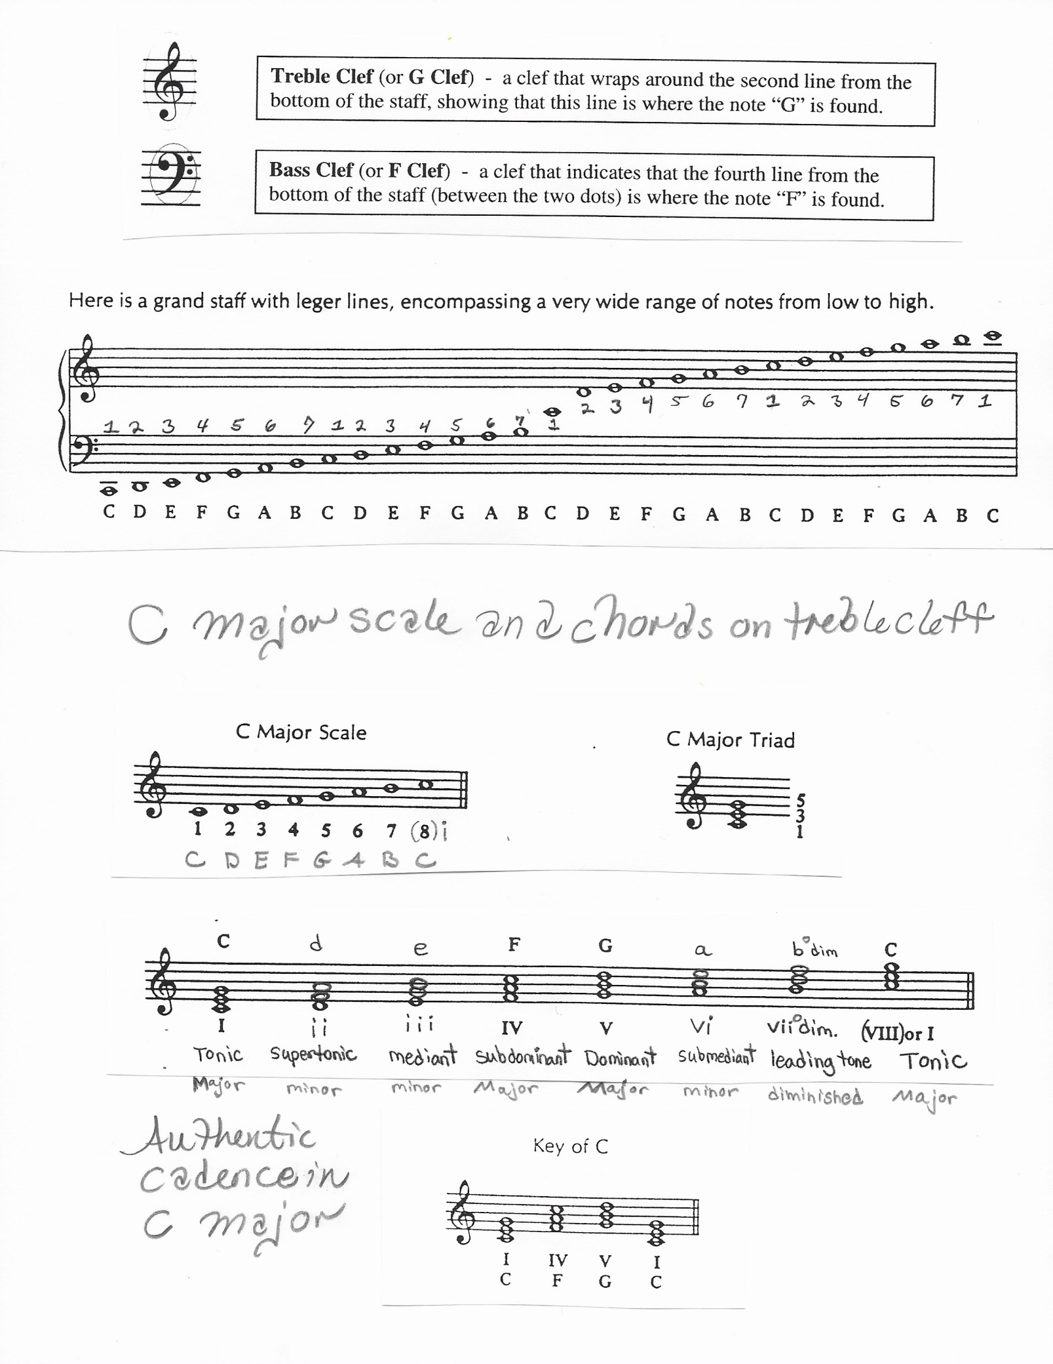

MUSIC THEORY: pg. 19
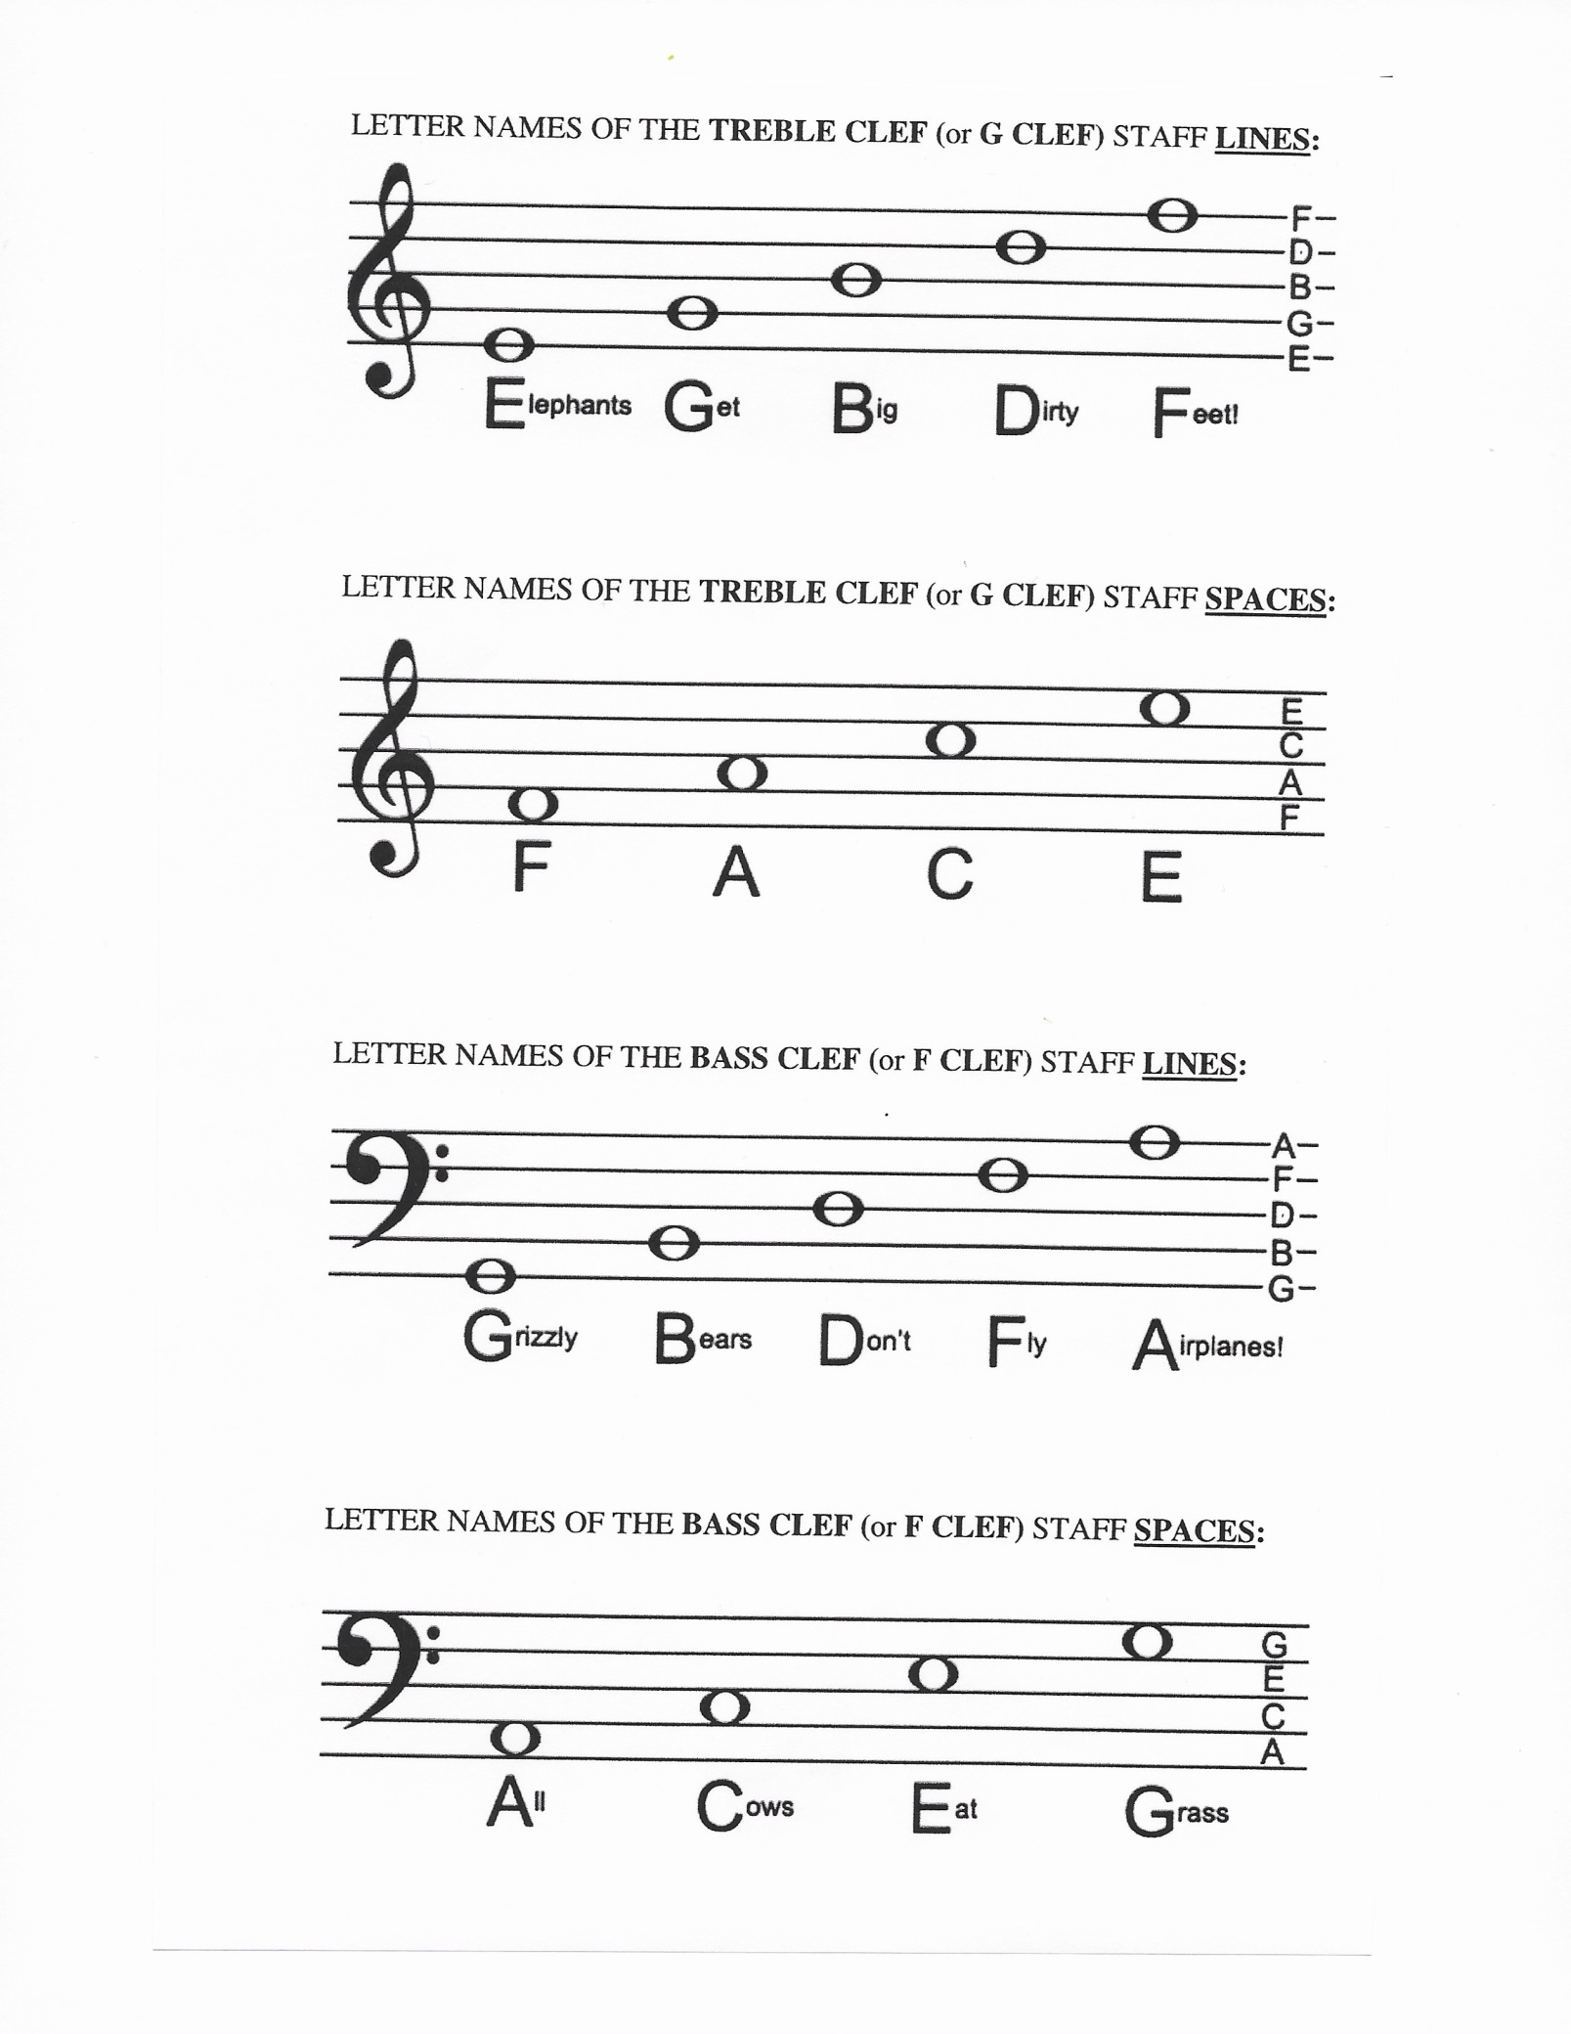

MUSIC THEORY: pg. 20

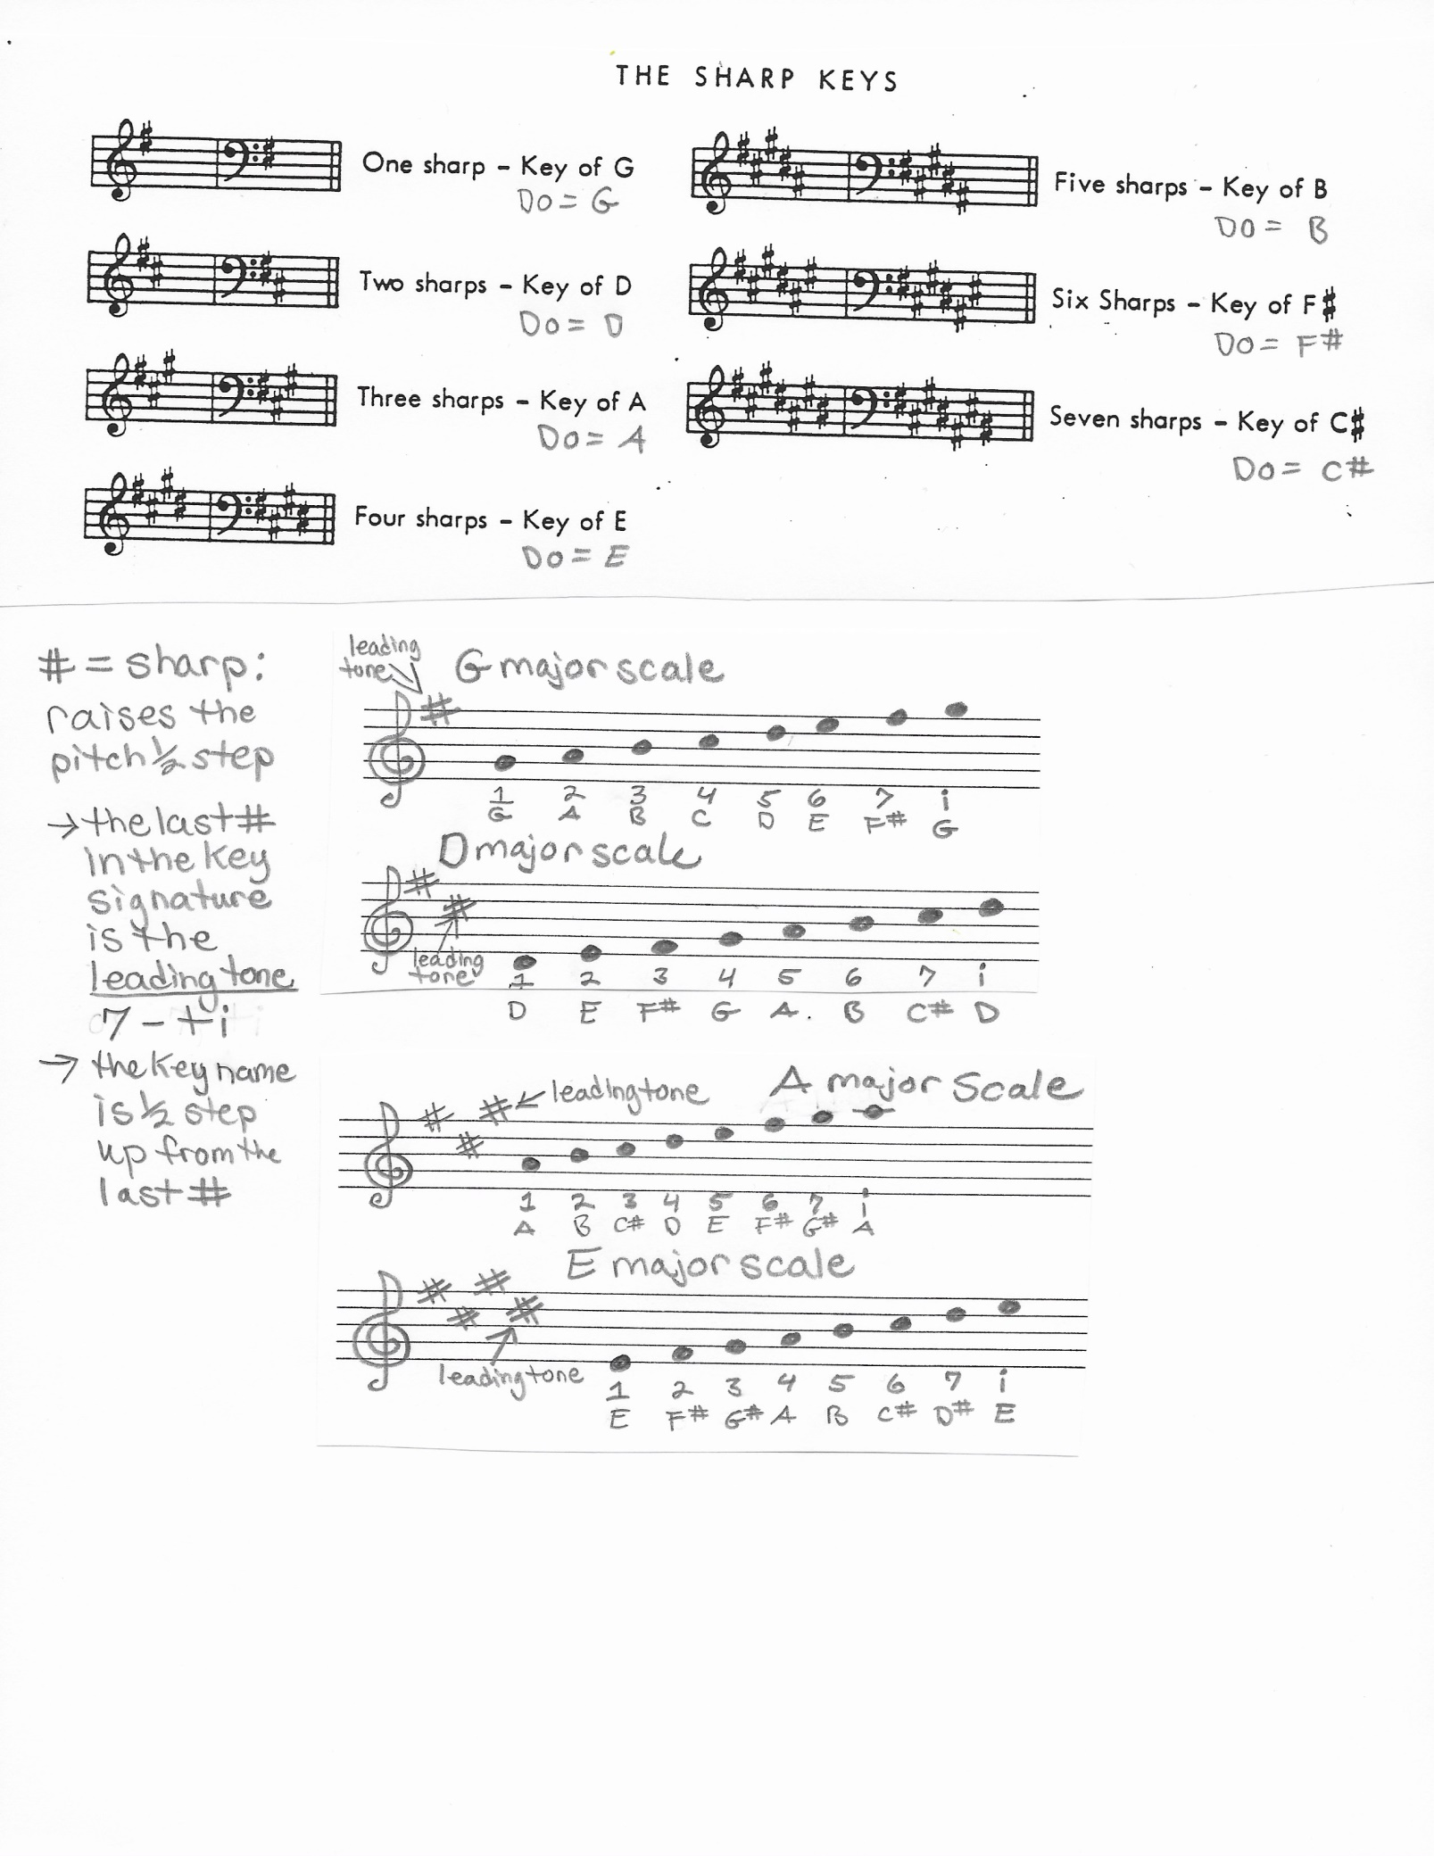

MUSIC THEORY: pg. 21

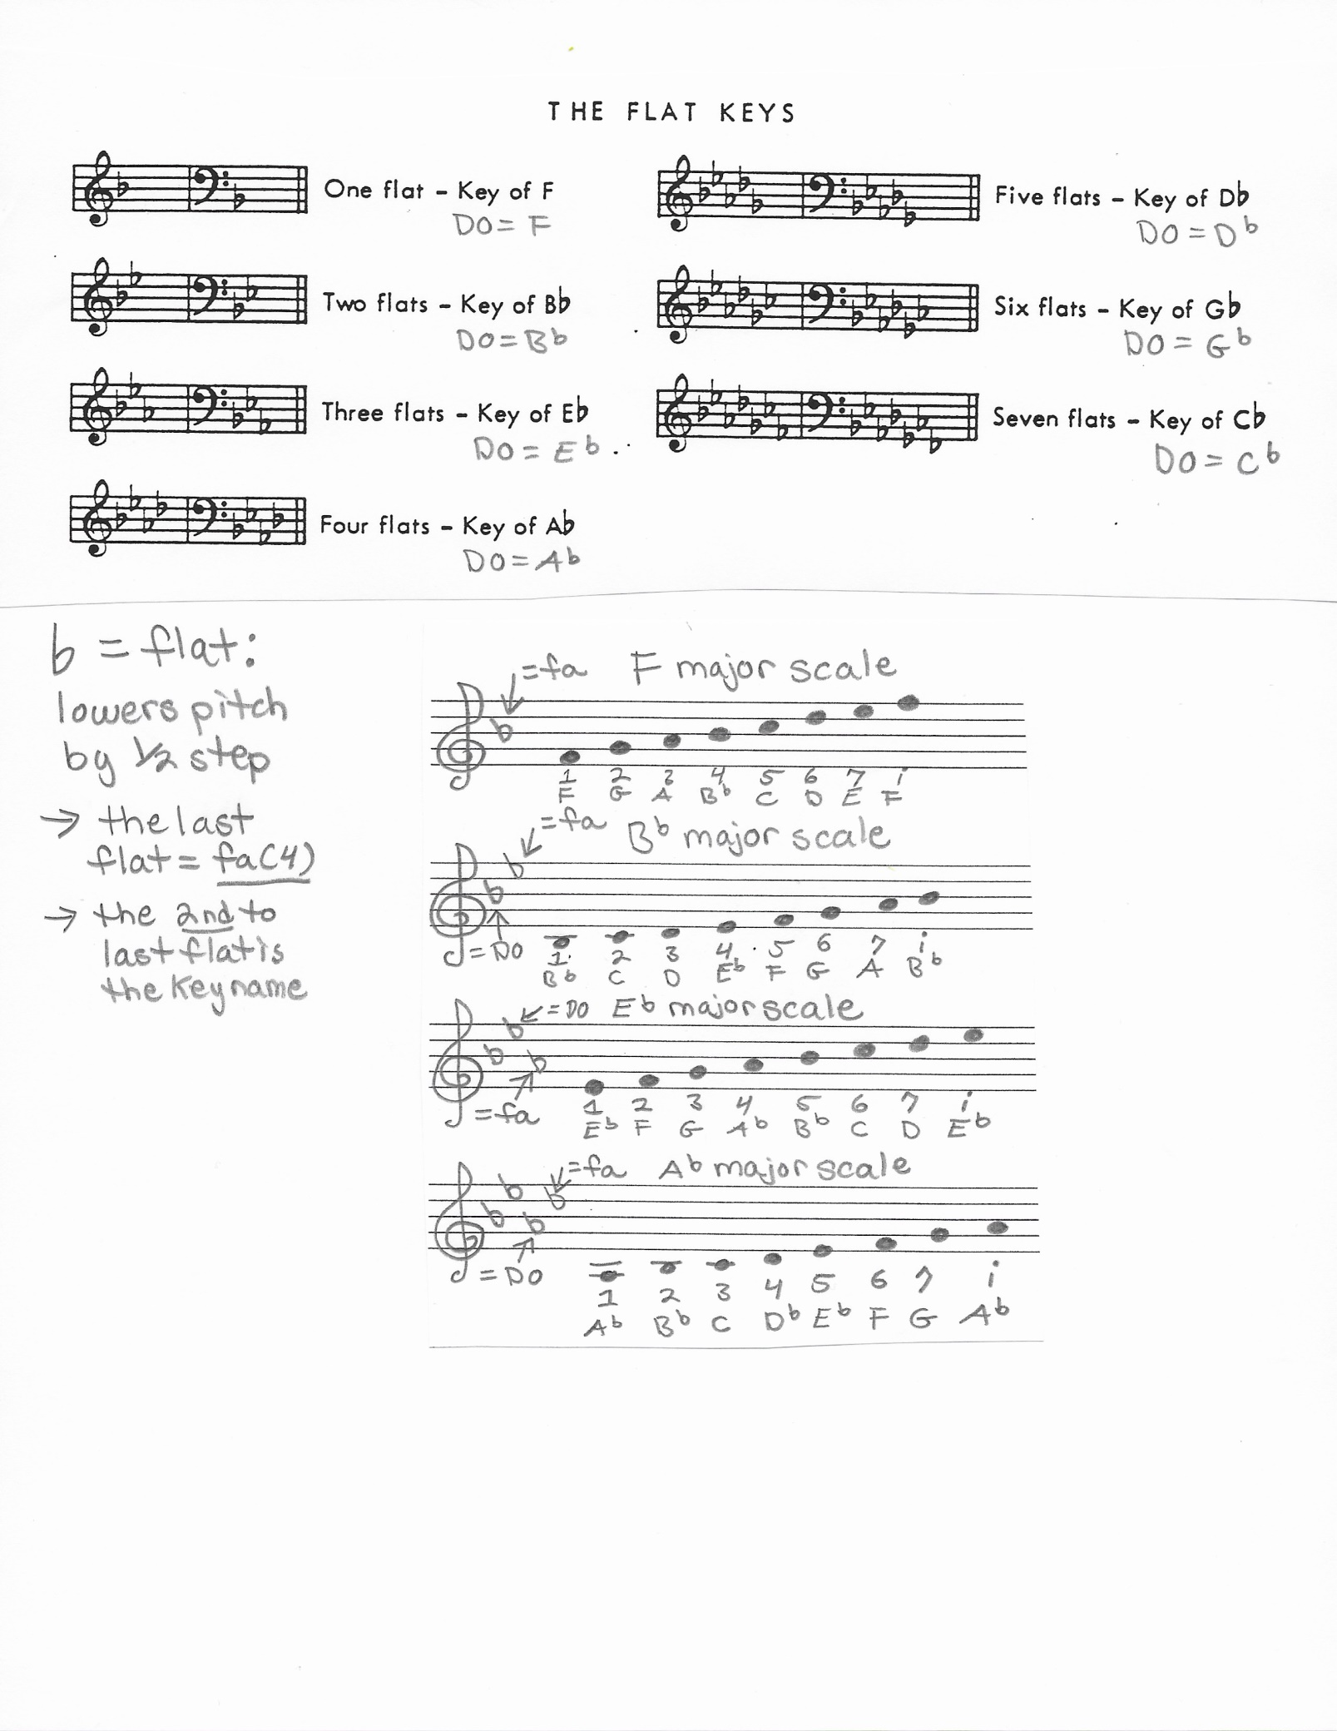

MUSIC THEORY: pg. 22

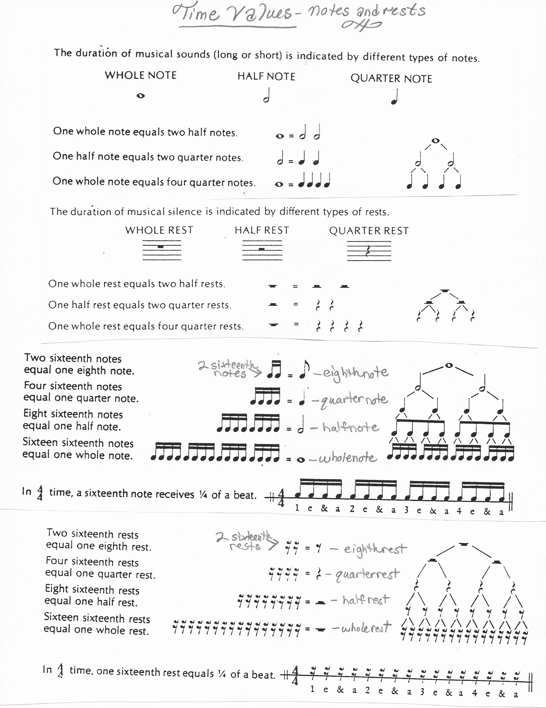

MUSIC THEORY: pg. 23

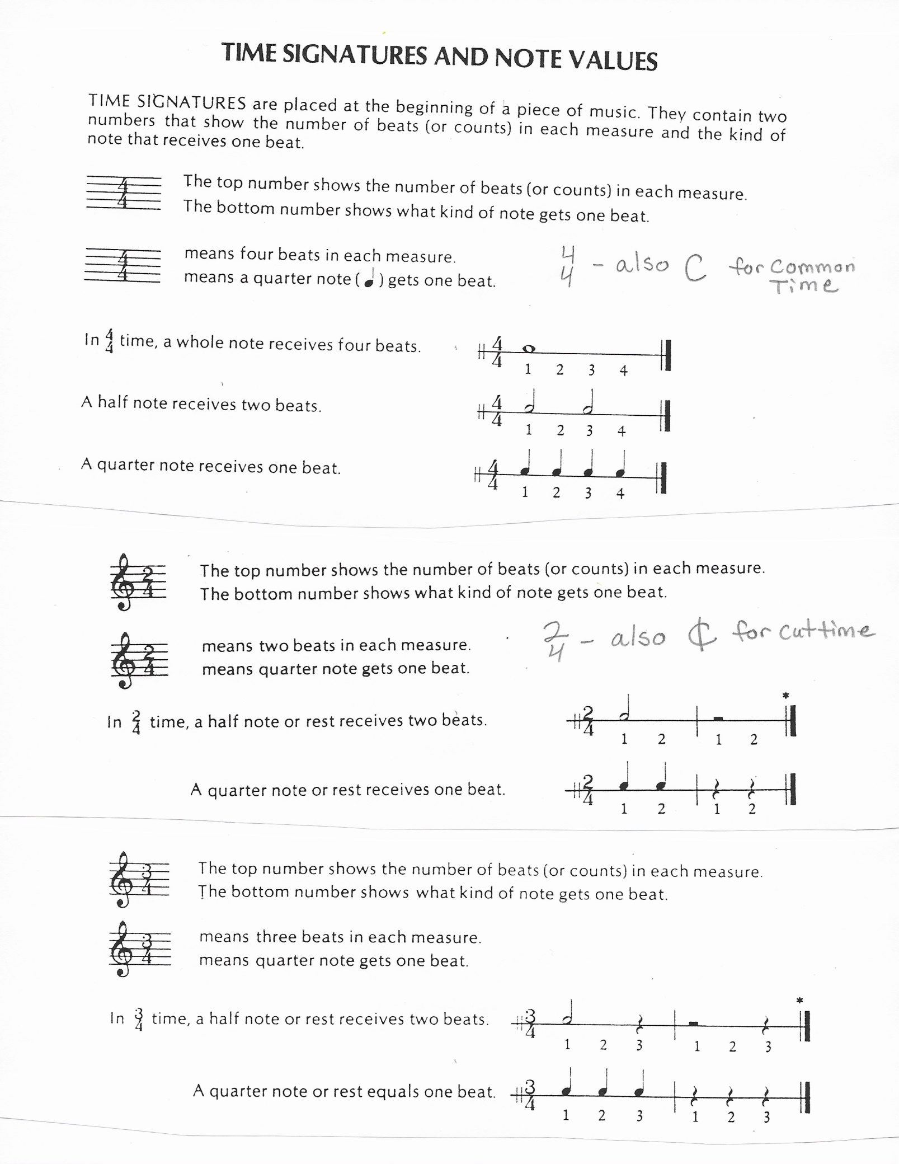

MUSIC THEORY: pg. 24

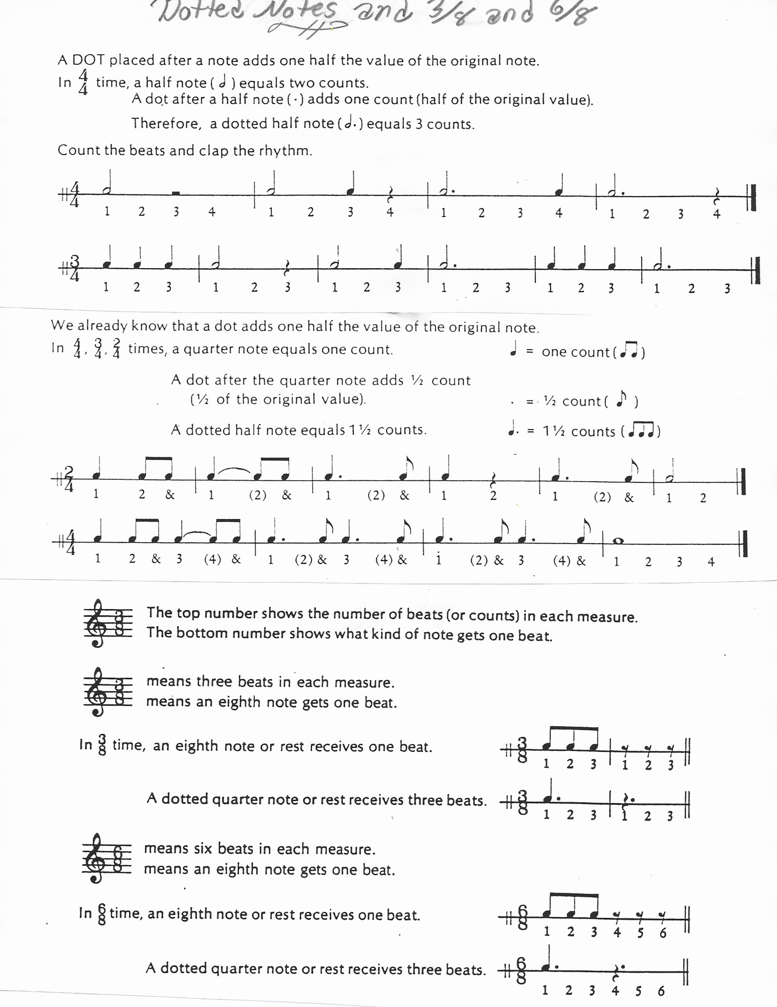

MUSIC THEORY: pg. 25

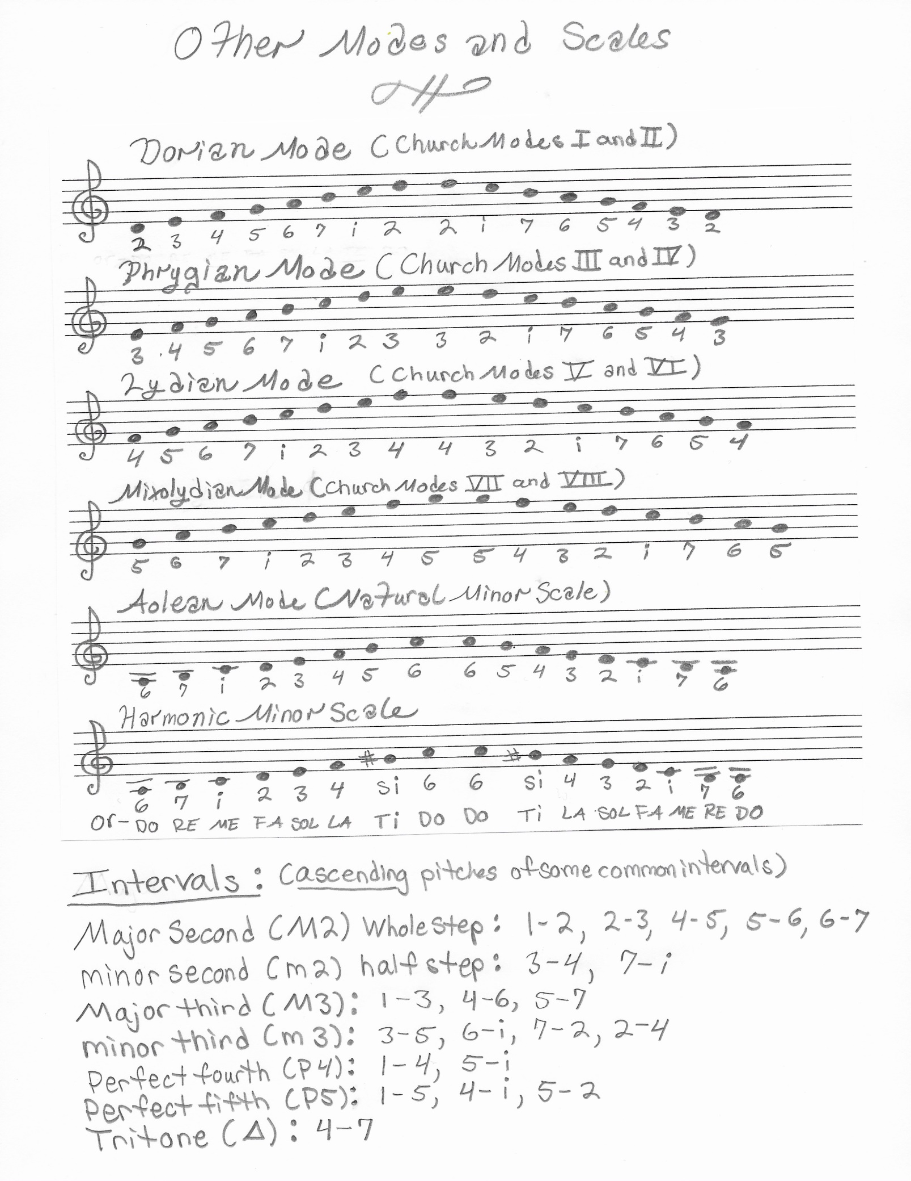

MUSIC THEORY: pg. 26

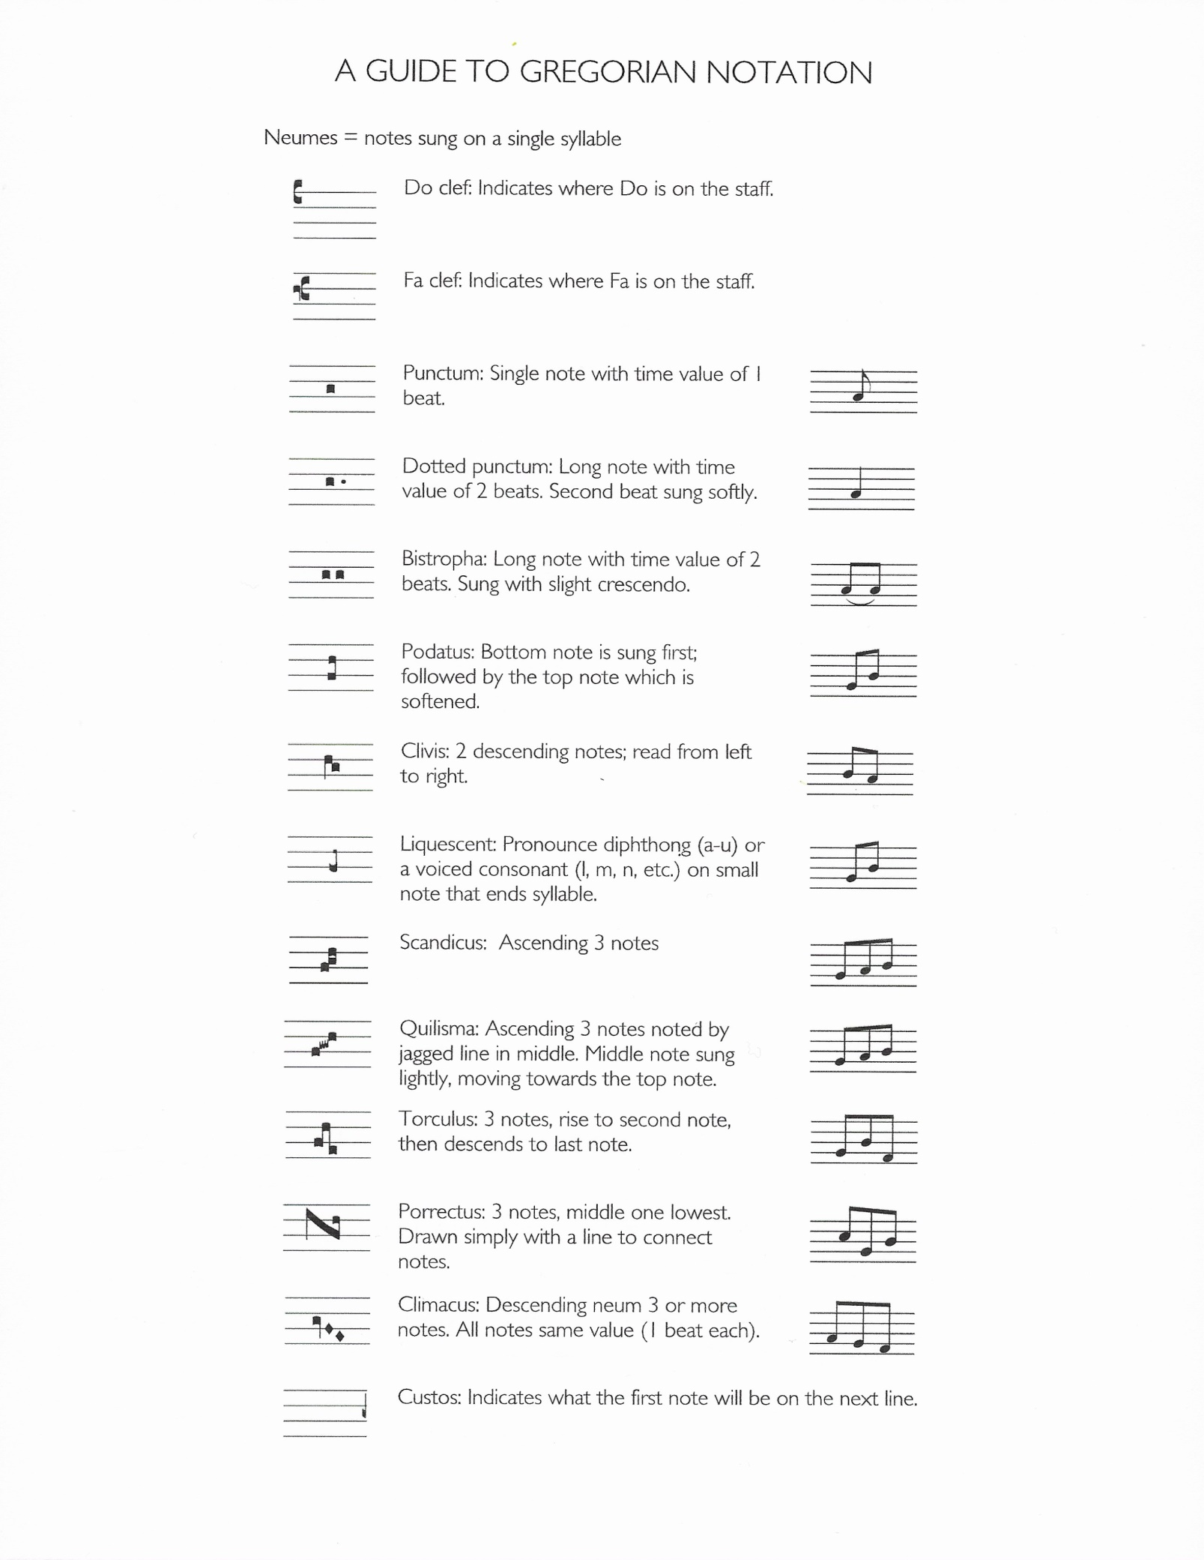

MUSIC THEORY: pg. 27

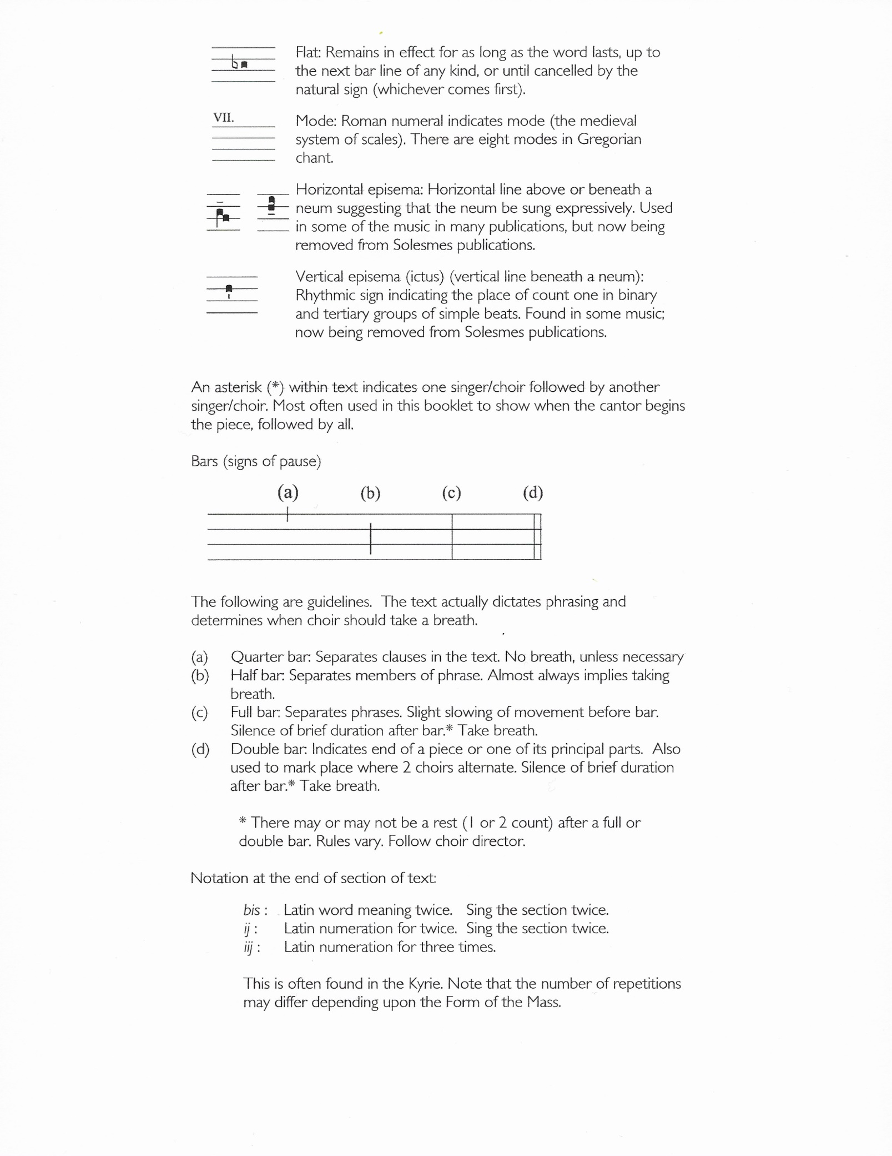

MUSIC THEORY: pg. 28

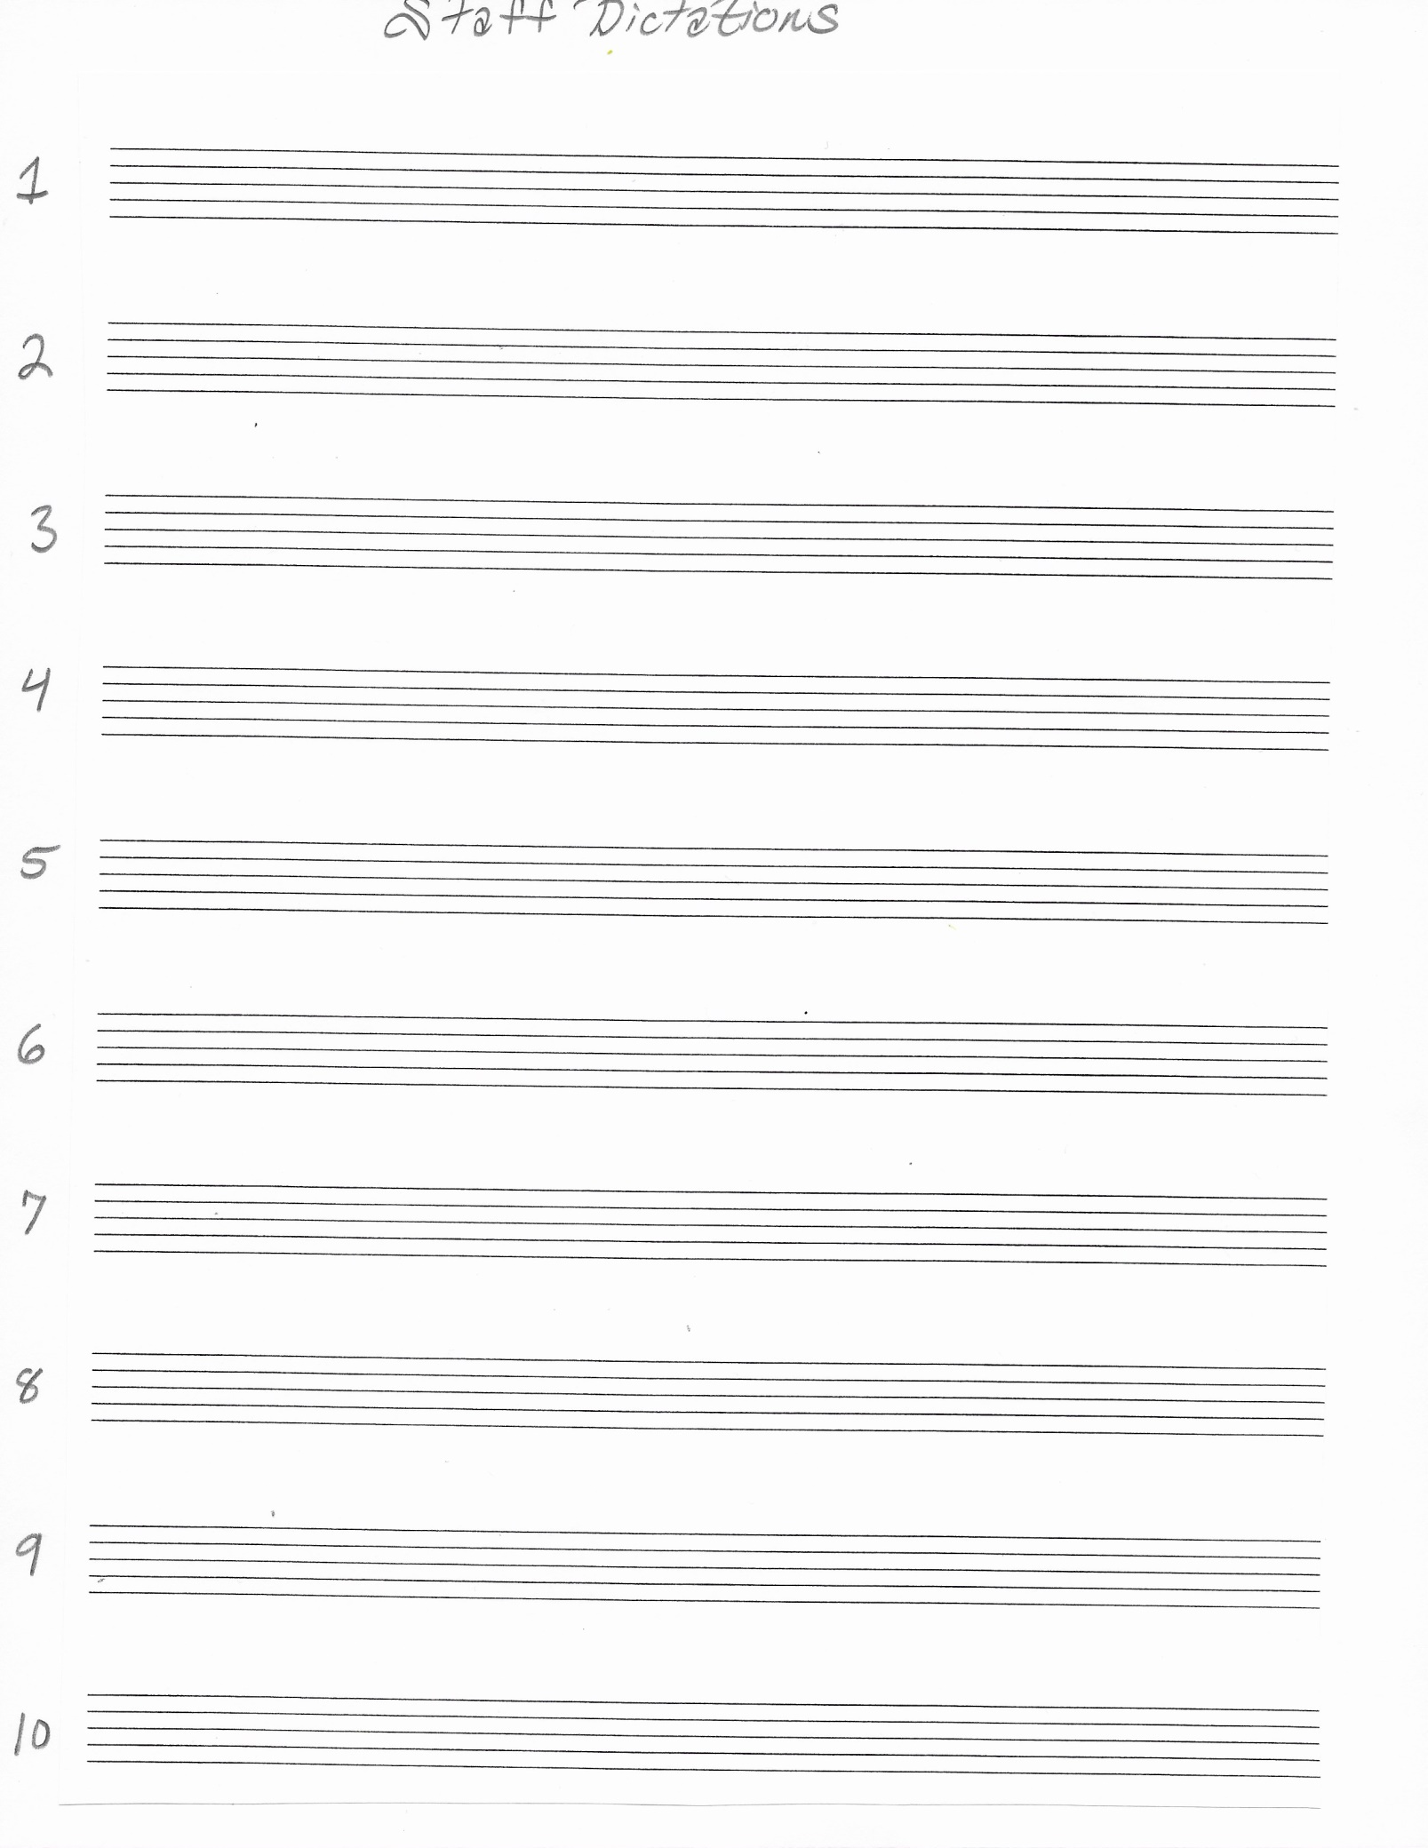

MUSIC THEORY: pg. 29

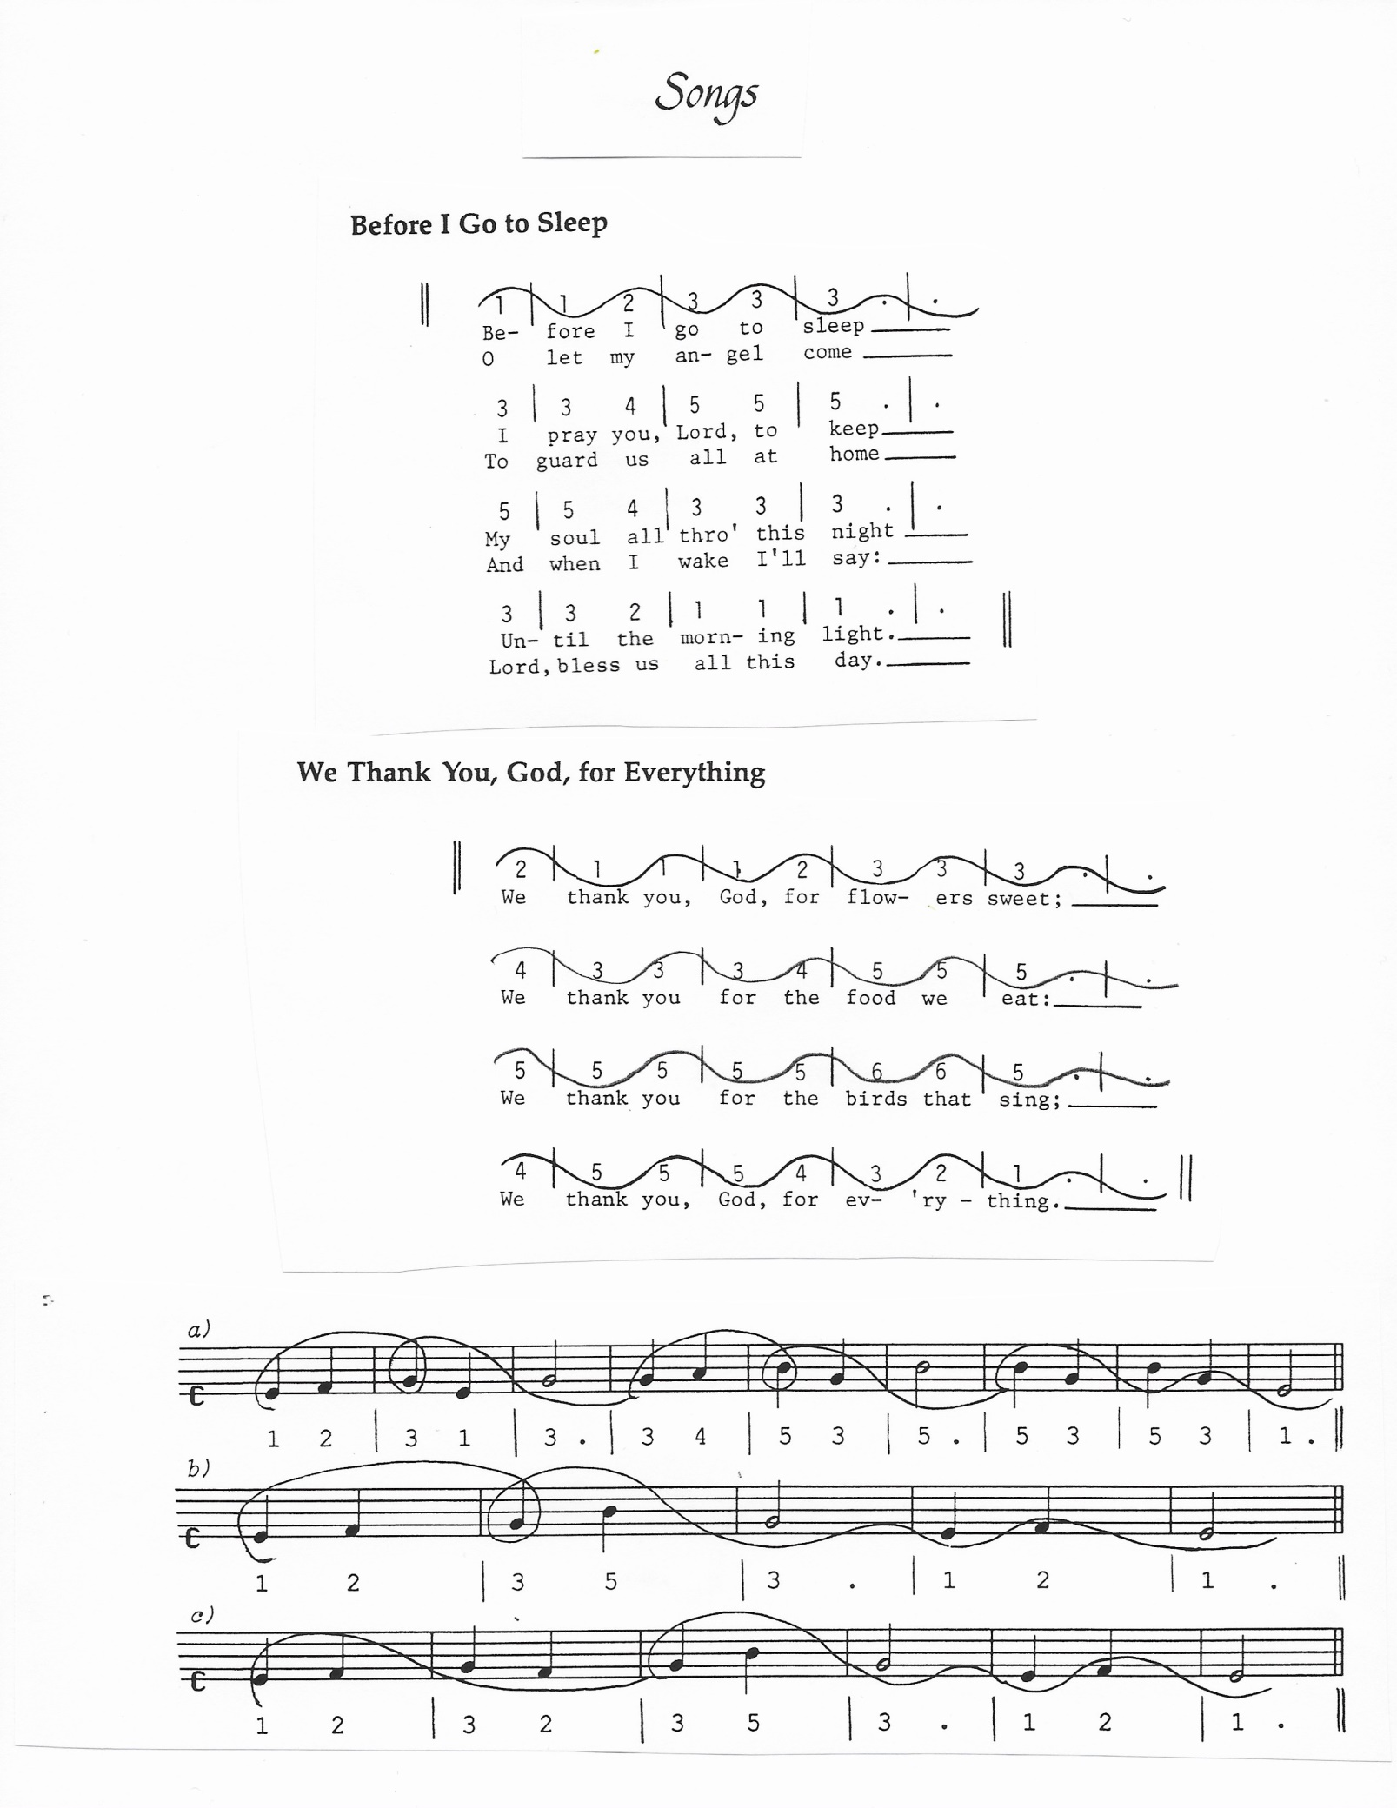

MUSIC THEORY: pg. 30

