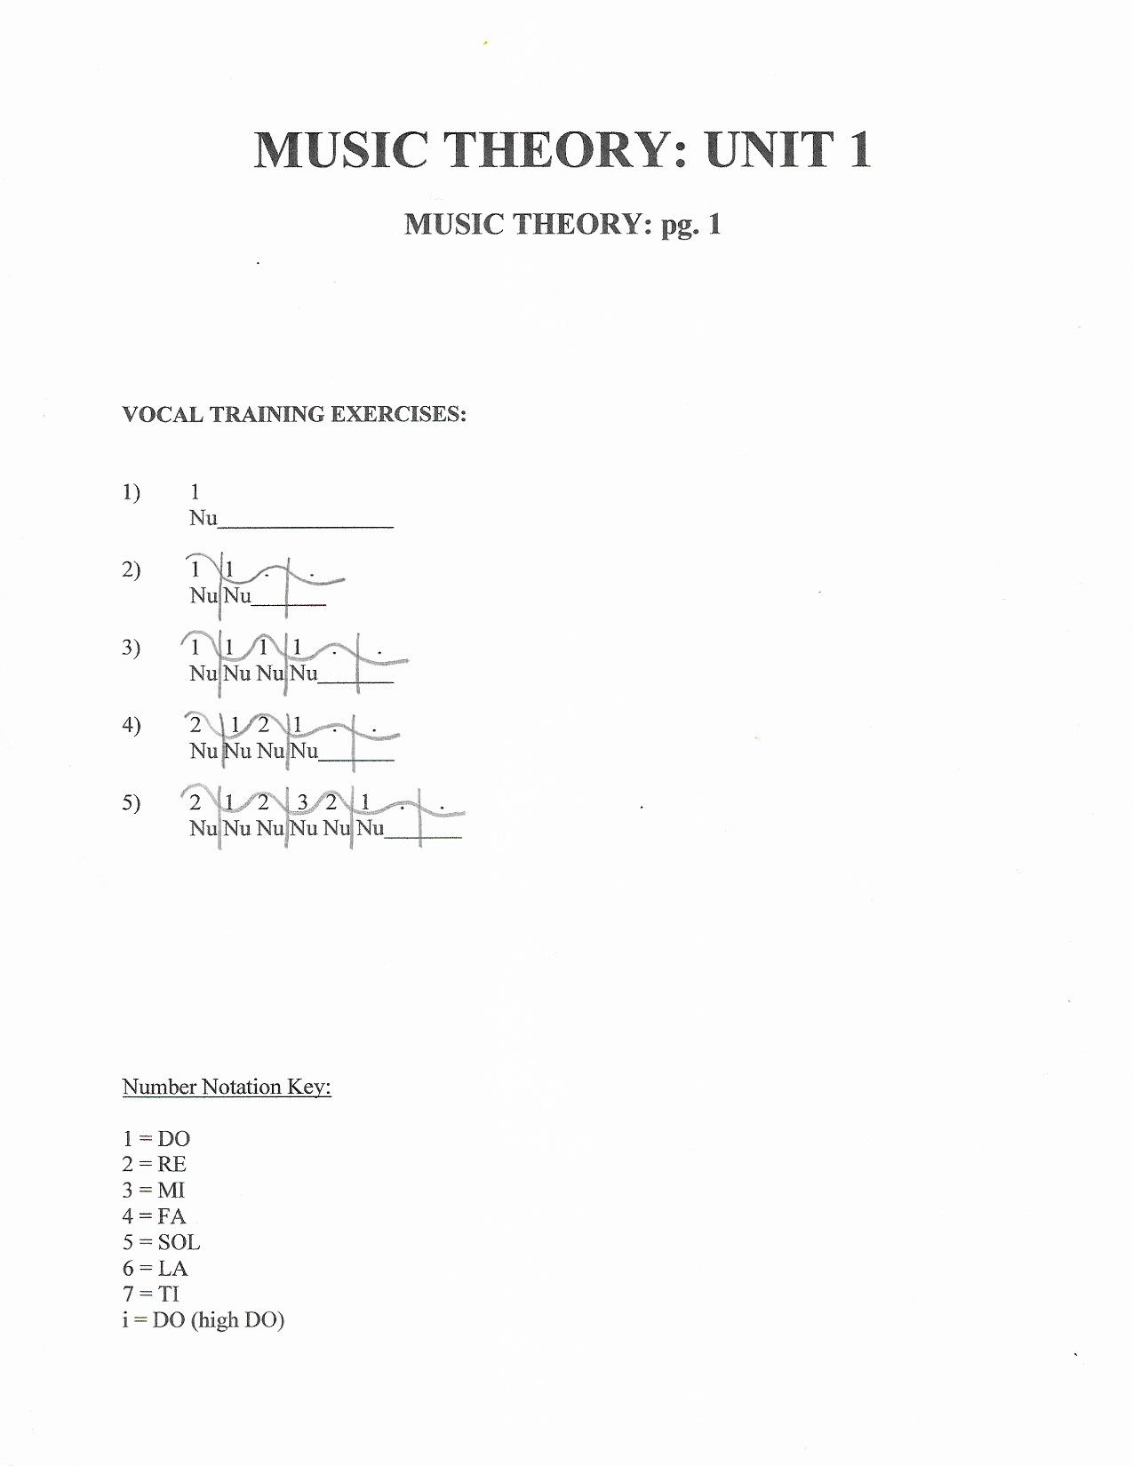
MUSIC THEORY: UNIT 1
MUSIC THEORY: pg. 1

VOCAL TRAINING EXERCISES:

1) 1
Nu

2) 1 1 . .
Nu Nu

3) 1 1 1 1 . .
Nu Nu Nu Nu

4) 2 1 2 1 . .
Nu Nu Nu Nu

5) 2 1 2 3 2 1 . .
Nu Nu Nu Nu Nu Nu

Number Notation Key:

1 = DO
2 = RE
3 = MI
4 = FA
5 = SOL
6 = LA
7 = TI
i = DO (high DO)
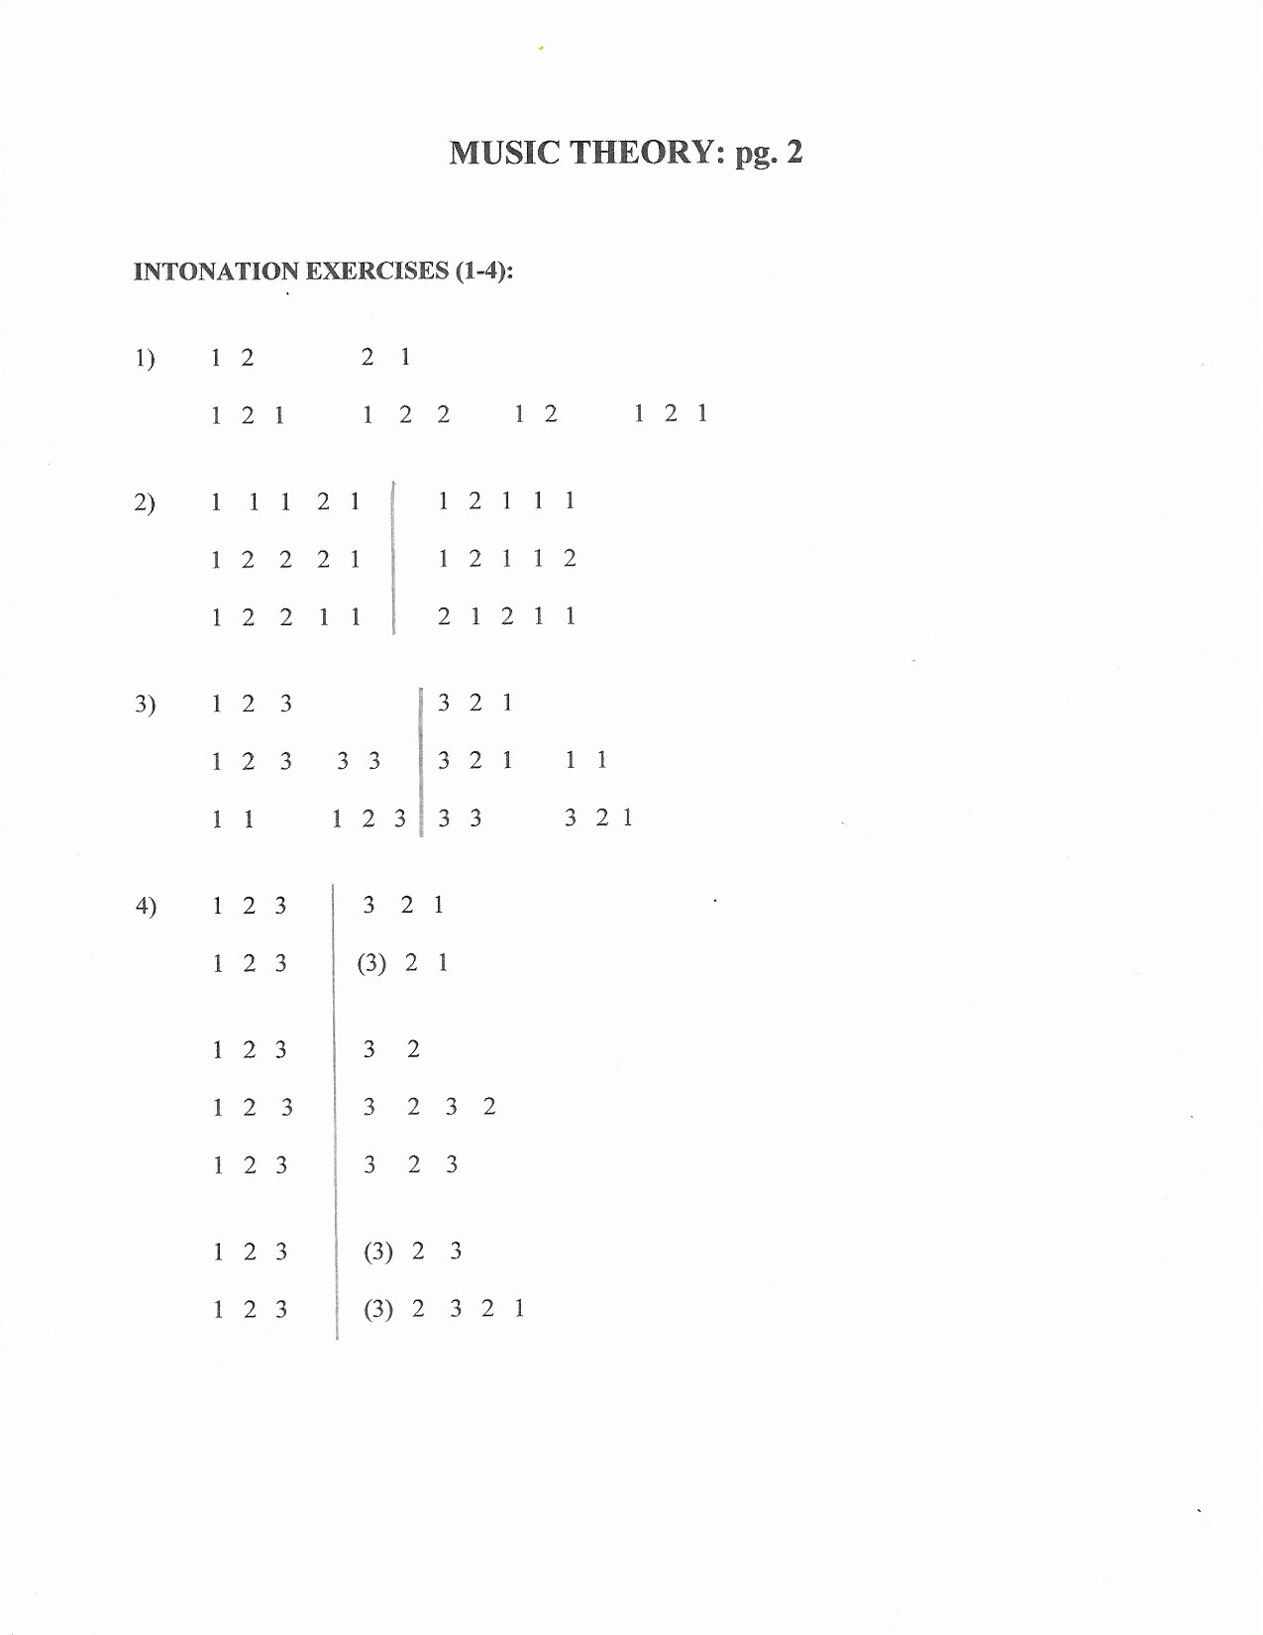
MUSIC THEORY: pg. 2

INTONATION EXERCISES (1-4):

1) 1 2 2 1

1 2 1 1 2 2 1 2 1 2 1

2) 1 1 1 2 1 1 2 1 1 1

1 2 2 2 1 1 2 1 1 2

1 2 2 1 1 2 1 2 1 1

3) 1 2 3 3 2 1

1 2 3 3 3 3 2 1 1 1

1 1 1 2 3 3 3 3 2 1

4) 1 2 3 3 2 1

1 2 3 (3) 2 1

1 2 3 3 2

1 2 3 3 2 3 2

1 2 3 3 2 3

1 2 3 (3) 2 3

1 2 3 (3) 2 3 2 1

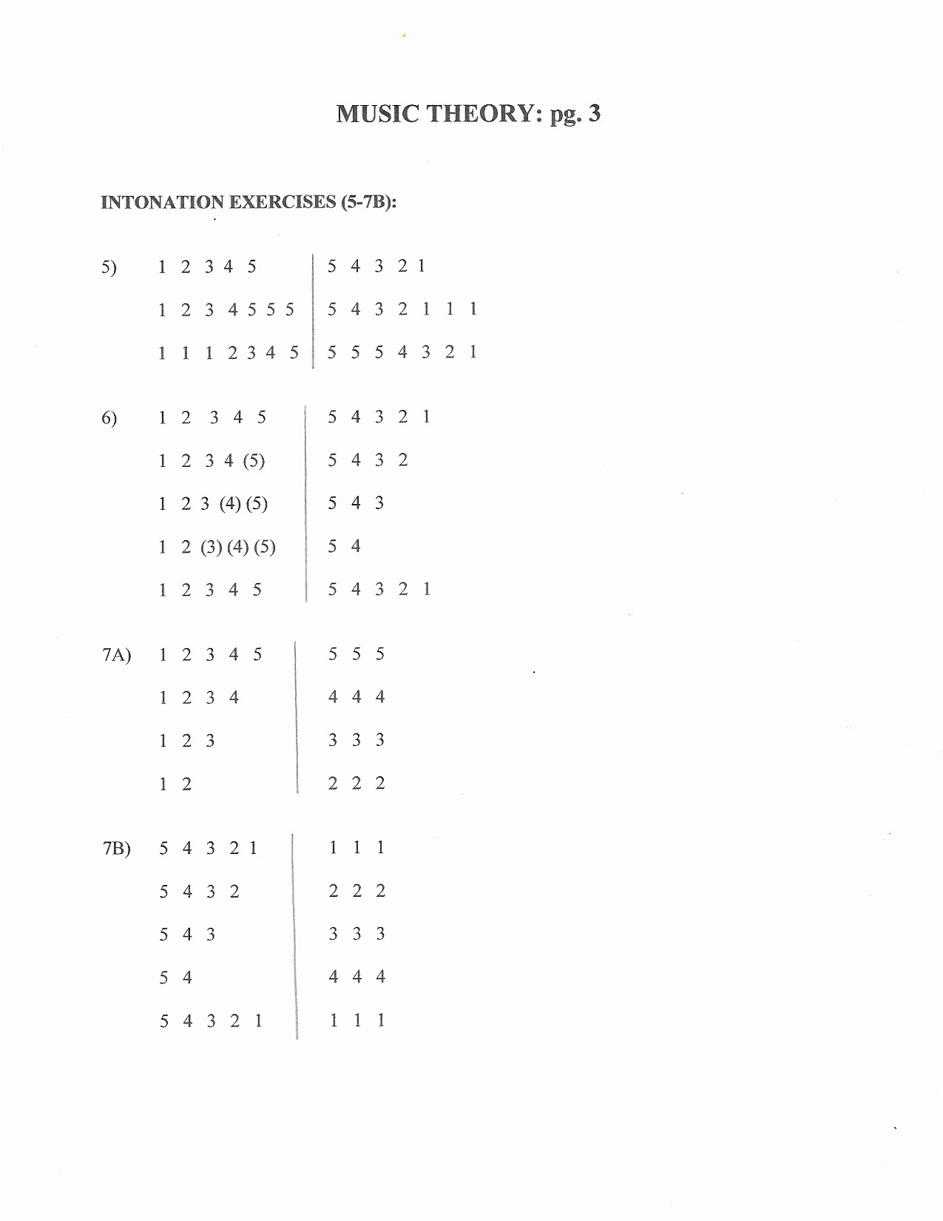
MUSIC THEORY: pg. 3

INTONATION EXERCISES (5-7B):

5) 1 2 3 4 5 5 4 3 2 1

1 2 3 4 5 5 5 5 4 3 2 1 1 1

1 1 1 2 3 4 5 5 5 5 4 3 2 1

6) 1 2 3 4 5 5 4 3 2 1

1 2 3 4 (5) 5 4 3 2

1 2 3 (4) (5) 5 4 3

1 2 (3) (4) (5) 5 4

1 2 3 4 5 5 4 3 2 1

7A) 1 2 3 4 5 5 5 5

1 2 3 4 4 4 4

1 2 3 3 3 3

1 2 2 2 2

7B) 5 4 3 2 1 1 1 1

5 4 3 2 2 2 2

5 4 3 3 3 3

5 4 4 4 4

5 4 3 2 1 1 1 1

MUSIC THEORY: pg. 4

INTONATION EXERCISES (8-11):

8) 1 2 3 4 5 5 4 3 2 1

1 2 3 4 4 5 5 4 3 2 2 1

1 2 3 3 4 5 5 4 3 3 2 1

1 2 2 3 4 5 5 4 4 3 2 1

9) 1 2 3 4 5 5 5 5 4 3 2 1 1 1

1 2 3 3 4 5 5 4 3 3 3 3

1 2 3 3 3 4 5 5 4 3 3 3 2 1

10) 1 2 3 4 5 5 4 3 2 1

1 2 3 4 4 3 2 1

1 2 3 3 2 1

1 2 2 1

1 2 3 4 5 5 4 3 2 1

11) 1 2 3 4 5 5 4 3 2 1
1 2 3 4 5 (5) 4 3 2 1

1 2 3 4 4 3 2 1
1 2 3 4 (4) 3 2 1

1 2 3 3 2 1
1 2 3 (3) 2 1

1 2 2 1
1 2 (2) 1

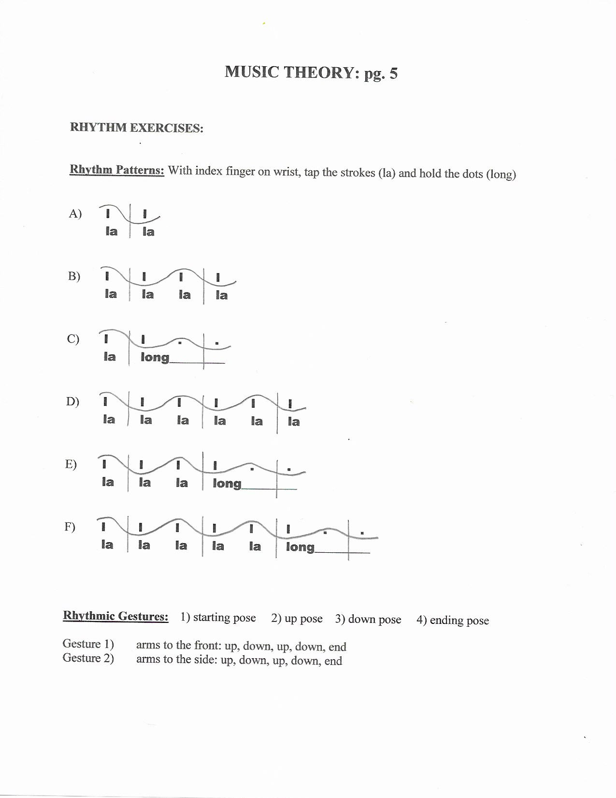
MUSIC THEORY: pg. 5

RHYTHM EXERCISES:

Rhythm Patterns: With index finger on wrist, tap the strokes (la) and hold the dots (long)

A) l l
la la

B) l l l l
la la la la

C) l l . .
la long_________

D) l l l l l l
la la la la la la

E) l l l l . .
la la la long_________

F) l l l l l l . .
la la la la la long_________

Rhythmic Gestures: 1) starting pose 2) up pose 3) down pose 4) ending pose

Gesture 1) arms to the front: up, down, up, down, end
Gesture 2) arms to the side: up, down, up, down, end

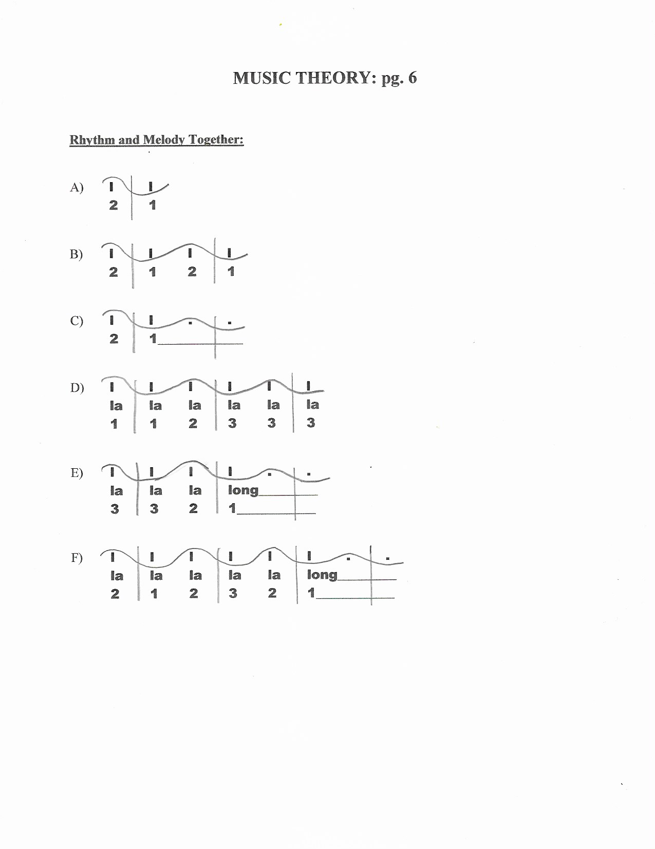
MUSIC THEORY: pg. 6

Rhythm and Melody Together:

A) l l
2 1

B) l l l l
2 1 2 1

C) l l . .
2 1_____________

D) l l l l l l
la la la la la la
1 1 2 3 3 3

E) l l l l . .
la la la long_________
3 3 2 1____________

F) l l l l l l . .
la la la la la long_________
2 1 2 3 2 1____________

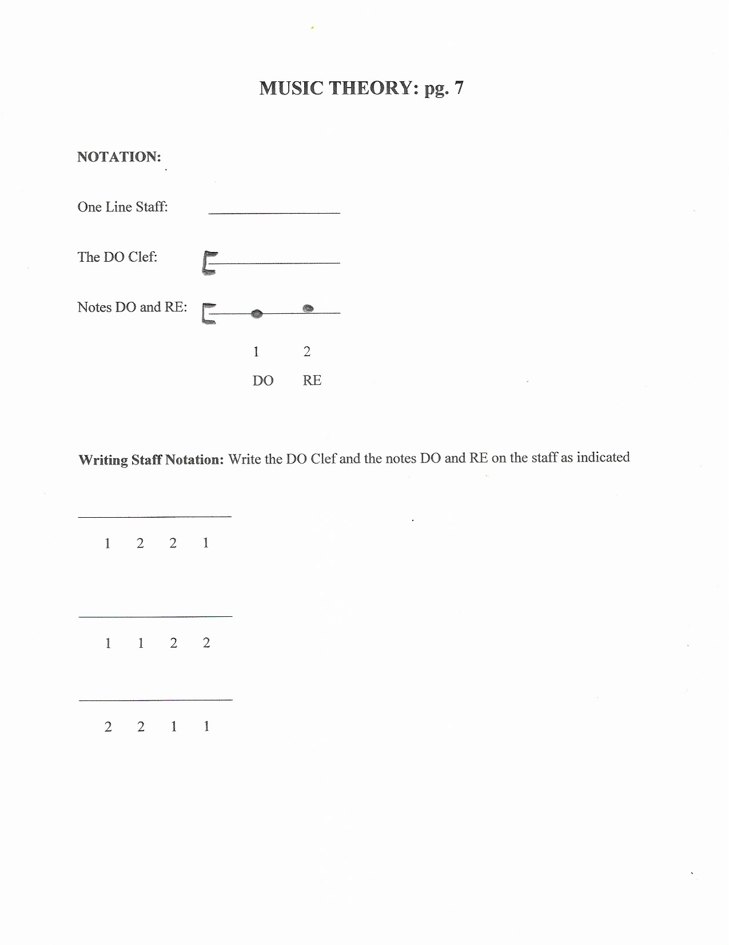
MUSIC THEORY: pg. 7

NOTATION:

One Line Staff: __________________

The DO Clef: __________________

Notes DO and RE: __________________

- 2
DO RE

Writing Staff Notation: Write the DO Clef and the notes DO and RE on the staff as indicated

_____________________

1 2 2 1

_____________________

1 1 2 2

_____________________

2 2 1 1

MUSIC THEORY: pg. 8

DICTATIONS: Write the melody and/or rhythm that you hear

1)

2)

3)

4)

5)

6)

7)

8)

9)

10)

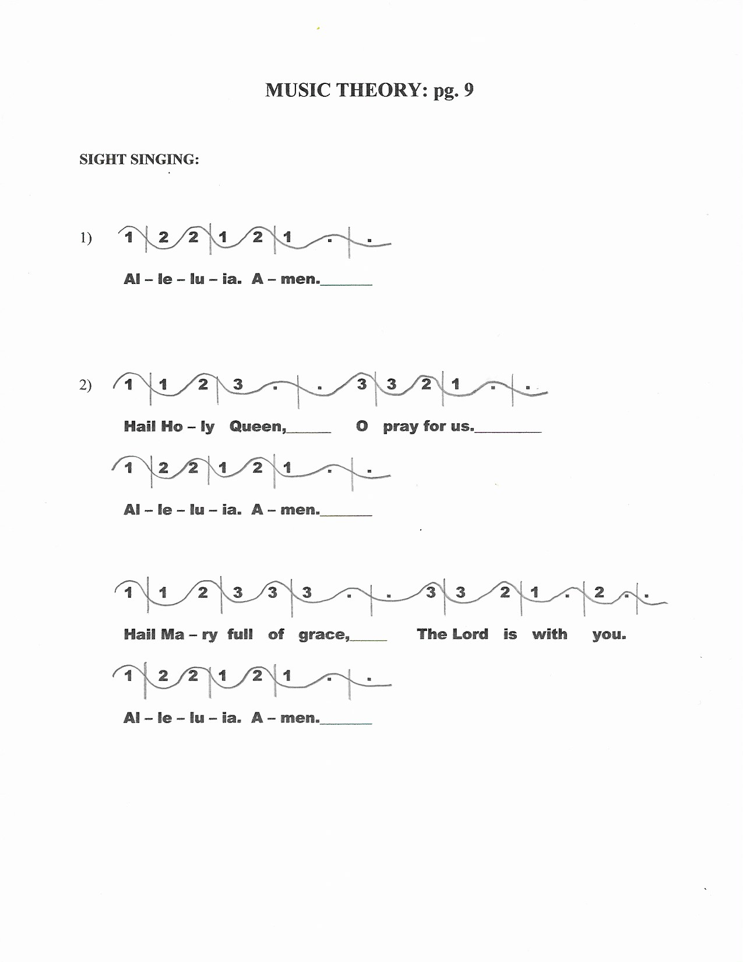
MUSIC THEORY: pg. 9

SIGHT SINGING:

1) 1 2 2 1 2 1 . .

Al – le – lu – ia. A – men._______

2) 1 1 2 3 . . 3 3 2 1 . .

Hail Ho – ly Queen,______ O pray for us._________

1 2 2 1 2 1 . .

Al – le – lu – ia. A – men._______

1 1 2 3 3 3 . . 3 3 2 1 . 2 . .

Hail Ma – ry full of grace,_____ The Lord is with you.

1 2 2 1 2 1 . .

Al – le – lu – ia. A – men._______

