REPERTOIRE: pg. 1

REPERTOIRE: UNIT 1

Latin Pronunciation Guide

Vowels:

Note: When two vowels are next to each other, pronounce both letters (eu is “eh –oo”). Exceptions: ae, oe.

Pronounce:

A “ah” as in father
E (or) AE “eh” as in get
I “ee” as in meet
I between two vowels, as “y” in yes or alleluia
O (or) OE open “oh” as in bought (round lips for “oh” and say “awe”)
U “oo” as in root
U before a vowel and after gn or q, like “W” as in quilt or Latin word qui

Consonants:

The pronunciation of Latin consonants is the same as English, with the following exceptions.

Pronounce:

C before a, o, or u, like “k” as in cat
C before e, i, y, ae, or oe, like “ch” as in church
C after X, and before e, i, y, ae or oe, like “sh” as in shirt or Latin word excelsis
CH “k” as in kite
G before a, o, or u, like “g” as in glory
G before e, i, y, ae, or oe, like “g” as in gem
GN “nyuh”, as in the middle of onion, or Latin word angus
H silent (exception: H is pronounced “k” only in mihi and nihil)
J “y” as in yes
N before ct, like “ng” as in finger, or Latin word sanctus
S between 2 vowels, like “z” as in zebra
S preceded by a consonant at the end of a word, like “z” as in zebra
SC (or SCH) before a, o, u, or consonant, like “sk” in skunk
SC before e, i, y, ae, or oe, like “sh” in shirt
TI before a vowel or consonant (except s, t, or x), like “tsee” as in gratia
TH “t” as in top
EX at beginning of a word; before a vowel, s + vowel, or h; like “gz” as in exult
Y “ee” as in candy
Z “dz” as in maids

REPERTOIRE: pg. 2

Gregorian Chant: Songs for Mass
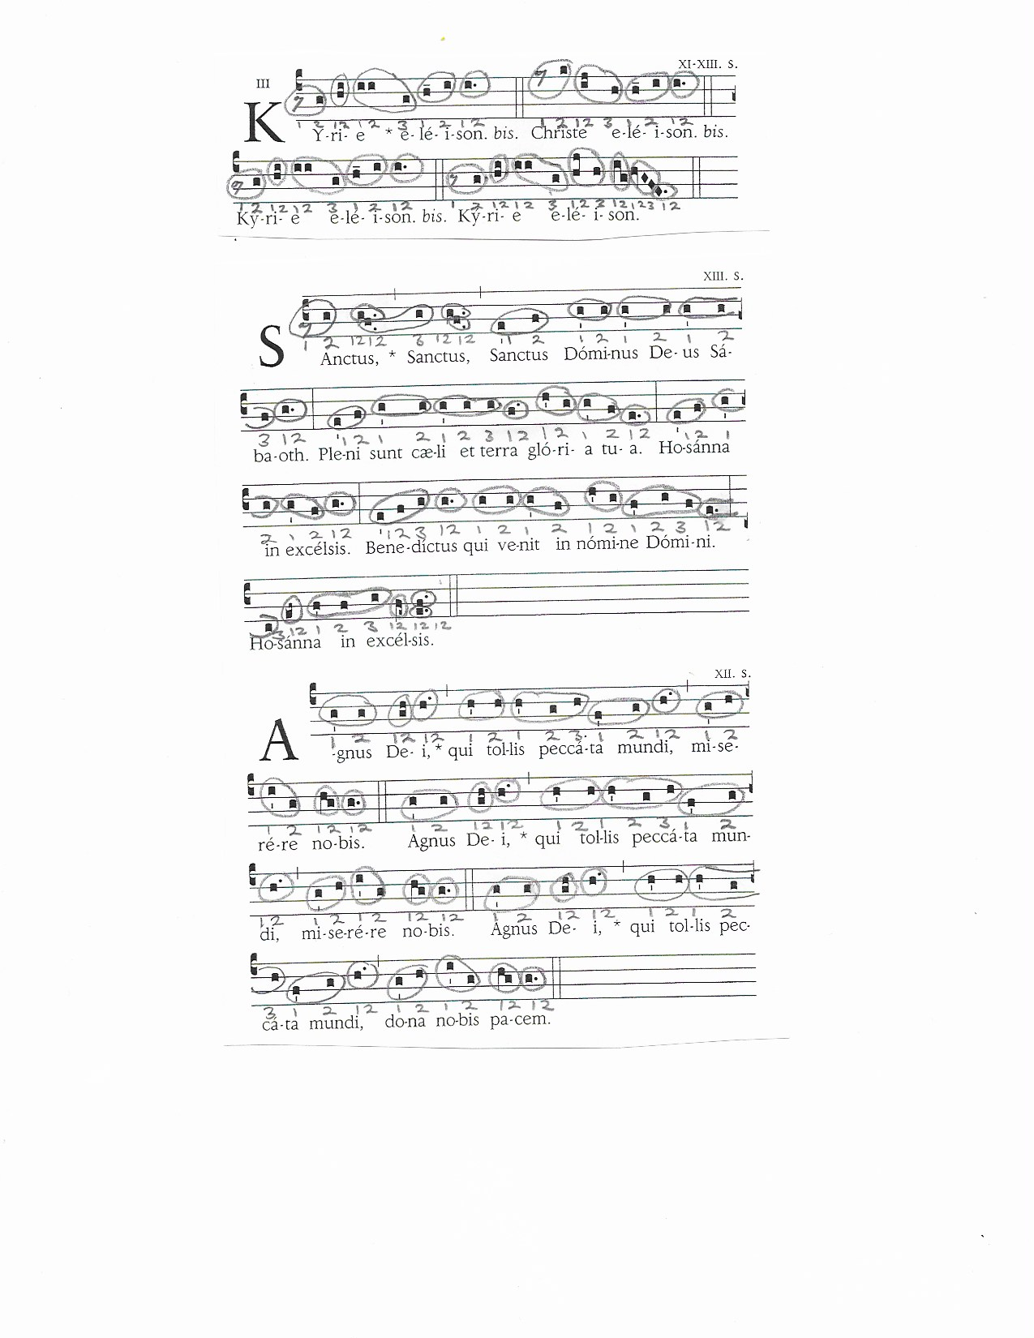

REPERTOIRE: pg. 3

Kyrie:

Lord have mercy.

Christ have mercy.

Lord have mercy.

Sanctus:

Holy, Holy, Holy Lord God of hosts.

Heaven and earth are full of your glory.

Hosanna in the highest.

Blessed is he who comes in the name of the Lord.

Hosanna in the highest.

Agnus Dei:

Lamb of God, you take away the sins of the world, have mercy on us.

Lamb of God, you take away the sins of the world, have mercy on us.

Lamb of God, you take away the sins of the world, grant us peace.

REPERTOIRE: pg. 4
Folk Songs: Songs of the Sea
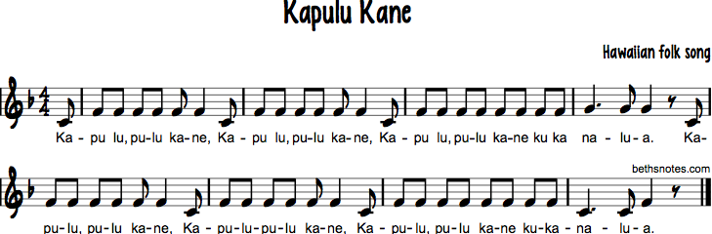

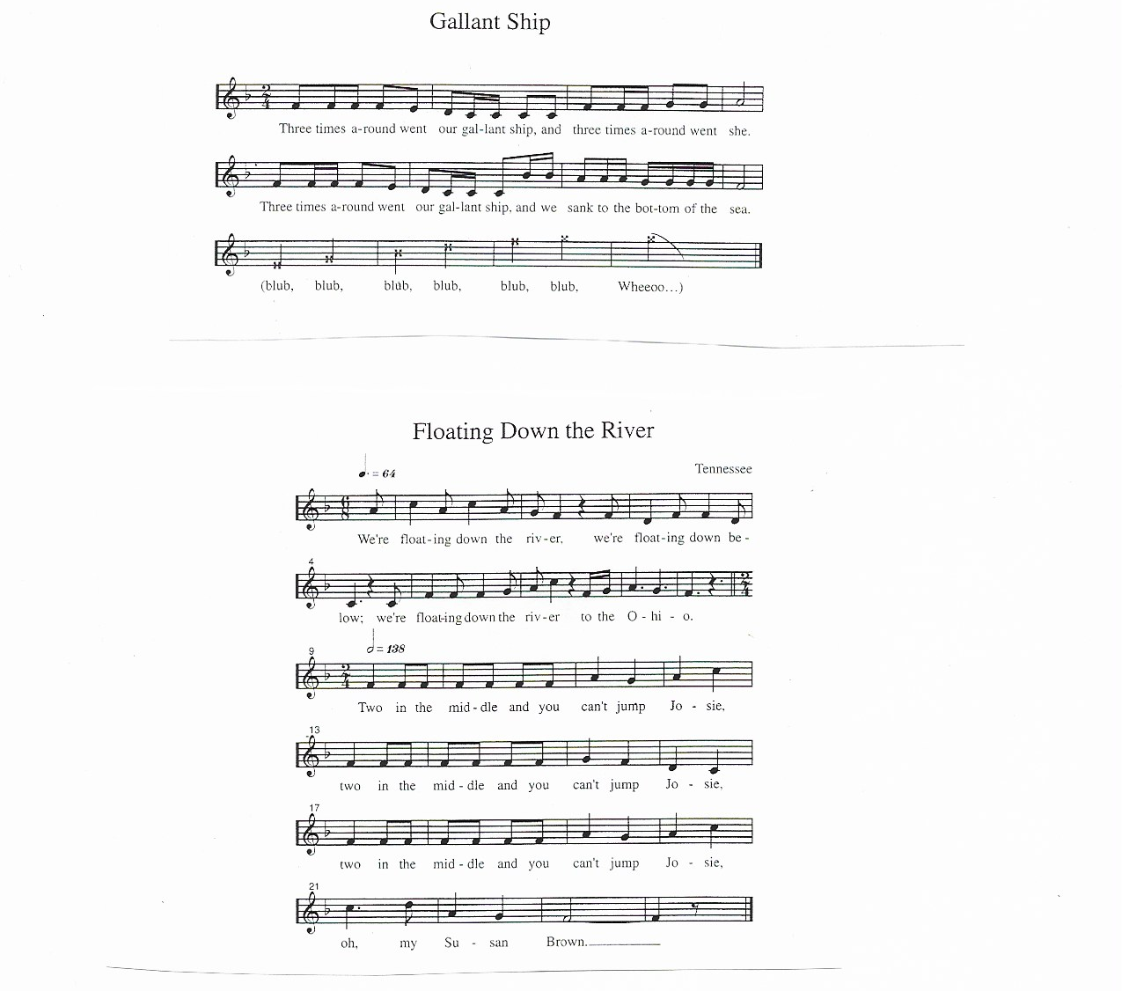
l l l. l l l.

REPERTOIRE: pg. 5
Folk Songs: Songs for Autumn
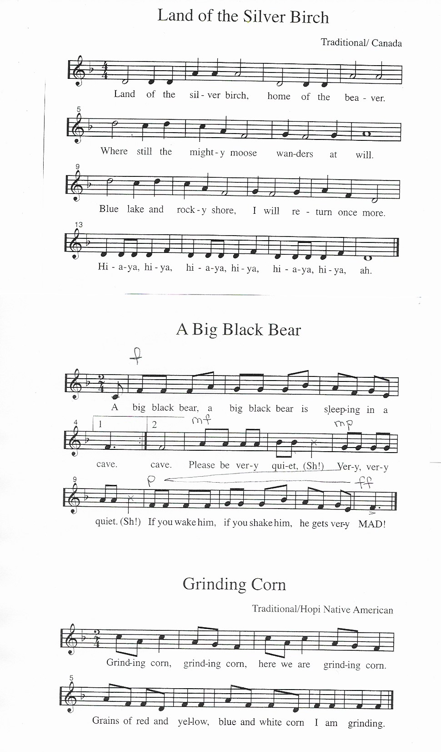

REPERTOIRE: pg. 6

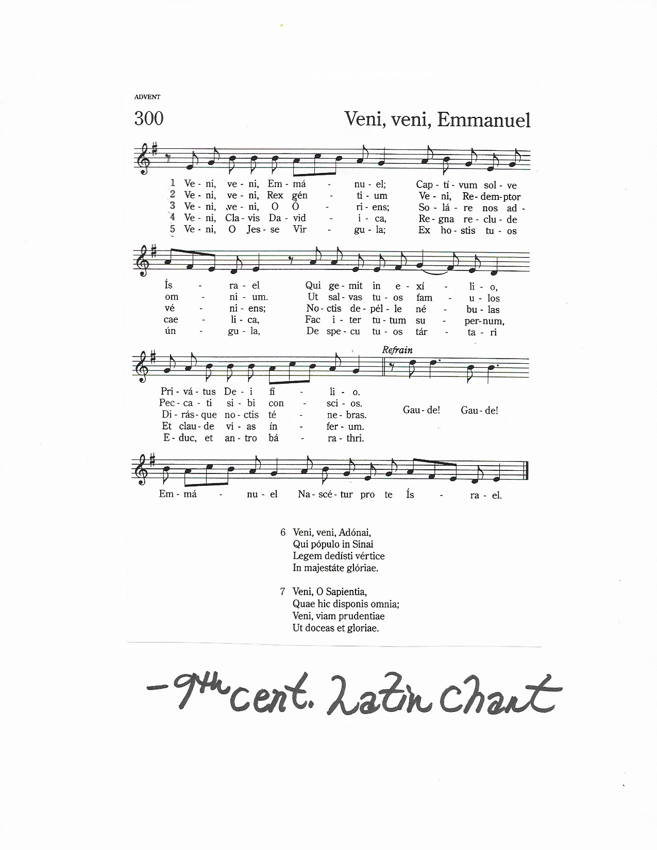
REPERTOIRE: pg. 7

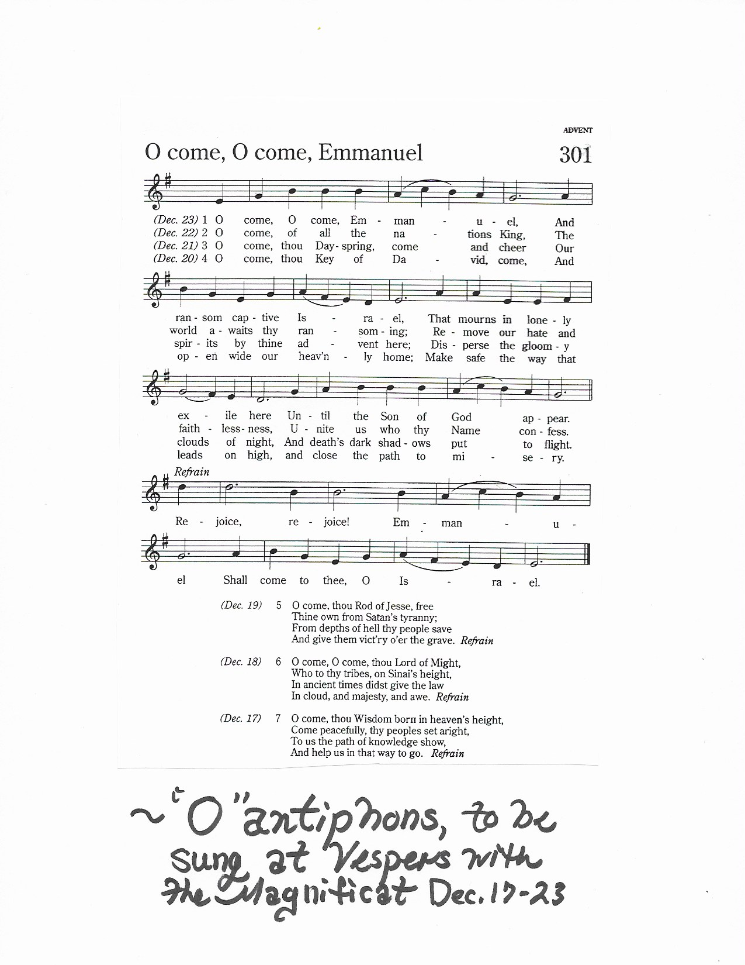
REPERTOIRE: pg. 8

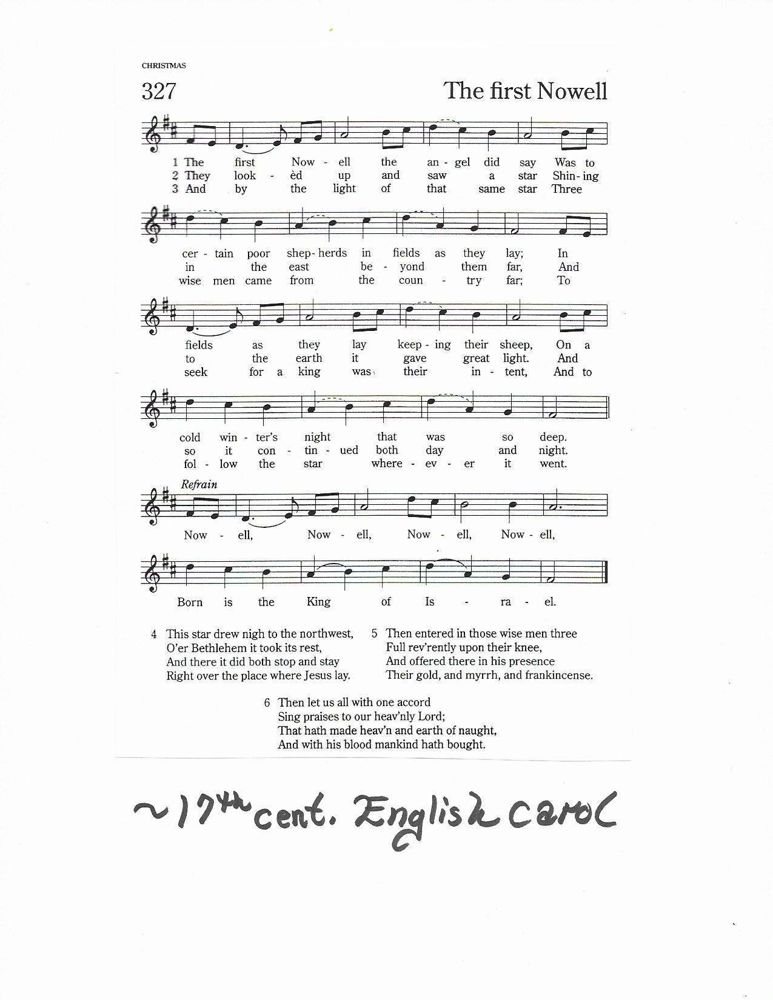
REPERTOIRE: pg. 9

REPERTOIRE: pg. 10
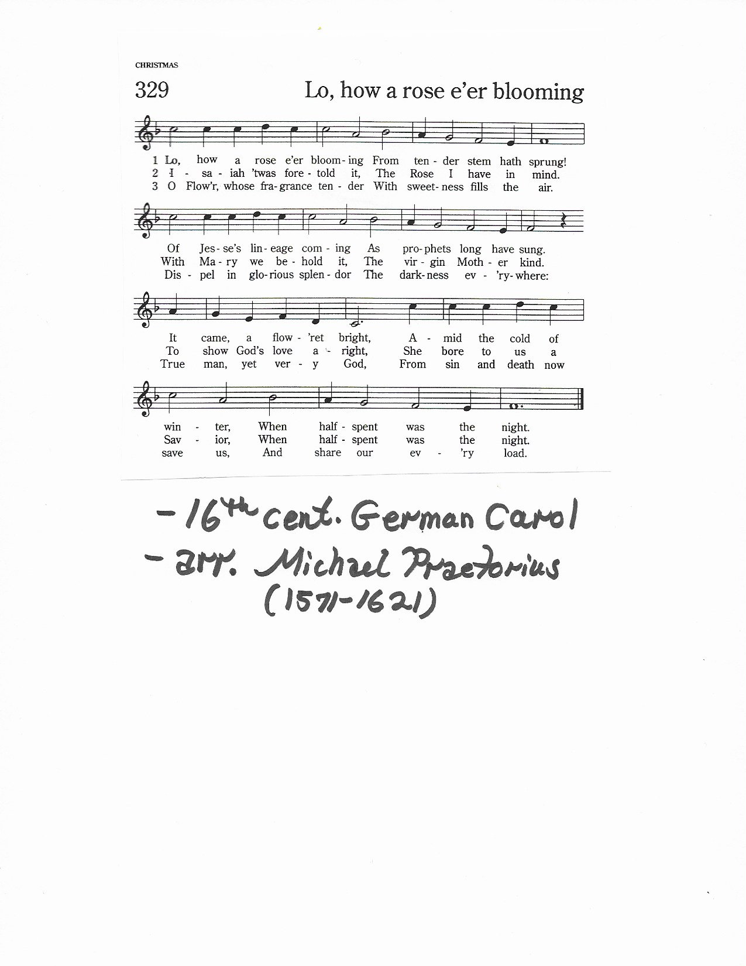

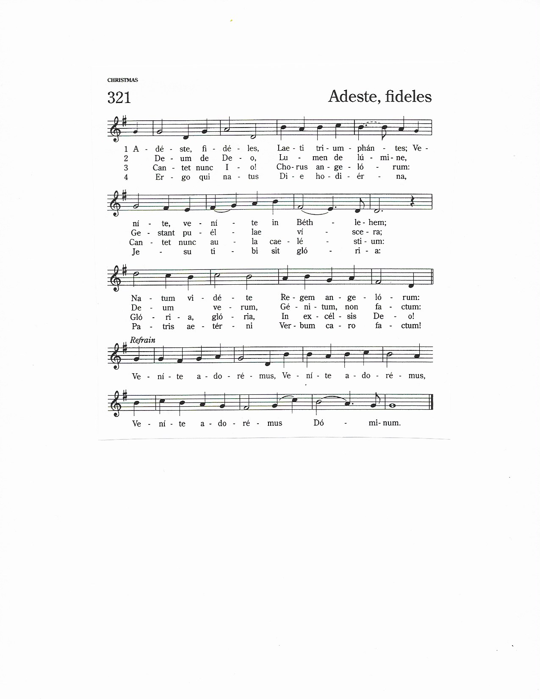
REPERTOIRE: pg. 11

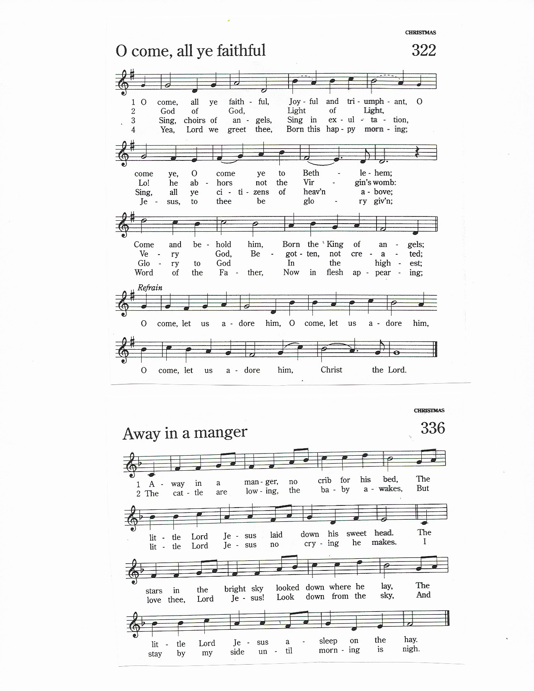
REPERTOIRE: pg. 12

REPERTOIRE: pg. 13
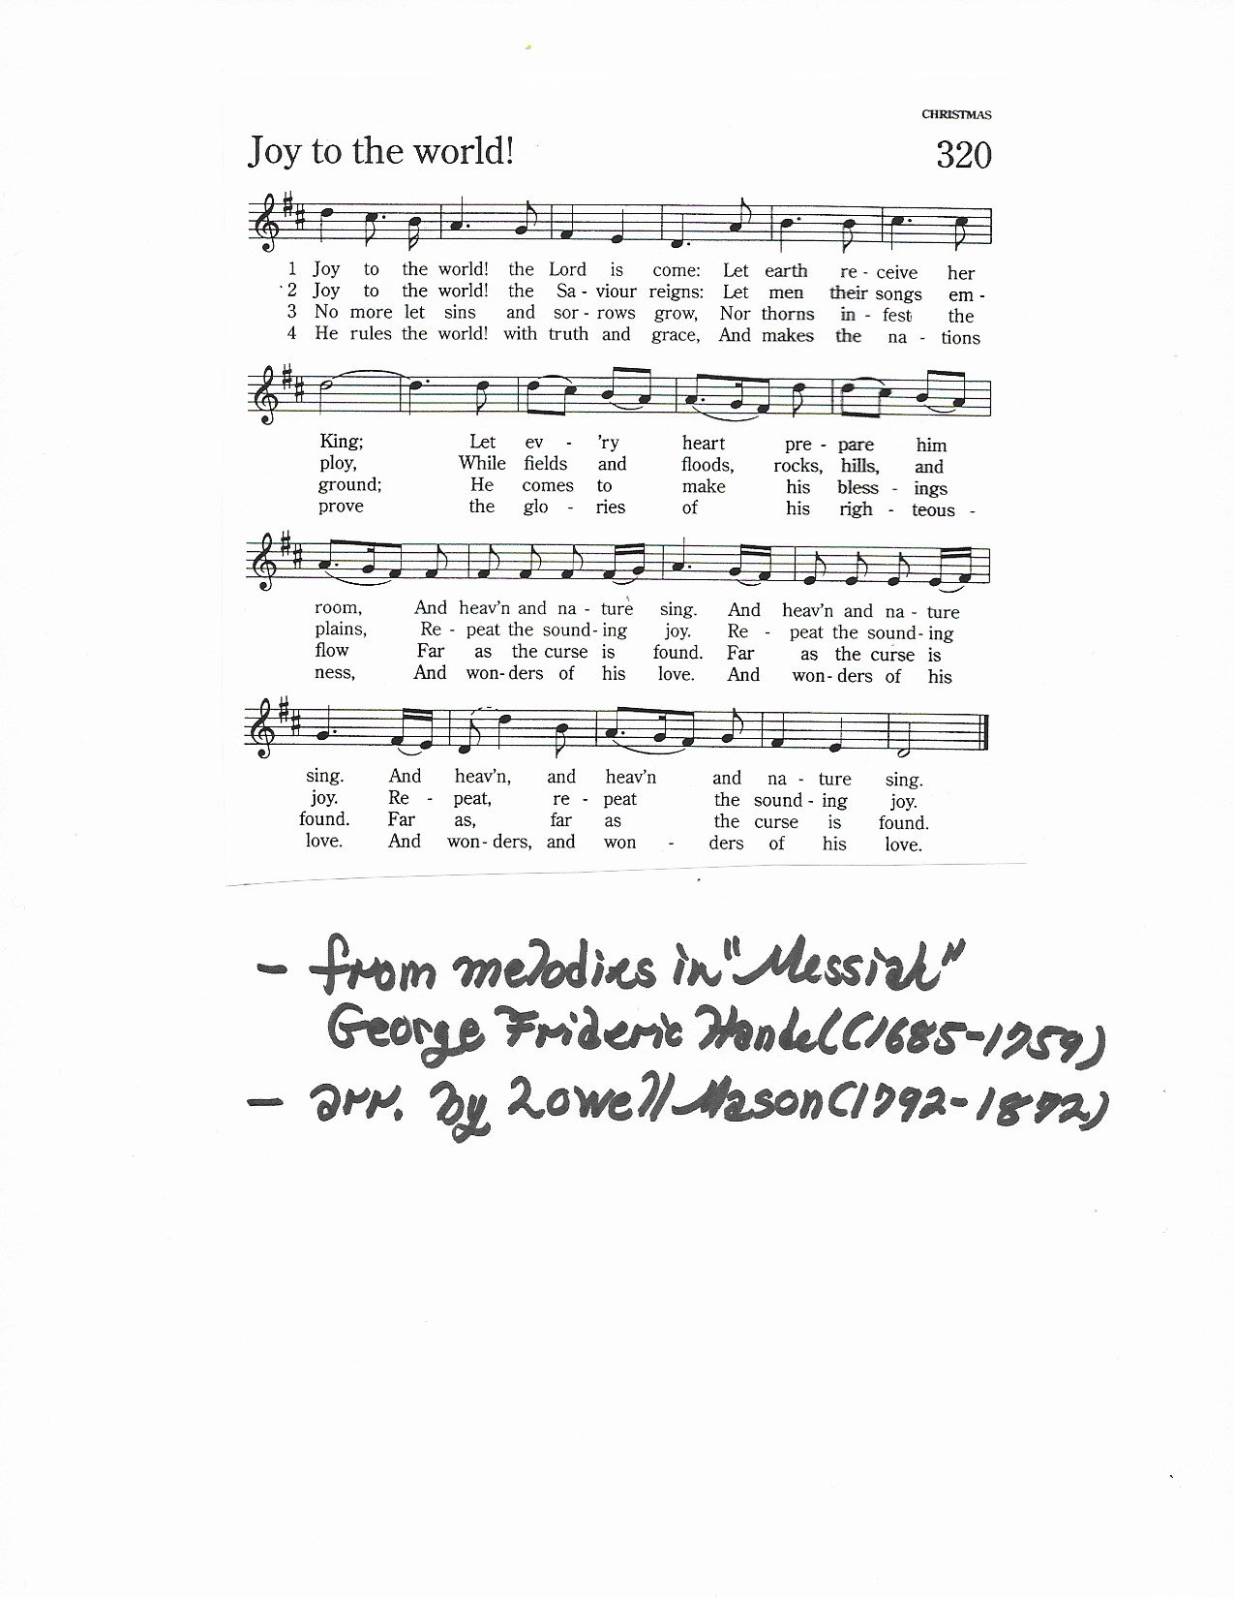

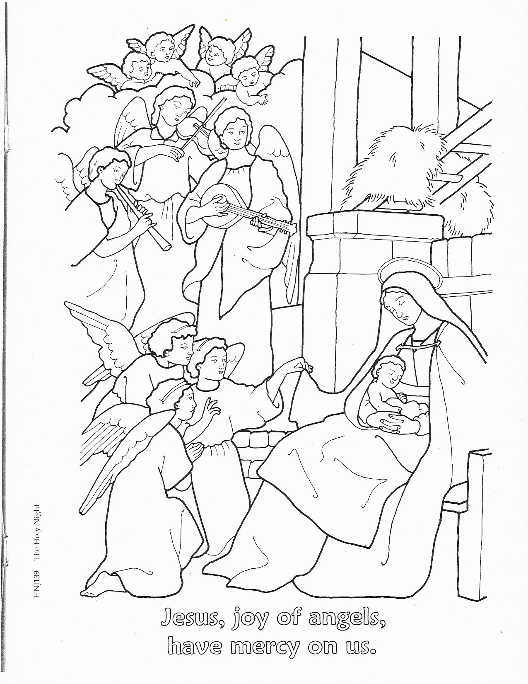
REPERTOIRE: pg. 14

REPERTOIRE: pg. 15
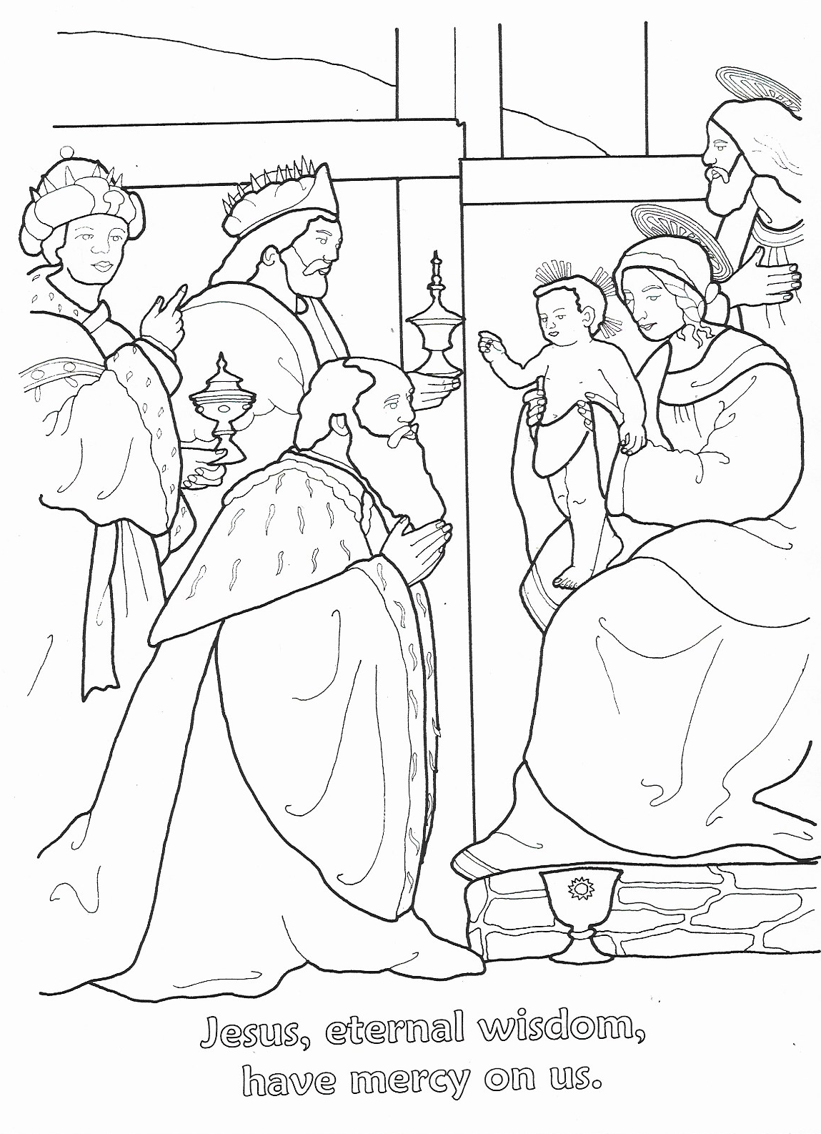

REPERTOIRE: pg. 16
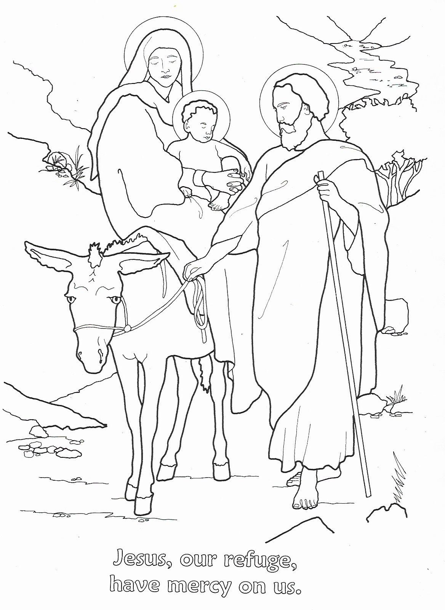

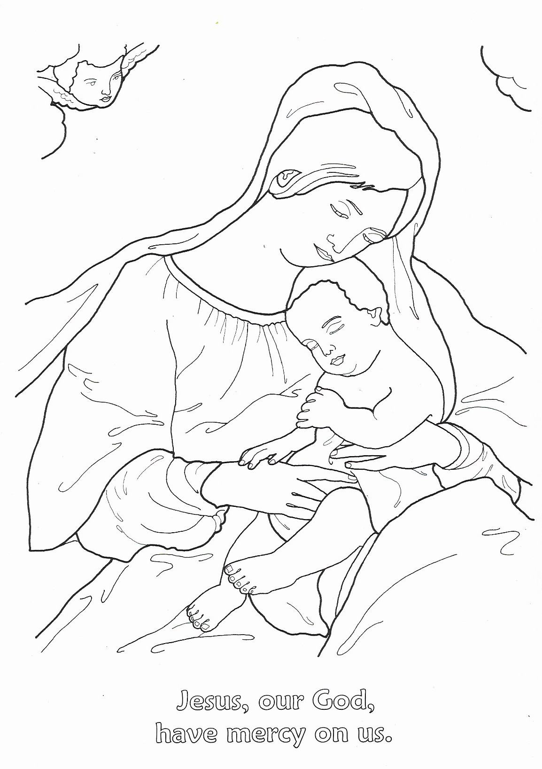
REPERTOIRE: pg. 17

