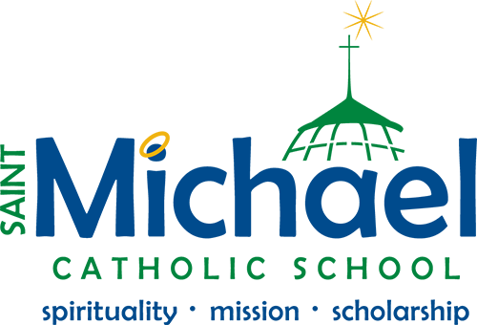
PTO President’s Letter
Welcome back to all returning families, and a warm welcome to the new families who are attending our school for the first time! We are particularly excited to welcome our new Secretary - Amanda Miller and Pre-School Parent - Katherine Connolly.
The Saint Michael School PTO is a nonprofit, volunteer parent/teacher organization whose membership includes all parents, legal guardians and staff at St Michael Catholic School.
The PTO’s mission is to promote open and positive communication and understanding between parents and staff of the St Michael Catholic School. Our efforts serve to enhance and maximize the education of every child while aiding them in achieving their highest potential.
Please consider joining our school volunteer program as our students can greatly benefit from your involvement and contributions to the school’s program and its operations. We seek volunteers to help us with the following events:
- Trunk-or-Treat
- Turkey Trot
- Poinsettias Sale
- Auction
- Yard Sale
- Movie Night
Join me, the PTO board, and our entire community as we embark on the quest to ensure Saint Michael School reaches its greatest potential. See you at the first PTO meeting on Tuesday, September 10th at 6:30 PM.
If you have any questions or ideas please contact Saint Michael School at 703-256-1222 or pto@stmikes22003.org

Regards,
Pedro Luiña
PTO President

