MUSIC HISTORY: pg. 30
The Nutcracker Ballet
The musical score for the famous ballet, the Nutcracker, was composed by the Russian composer, Peter Ilyich Tchaikovsky (1840-1893). Classical ballet is a style of dancing in which the women usually wear pointe shoes, a special shoe that allows them to dance on the tips of their toes. It takes many years of training to develop their muscles and technique so that they are strong enough to dance en pointe. The Nutcracker ballet is based on a children’s story written by the German author E.T.A. Hoffmann (1776-1822). In the ballet, a young girl named Marie, (or Clara, in some versions of the ballet) receives a toy Nutcracker as a present at a party on Christmas Eve from her Godfather Drosselmeyer, who makes wonderful mechanical toys. The Nutcracker is not a very handsome little soldier, but in spite of this, he soon becomes Marie’s favorite present. The joy of the festivities is saddened, however, when Marie’s brother Fritz breaks her beloved Nutcracker, and the party soon ends. Although her Godfather had helped Marie to bandage the wounded doll, she is still filled with concern for her new favorite toy, and sneaks downstairs after everyone has gone to bed to check on her Nutcracker. She is soon met with an army of mice who attack Nutcracker and the other toys! When the horrid seven-headed Mouse King is about to overpower Nutcracker, Marie saves him by throwing her left shoe at the wicked mouse and all the mice vanish. The spell is broken, and the Nutcracker is transformed into a handsome prince! The Nutcracker Prince leads Marie to his kingdom, the Land of Sweets, where she is swept into a snowstorm of beautiful dancing snowflakes, is fed delicious chocolates, marzipan and other sweets, and finally is greeted by the Sugar Plum Fairy who dances the grande pas de deux with her Cavalier. A grande pas de deux is a partner dance in four parts. First the man and woman dance a slow Adagio, followed by a solo variation for the man, a solo variation for the woman, and then the Coda, in which they dance together again. The coda is usually fast and exciting. The grande pas de deux is the climax of the ballet, and is usually right before the Finale, in which all the main characters of the ballet dance together one more time. Marie grows tired as the celebration goes late into the night. She wakes to find herself back in her own bed, where she is left to wonder - was it all just a dream?
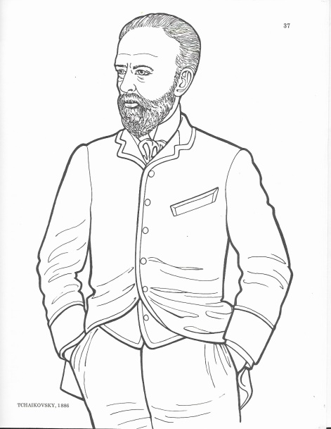

MUSIC HISTORY: pg. 31
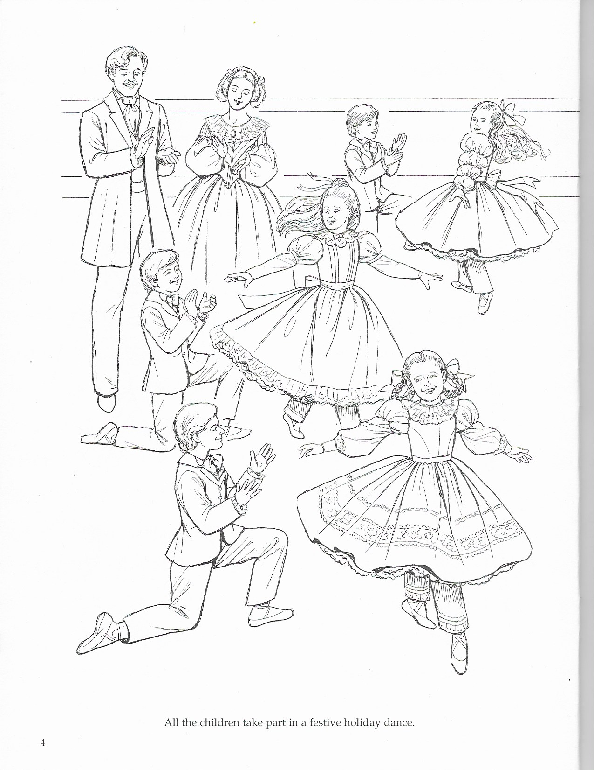

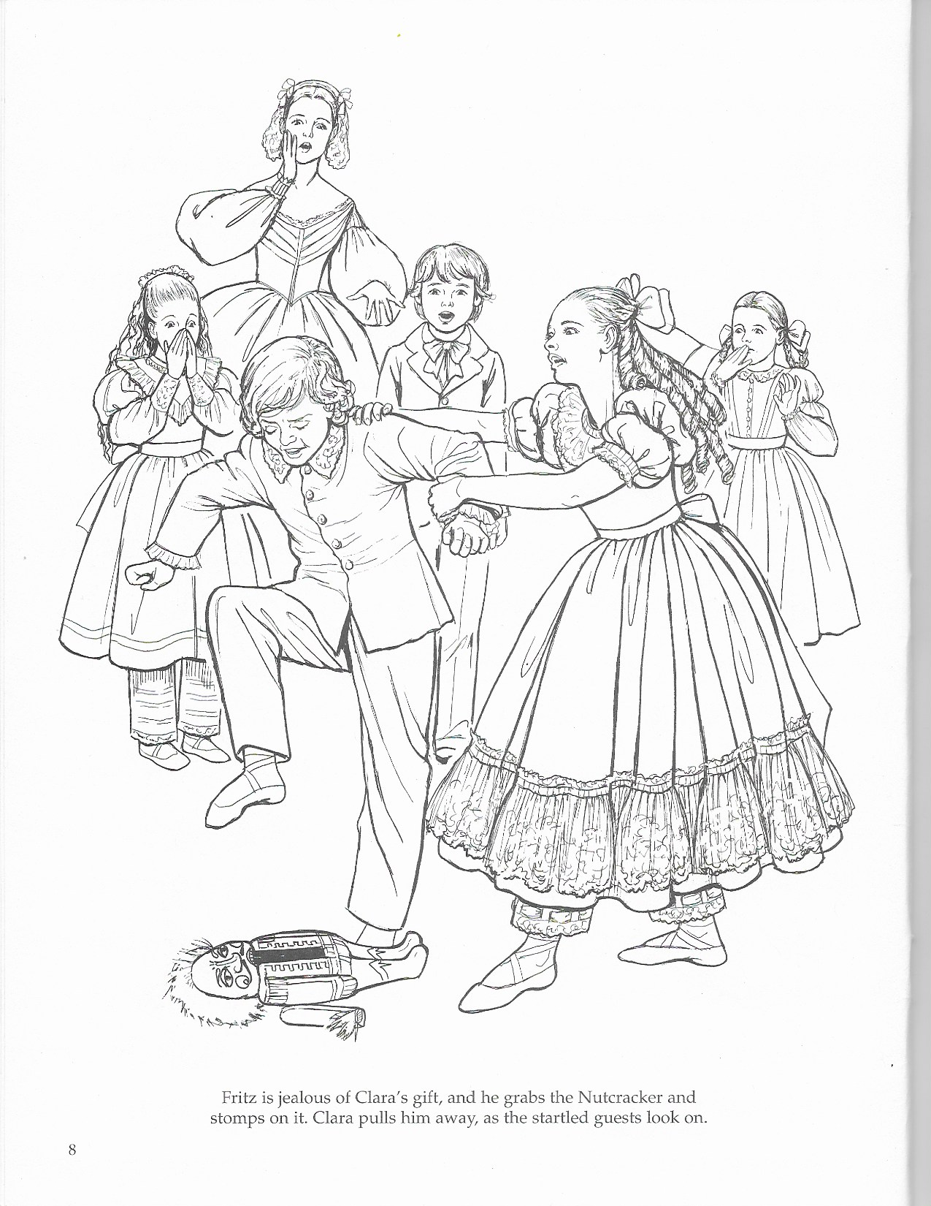
MUSIC HISTORY: pg. 32

MUSIC HISTORY: pg. 33
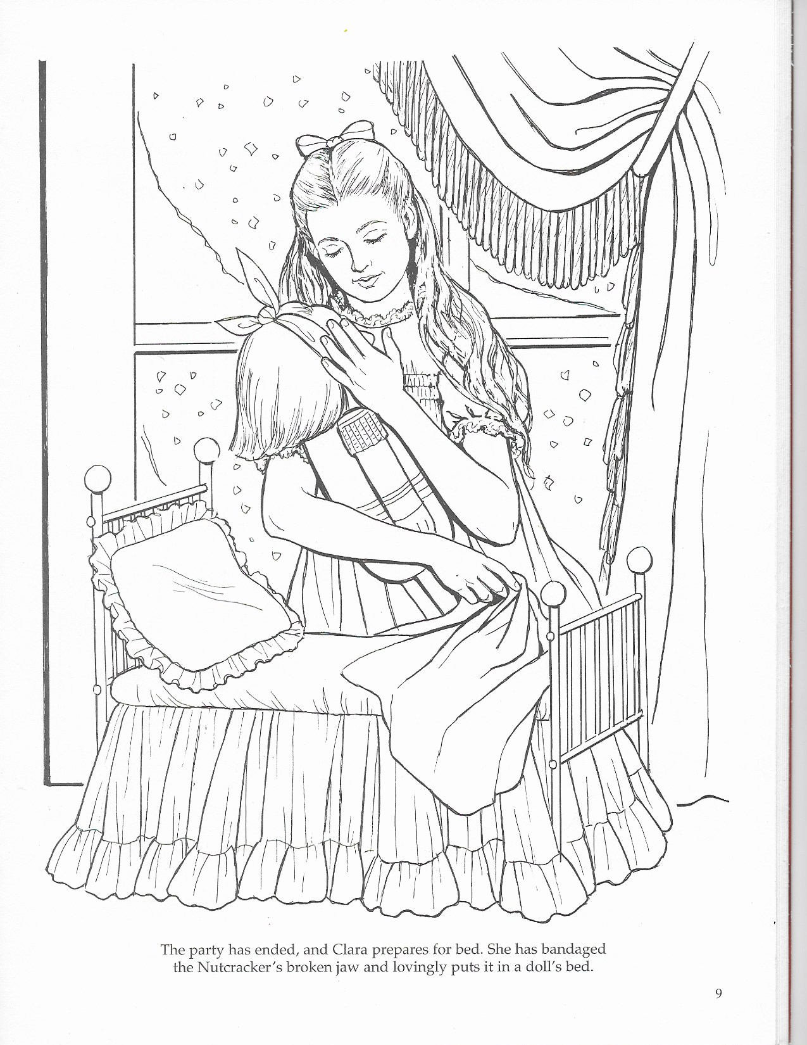

MUSIC HISTORY: pg. 34
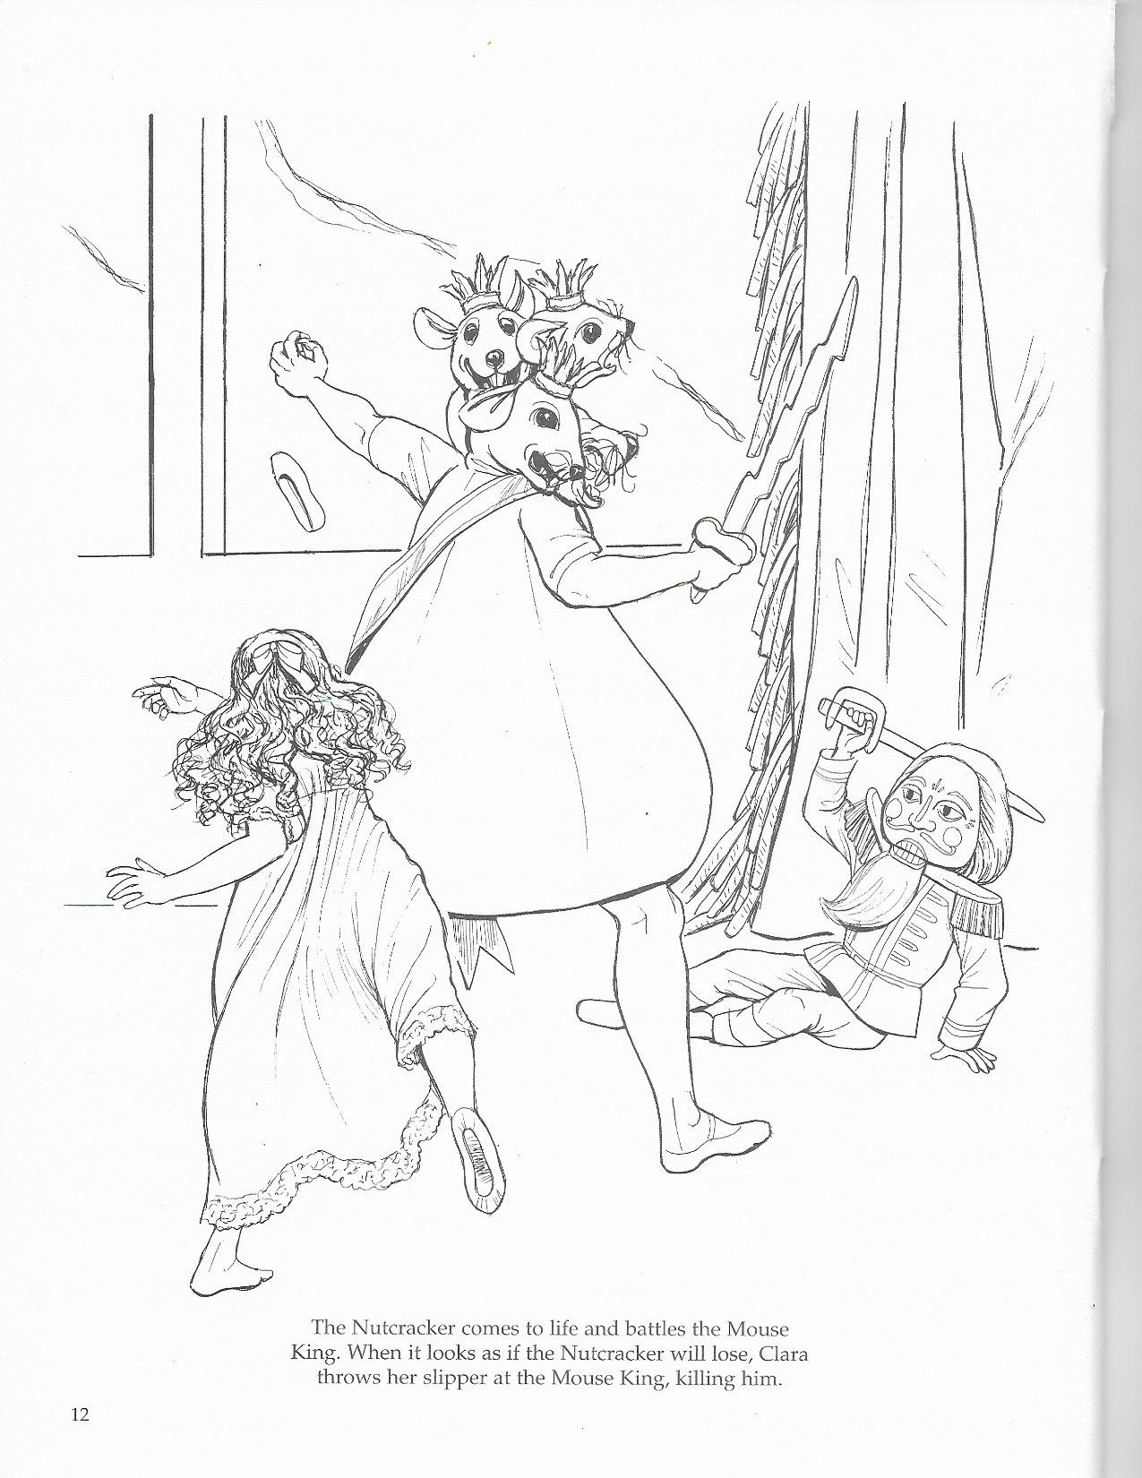

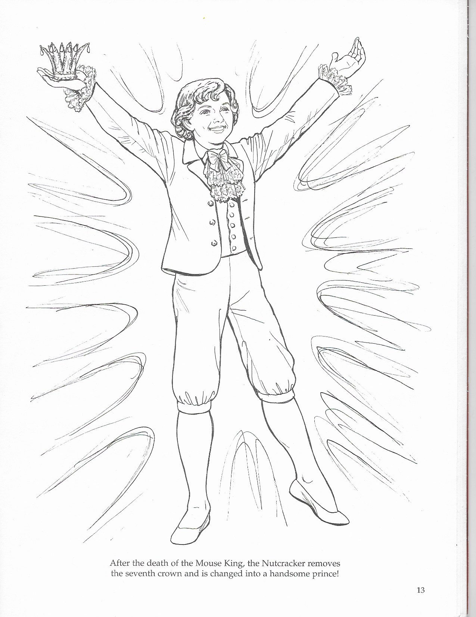
MUSIC HISTORY: pg. 35

MUSIC HISTORY: pg. 36
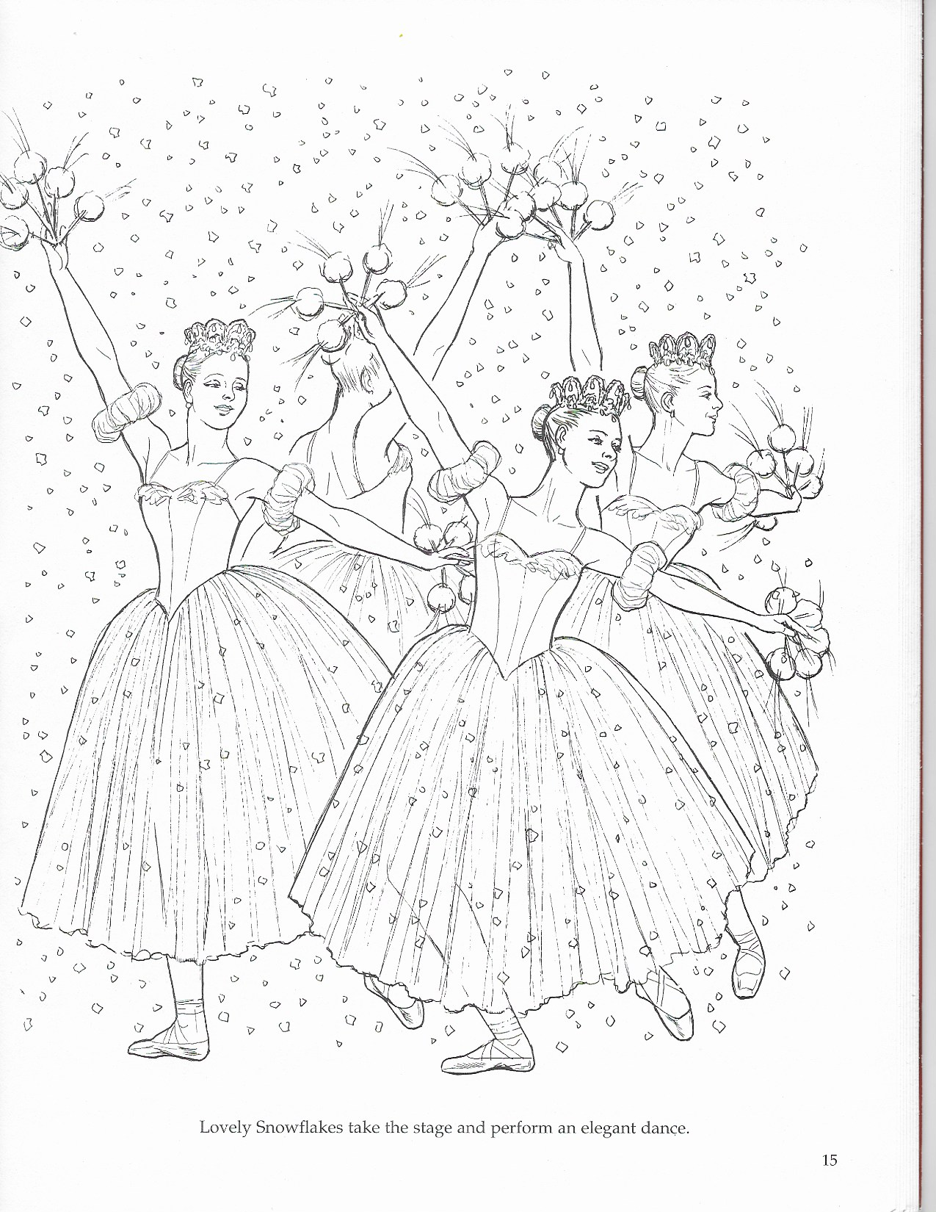

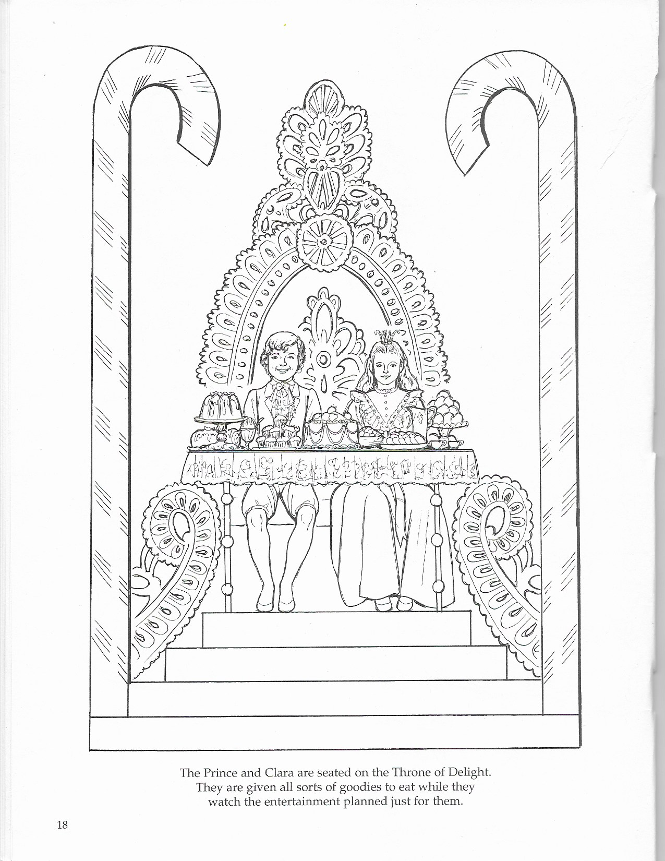
MUSIC HISTORY: pg. 37

MUSIC HISTORY: pg. 38
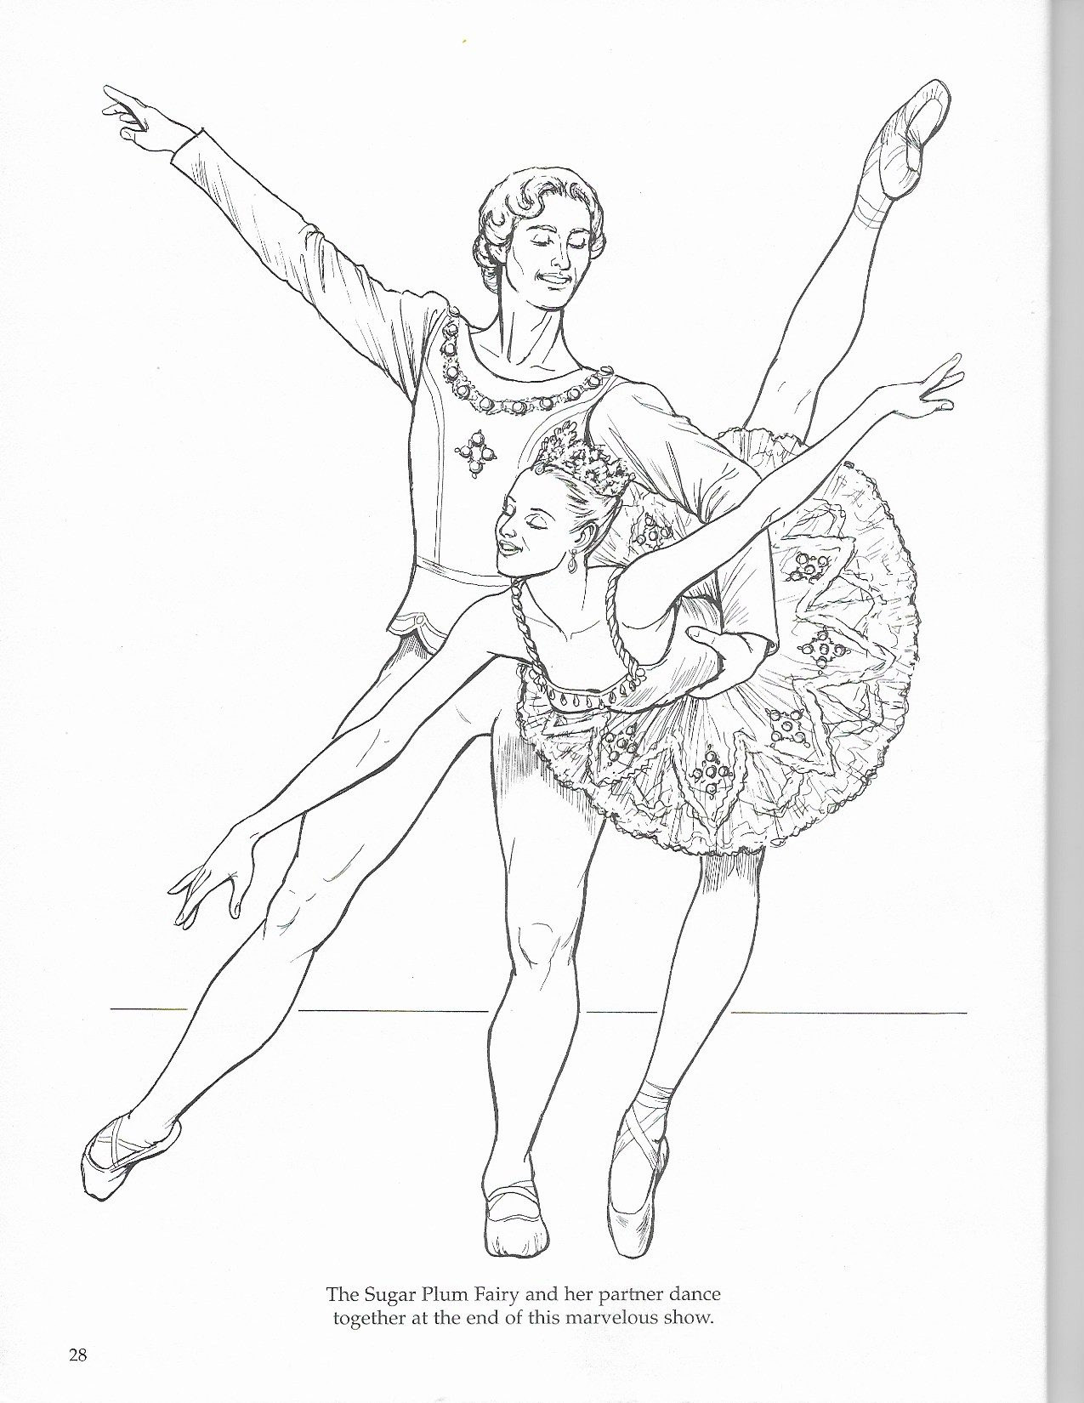

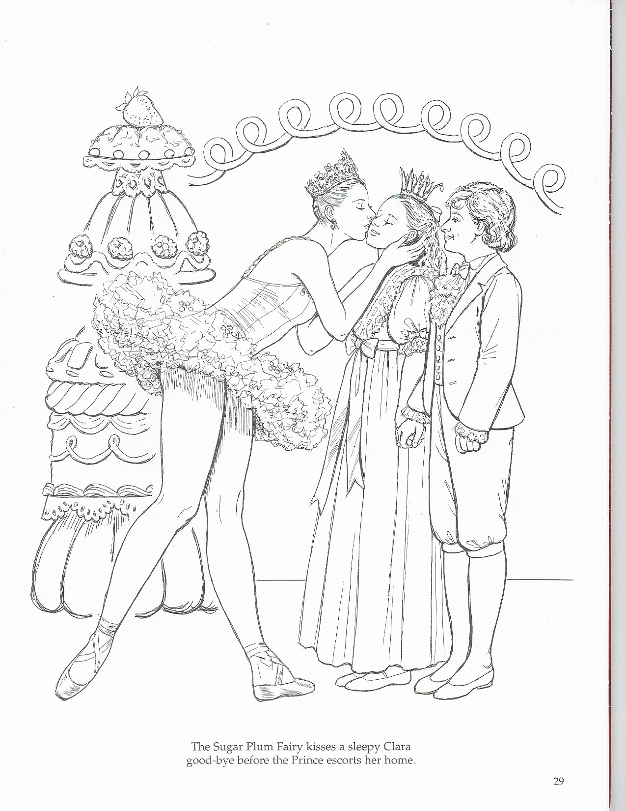
MUSIC HISTORY: pg. 39

