Music History

“Faith becoming music is part of the process of the Word becoming flesh” – Pope Benedict XVI

“I long to be entirely transformed into a hymn of Your glory. When I find myself on my deathbed, may the last beat of my heart be a loving hymn in praise of Your unfathomable mercy.” – St. Faustina
Approximate Time Period | Styles and Characteristics | Some Famous Composers
Medieval  (476 – 1430 A.D.) | Gregorian Chant: named for St. Gregory the Great (Pope from 590-604). Chant is modal and unaccompanied, and pays great attention to fitting melody and text.  Notre Dame School: experimented with music using simple hollow sounding harmonies such as in Medieval conductus and other forms of chant-based music for 2, 3 or 4 voice parts | Mostly anonymous, composed primarily in monasteries and universities.  Hildegard (1098-1179)  Dufay (1400-1474)
Renaissance  (1430 – 1600 A.D.) | New Polyphonic Style: many melodies woven together to create harmony, unaccompanied, usually for four or more vocal parts, use of major and minor tonality, as well as some modal tonality, pendulum-like pulse of tension and release to create an airy floating effect | Despres (1440-1521)  Tallis (1505-1585)  Palestrina (1525-1594)  Lasso (1532-1594)  Byrd (1543-1623)  Victoria (1548-1611)
Baroque  (1600 – 1750 A.D.) | New Homophonic Style: melody with harmony, sometimes use of a ground bass (repeating bass line), major/minor tonality with specific part-writing rules, music usually for 4 voice parts with organ or orchestral, a steady beat throughout with an often driving rhythmic pulse, such as in Handel’s “Halleluiah Chorus”  Continuation of the Old Polyphonic Style: composers such as Monteverdi continued to use the old polyphonic style of writing along with the new homophonic style; Bach and others developed new polyphonic techniques, such as the fugue | Monteverdi (1567-1643)  Purcell (1659-1695)  Vivaldi (1678-1741)  Bach (1685-1750)  Handel (1685-1759)
Classical  (1750 – 1800 A.D.) | Classical Homophonic Style: characterized by balance and symmetry, question and answer phrasing, elegance in style and clarity of expression, major and minor tonality, steady rhythmic pulse, use of organ or orchestra usually with four vocal parts, use of harmonic dissonance for expression of the text, continued use of some polyphonic writing, such as fugues | Haydn (1732-1809)  Mozart (1756-1791)
Romantic  (1800 – 1900 A.D.) | Romantic Homophonic Style: increased use of chromaticism and dissonance within major and minor tonality, often use of large orchestra usually with four voice parts, heightened use of dynamics (very loud, or very soft), soaring melodies, emotional and highly expressive | Beethoven (1770-1827)  Schubert (1797-1828)  Berlioz (1803-1869)  Mendelssohn (1809-1847)  Verdi (1813-1901)  Faure (1845-1924)
Contemporary  (20th century – present) | Exploration of Many New Styles: Some composers explore new forms and harmonies that breakdown major and minor tonality. Some composers continue to be inspired by the past and re-interpret old styles within a modern context, such as the rediscovery of Medieval modes by many composers, and Durufle’s use of Gregorian chant | Stravinsky (1882-1971)  Poulenc (1899-1963)  Durufle (1902-1987)

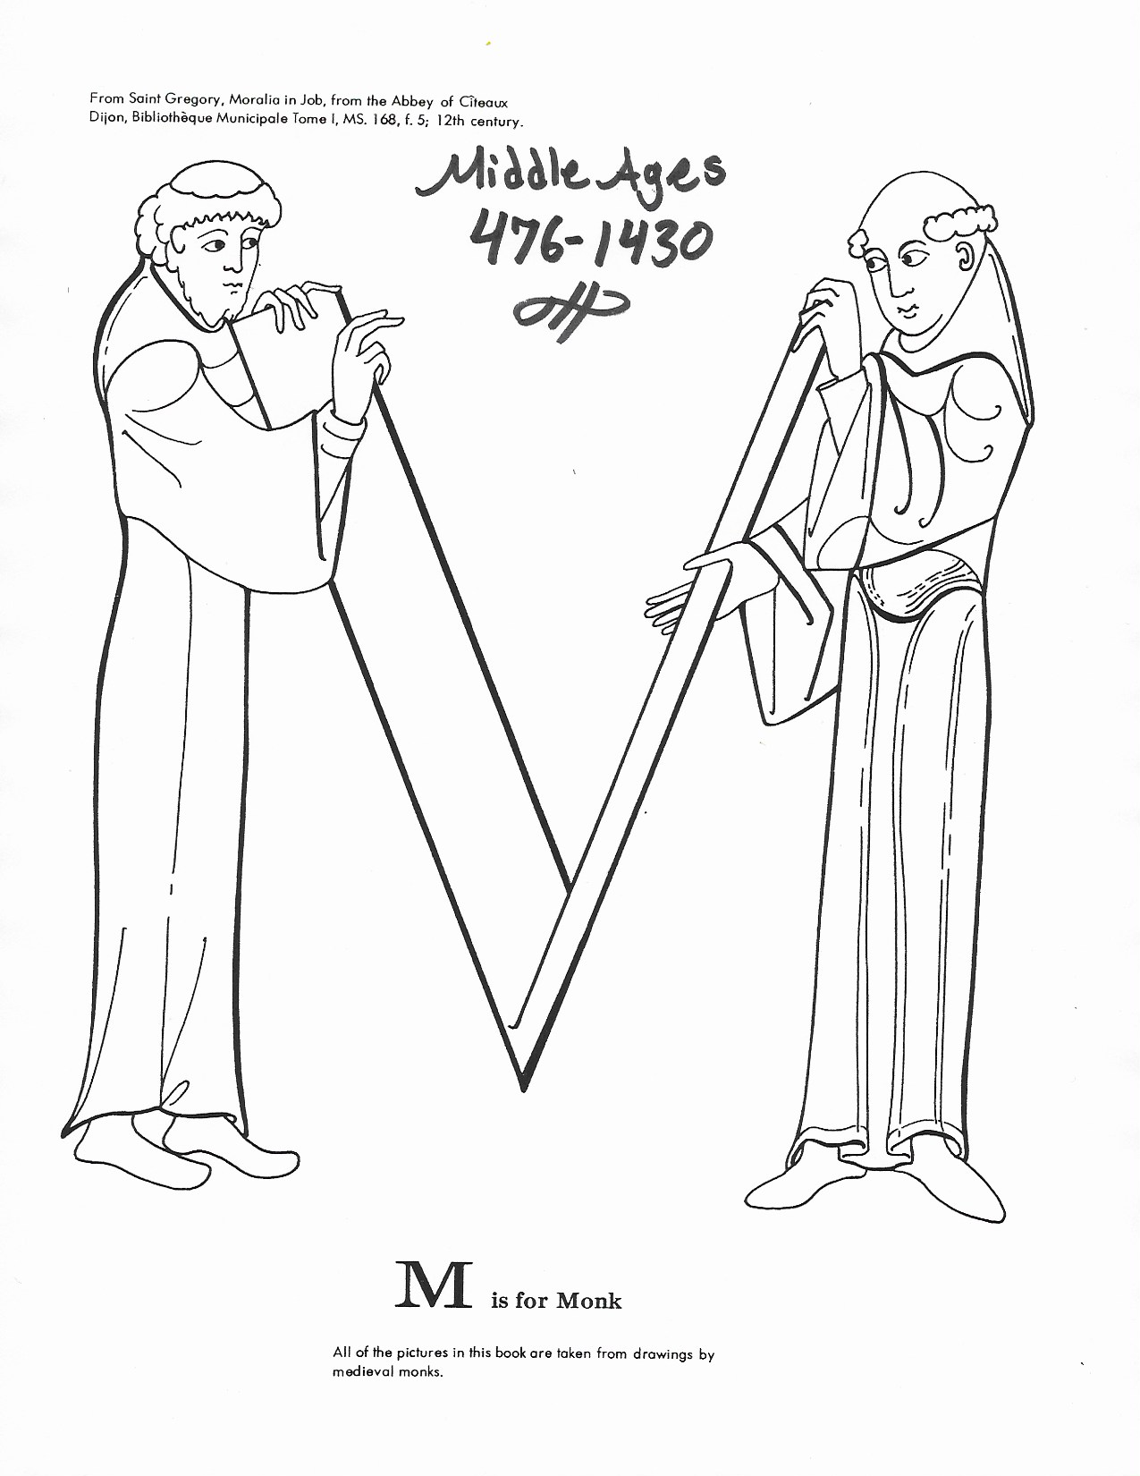
MUSIC HISTORY: pg. 1

MUSIC HISTORY: pg. 2

Gregorian Chant

Liturgical chant is as old as the church itself. What we call Gregorian Chant, however, took centuries to develop. The first Christians used Jewish chants and Psalms in their worship. Greek music, which had a complex system of scales, also influenced music in the early Church. Different styles of chant developed in different regional areas. Over time, people developed a system of notation using a four lined stave. This enabled people to remember the music better, and to share their music with other people living in different areas. The earliest surviving examples of chant that we have today, date form the time of St. Ambrose (340-397). St. Ambrose of Milan, who was instrumental in the conversion of St. Augustine, also developed the chant style and selected four Ecclesiastical, or “church” modes. Each mode is a different musical scale. St. Ambrose also wrote metrical, or metered, hymns. Metered music, unlike chant, has a regular pattern of beats per measure. St. Ambrose said, “He who sings, prays twice”.
Gregorian chant is named after Pope Gregory I (540-604), also called Gregory the Great. St. Gregory had an interest in the religious life from an early age. He began his life in the church by founding a monastery out of his home. Gregory I began his life-long work for the conversion of England before becoming Pope in 590. He preferred to use the title "Servant of Servants", a title still used for the Pope today. St. Gregory also worked to standardize the liturgy of the Catholic Church, including the music to be used during Masses. He probably only composed a few of the chants known as "Gregorian", but he collected and organized the existing repertoire of church music and influenced the composition of new music for the church. Most of the chants known as Gregorian were written by Medieval monks.
Gregorian chant was the standard form of Church music throughout the Middle Ages, and is still in use today. St. Gregory believed that the purpose of music is to remind people of the divine and perfect beauty of God, and to inspire divine thoughts in the listeners. The style of Gregorian chant emphasizes this ideal, through freely flowing melodic lines and artful expression of the religious text. Gregorian chant is sung prayer. Some chants, called syllabic, have one note for each syllable of text. Other, more florid chants, called melismatic, have several notes per syllable of text. The delicately curved phrases, called arch structures, echo the curls of incense around the altar in sound. When singing a chant, tempo and inflection are varied to fit the rhythm, tempo and mood of the text. As in speech, there is a slight crescendo at the beginning of the phrase, which is usually ascending, and the ends of the phrases naturally soften and the tempo slows slightly.

The style of Gregorian chant:
- melody emphasizes the clear expression of the text
- melodic shape follows the accents of the Latin text
- modal melodies, rather than major/minor tonality
- often uses arch structures (arch shaped melodic line)
- rhythm is fluid and floating, and varies to fit the mood of the text
- music is unmetered, does not have a regular pattern of beats per measure
- can be syllabic (one note per syllable) or melismatic (several notes per syllable)

MUSIC HISTORY: pg. 3

Devotion to Our Blessed Mother: St. Dominic relied on the intercession of the Blessed Virgin of Mary for the conversion of sinners. He knew that Jesus Christ first came into the world through the Virgin Mary, therefore he looked to Mary to bring Jesus into the hearts of unbelievers. In the year 1214, St. Dominic had a vision of the Blessed Virgin Mary while he was praying in a forest near Toulouse, France. The Virgin Mary appeared to Dominic accompanied by angels. She showed him a wreath of roses, representing the rosary, and instructed him to pray and teach the rosary as a powerful means for converting sinners.
Our Blessed Mother’s Birthday is September 8th. Here are three chants in honor of the Virgin Mary that may have been familiar to St. Dominic. Listen for whether the chants are mostly syllabic, or mostly melismatic. Also listen for the arch structure of the melodies, and the overall mood of each chant.

Ave Regina Caelorum:
Hail, queen of the heavens, hail, queen of angels!
Hail. Stem of Jesse! Gateway to heaven, Through thee light has risen over the world.
Rejoice, O glorious Virgin, most beautiful among women!
Hail, highly honored one, implore Christ for us.

Alma Redemptoris Mater:
O Kind Mother of the Redeemer, who remainest the ever-open door to heaven,
And star of the sea, come to the aid of the people who have fallen
and strive to be raised up again.
Thou hast given birth – to the wonder of all nature – to the Holy Creator.
Thou who remainest ever virgin,
both before and after receiving that greeting of the angel Gabriel,
have mercy on us sinners.

Salve Regina:
Hail Holy Queen, Mother of mercy,
Our life, our sweetness and our hope.
To thee do we cry, poor banished children of Eve.
To thee do we send up our sighs, mourning and weeping in this vale of tears.
Turn then, our most gracious advocate,
Thine eyes of mercy towards us.
And after this our exile,
Show us the blesses fruit of they womb, Jesus.
O clement, O loving, O sweet Virgin Mary.

MUSIC HISTORY: pg. 4

Gregorian Chant Questions

- How old is liturgical chant?

- What types of music is liturgical chant based on?

- What is the difference between metered and unmetered music?

- Who is St. Ambrose?

- What is a mode?

- Who is Gregorian Chant named for?

- Who wrote most of the chants known as Gregorian?

- What did St. Gregory believe the purpose of music is?

- What does syllabic mean?

- What does melismatic mean?

- What is an arch structure?

- Who is St. Dominic?

MUSIC HISTORY: pg. 5
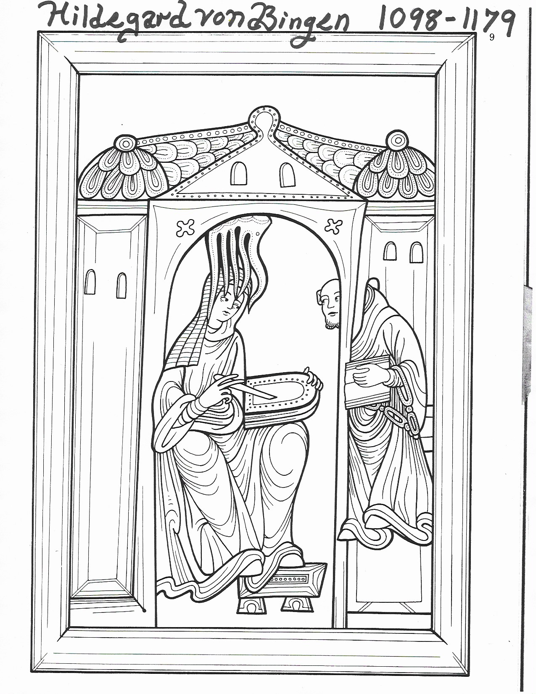

MUSIC HISTORY: pg. 6

Hildegard von Bingen

During the Middle Ages, religious poetry was very popular. Some composers, such as Hildegard of Bingen (1098-1179), also wrote poetry. Hildegard experienced religious visions, which began when she was a child. She began her education in a convent at age eight, and became a nun when she was fifteen. As an adult, Hildegard became the abbess and founder of a convent in Rupertsburg, Germany. Hildegard was a knowledgeable and influential woman, who was consulted by kings and two popes. She wrote several books on a wide variety of subjects. She also wrote music, set to her own poetry, which was sung by the nuns in her convent. She also wrote a morality play, a type of Medieval play that provided entertainment that was based on Catholic teaching. Her morality play, “Ordo Virtutem” (Order of the Virtues) is about the struggle of the soul against the Devil, with the aid of the sixteen virtues. Her individual style of music differs from traditional Gregorian chant. Hildegard’s compositions are primarily sequences, a piece of religious poetry with paired rhyming phrases, set to music. Sometimes sequences are sung at Mass, such as the sequences for Easter, Pentecost and Corpus Christi. The beautiful sequence “O virga ac diadema”, in honor of Mary Mother of God, from Hildegard’s collection “Symphonia armonie celestium revelationum” (Harmonic symphonies of heavenly revelation), makes poetic reference to Our Lady’s Immaculate Conception and the Virgin Birth of Christ.

Style of Hildegard’s sequences:
- composed music to her own poetry
- paired rhyming phrases (aa, bb, cc…), sometimes with a single line at the beginning or end of the poem
- the melody of the second phrase in each pair is often varied to fit the text
- flowing, melismatic melodies intended for female voices, contain wider vocal range than typical Gregorian chants

O Virga Ac Diadema
O branch (rod) and crown for the King’s purple robes,
you who in virginity’s fastness are like a corselet of mail.

You, in full leaf, flowered in another season
than that in which Adam fathered the race of Man.

Hail, hail! Another life has proceeded from your womb
than that in which Adam plundered his sons.

O flower, you did not bloom in the dew, nor in droplets of rain
nor has air flown over you, but the divine shining on the noblest bough produced you.

MUSIC HISTORY: pg. 7

Hildegard Questions

- Who was Hildegard von Bingen?

- How does her style of music differ from the style of Gregorian chant?

- What is a morality play?

- What is a sequence

- Who did Hildegard intend for her music to be sung by?

- Who wrote the text, or poetry, for Hildegard’s music?

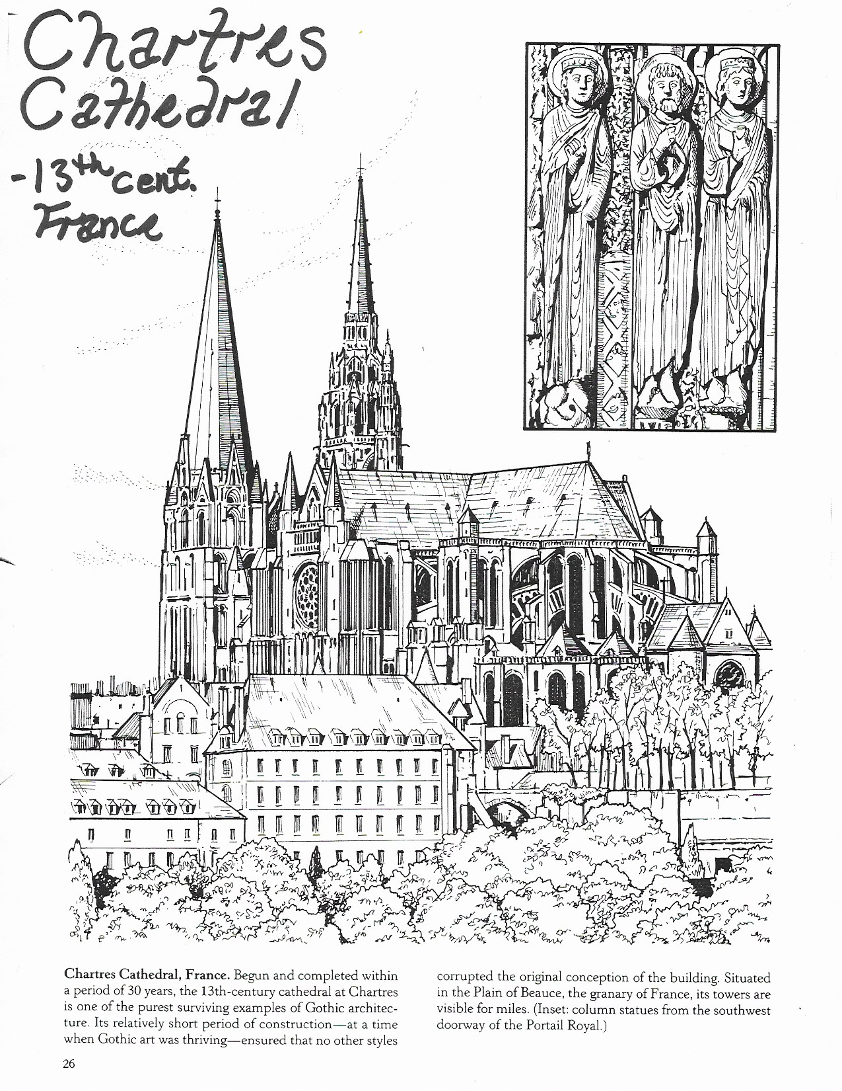
MUSIC HISTORY: pg. 8

O branch, God foresaw your efflorescence on the first day of creation.

MUSIC HISTORY: pg. 9

Medieval Cathedrals

Light and Symmetry
The Medieval people wanted the church building, in which the Body and Blood of Jesus Christ in the Blessed Sacrament is housed, and in which the Sacrifice of the Holy Mass is celebrated, to be a visual representation of the Body of Christ, and an image of Heaven. Jesus Christ said, “I am the light of the world”. Therefore, the Medieval architects tried to fill their churches and cathedrals with as much light as possible. The jewel colored sunlight, brought inside the church from the stained glass windows, was intended to create on earth, a heavenly image of Christ, the light of the world. This new style of architecture, inspired by light, was later called the Gothic style.
Here are the three main features that we recognize as part of the Gothic style which allow light to fill the building: 1) large stained glass windows, including one or more rose windows, 2) high ceilings, which allow the light fill large spaces, and 3) pointed arches, which do not allow light to get trapped in the corners.
An equally important idea in the building of Gothic cathedrals was the use symmetry and mathematical proportions. St. Augustine (354-430) applied the same theories of proportions in music to architecture, as did the ancient Greeks. The Greeks noticed that the proportions of the musical intervals were the same as the proportions in Solomon’s Temple. St. Augustine believed that symmetry was equally pleasing to the eye as it was to the ear. He said that in order to understand music, one needs to look at the building. In this way of thinking, a cathedral is “frozen” music. “Music and architecture are sisters, architecture mirrors eternal harmony, and music echoes it”. The Classical relationship between symmetry and beauty as defined by St. Augustine, was important in music and architecture throughout the Middle Ages. In Gothic architecture, however, geometric proportions that can only be measured with a compass, became more important than musical/mathematical proportions, measured with a ruler.
The floor plan for many Gothic cathedrals is shaped like a Cross. The Cross unfolds from the center outwards using patterns of geometric shapes derived from the cube, hexagon, triangle, circle and the eye shape created by two overlapping circles, all with symbolic meanings. For example, a cube represented God the Father (in Solomon’s Temple, the Holy of Holies was a cube). If you look at the point of a cube, it look like a hexagon, which is made up of six triangles represented Jesus Christ (3, the number of the Trinity, and 6, the day on which man was created). The circle, in the form of the rose window, was an architectural symbol for the Virgin Mary. The double circle, (two overlapping circles) represents Heaven and earth. Where the two circles overlap, an eye shape is formed, which looks like a fish. The fish, ICHTHUS in Greek, represents Jesus Christ: Iesous (Jesus) CHristos (Christ) Theo (of God) Uios (Son) Soter (Savior), and was a secret symbol used by early Christians. Jesus Christ is True God and True Man, and our mediator between Heaven and earth. The top half of the eye creates the pointed arch common in Gothic architecture. Two triangles inserted into the eye create a diamond. If you place three diamonds together, you are again looking at the point of a cube.

MUSIC HISTORY: pg. 10

Cathedral Building and Community Spirit
Building a cathedral was a community project that involved and impacted the whole town. People had to work together to ensure that the job would get finished. Many of the great Gothic Cathedrals, including Notre Dame de Chartres, were begun as renovations. The town of Chartres, France is not far from Paris. When their cathedral was destroyed in a fire, the people were inspired by a miracle to build an even more beautiful cathedral to worship God. Notre Dame de Chartres, housed two important relics, the Virgin Mary’s tunic, which she wore when Christ was born, and an ancient statue of the Virgin Mary. Immediately after the fire, people thought that both relics had been destroyed by the flames. However, two priests had tried to save the holy relics. But, they were unable to escape from the falling building, and were trapped in a small chamber underneath fallen rubble. Miraculously, the priests and the relics were found unharmed several days later. The second “miracle” of Chartres, was the pious community spirit that accompanied the rebuilding of the cathedral, begun in 1144. The stone for the building of the Cathedral had to be hauled in on wagon loads from a quarry seven miles away. A letter from this time describes the great holiness with which the people of Chartres went about this project:
Who has ever seen! Who has ever heard tell, in ages of the past that kings, princes, and lords, mighty in their generation, swollen with riches and honors, that men and women, I say, of noble birth have bowed their haughty necks to the yoke and harnessed themselves to carts like beasts of burden, and drawn them, laden with wine, corn, oil, and stone, wood and other things needful for the maintenance of life or the construction of the church, even to the doors of the abode of Christ? But what is even more astonishing is that, although sometimes a thousand or more or men and women are attached to one cart - so vast is the mass, and so heavy the machine, so weighty the load – yet so deep a silence reigns that not a voice, not a whisper even can be heard. When they halt on the road, nothing is heard but the confession of sins, and pure and supplicant prayer to God to obtain pardon. At the voice of the priests who exhort their hearts to peace, they forget all hatred, discord is thrown far aside, debts forgiven, and the union of hearts re-established. But if anyone is so hardened that he cannot forgive his enemies or if he rejects the counsel of the priest who has piously advised him, his offering is instantly thrown from the wagon as impure, and he himself ignominiously and shamefully excluded from the society of the holy. Forward they press, unchecked by rivers, unhindered by mountains. You might think they were the children of Israel crossing the Jordan, and for them, as for the children of Israel, miracles are wrought. One sees old people, young people, little children, calling on the Lord with a supplicant voice, and uttering to Him, from the depth of the heart, sobs and sighs with words of glory and praise! After the people, warned by the sound of trumpets and the sight of banners, have resumed their road, the march is made with such ease that no obstacle can retard it. But when they come to the church, they set their wagons in a circle so as to form, as it were, a spiritual camp, and all the following night the watch is kept by the whole army with hymns and songs of praise. Candles and lamps are lit on each wagon; the sick and the feeble are placed thereon, and they bring them the precious relics of the saints for relief. Afterwards the priests and clerics close the ceremony by processions which the people follow with devout hearts, imploring the clemency of the Lord and of His Blessed Mother for the recovery of the sick. (Abbot Haimon of Saint-Pierre-sur Dives, Normandy; to the Tutbury Abbey monks, in England).

MUSIC HISTORY: pg. 11

Canterbury Cathedral – begun in 12th cent., England
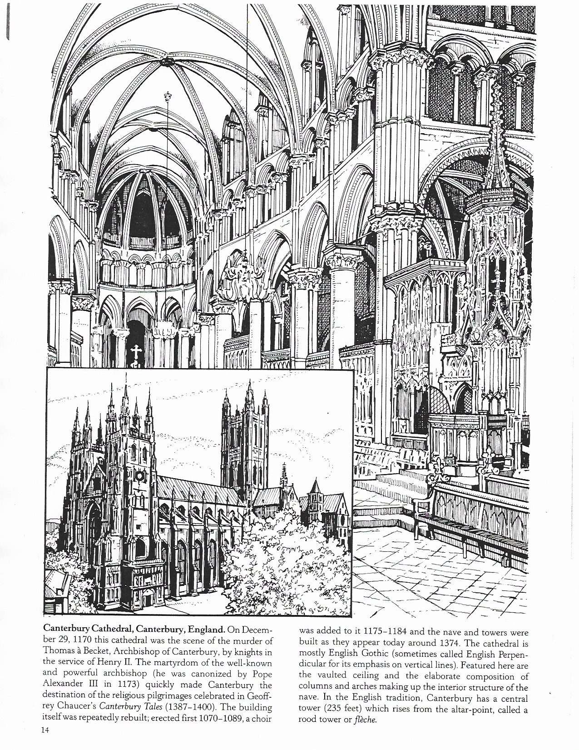

MUSIC HISTORY: pg. 12

Cathedrals: A Long Term Project
Building a cathedral was a long term project, many took around a century to build, or sometimes even longer. Canterbury Cathedral, in England, took 343 years to build, from 1175-1517! Architects, craftsmen and workers realized at the outset of the project that they would probably never see the completed cathedral. Large amounts of heavy stone had to be hauled on wagons from many miles away. The stones then had to be cut and lifted into place. The detailed craftsmanship of the stone carvings and stained glass windows in the cathedral took hours of careful work to complete. Work on a cathedral was also often delayed or interrupted because of bad weather, waiting (sometimes months) for mortar to dry, re-planning to correct problems or incorporate new ideas, civil unrest, or lack of funding. The Medieval builders relied on God to direct their daily work, with the faith that God would provide for their needs. They trusted that God would provide other workers after them to finish what they could not finish themselves.
Like Chartres Cathedral, the building of Canterbury Cathedral, in England, began as a renovation project after the old church burnt down. Canterbury was a very popular pilgrimage site during the Middle Ages. Many people traveled there to visit the shrine of St. Thomas Becket (1118-1170), and to pray for his intercession. St. Thomas Becket had been the archbishop of Canterbury and was murdered in Canterbury Cathedral by some of King Henry II’s knights.
Here is an outline of the building of Canterbury Cathedral in the Gothic style:
1174 A fire burns down the old Romanesque style cathedral
1175 – 1184 The Choir, Trinity Chapel and Corona are built
1185 – 1217 Inactivity
1218 – 1220 St. Thomas Beckets shrine and Prior’s Chapel finished
1221 – 1235 Inactivity
1236 – 1238 Cloister and Refectory built
1239 – 1303 Inactivity
1304 – 1320 Choir screen and Chapter House rebuilt
1321 – 1335 Inactivity
1336 Window put in St. Anselm’s Chapel
1337 – 1340 Inactivity
1341 – 1343 Infirmary and Table Hall rebuilt
1344 – 1362 Inactivity
1363 – 1366 Black Prince’s Chantry and Chapel of Our Lady in the Crypt built
1367 – 1376 Inactivity
1377 – 1468 Crypt, Nave, Transept, Cloisters, Chapter House, Pulpitum,
St. Michael’s Chapel, South Transept vault, Southwest Tower,
Henry IV’s Chantry, North Transept, Lady Chapel vault,
and Tabernacle arch built
1369 – 1489 Inactivity
1490 – 1517 Central tower, Strainer arch, Christ Church Gateway built

Total years: 343 Active years: 161 Inactive years: 182

MUSIC HISTORY: pg. 13

Questions on Gothic Cathedrals

- Medieval architects tried to fill their churches with as much as possible.

- What are the 3 man features of the Gothic style?

- How did St. Augustine describe the relationship between architecture and music?

- The floor plan of many Gothic cathedrals is shaped like a .

- What happened when Chartres Cathedral was destroyed by a fire?

- What did the people of Chartres do after the fire?

- How long did it take for Canterbury Cathedral to be built?

- Who was St. Thomas Becket?

MUSIC HISTORY: pg. 14

Guillaume Dufay
Towards the end of the Middle Ages, a new type of motet began to appear. The late Medieval motet usually had three voices (tenor, alto, soprano), and later four voices (bass, tenor, alto, soprano). The late Medieval motet was based on a clearly recognizable chant melody in the tenor voice, or an ornamented version of the chant melody in the soprano. Unlike earlier forms of Medieval part music, the late Medieval motet strived for greater equality between the voices. Guillaume Dufay (1400-1474), was a Burgundian composer, who wrote motets, masses and chansons (songs). In the Middle Ages, cathedrals were the center of learning, and as is still the case today, many churches and cathedrals had schools. When Dufay was nine years old he began his education and career in music as a choir boy at Cambrai Cathedral. One of the best composers of his generation, Dufay was employed at the Burgundian court, the Papal court in Rome, in Florence, and was made canon of Cambrai Cathedral in 1439. Dufay’s “Alma Redemptoris Mater”, based on the Gregorian chant by the same title, is an example of a late Medieval motet. The soprano line is an embellished version of the Gregorian Chant melody.

Style of Late Medieval Motets:
- usually 3 voice texture (tenor, alto, soprano), with nearly equal importance given to each voice
- based on a clearly recognizable Gregorian chant melody and text, either in the tenor, or an ornamented version in the soprano
- lyrical phrases with graceful melismas leading into the end of each phrase, usually ending in an octave interval
- use of 6ths and 3rds in addition to 4ths, 5ths, and octaves
- more harmonious, but still “antique’ sounding harmonies
Listen for the adaptations of the Gregorian chant melody in Dufay’s “Alma Redemptoris Mater”. “Alma Redemptoris Mater” is the Marian antiphon for Advent.

Alma Redemptoris Mater
O kind mother of the Redeemer,
who remains the ever-open door to heaven,
And star of the sea, come to the aid of the people who have fallen
and who strive to be raised up again.
You have given birth,
to the wonder of all nature, to Your Holy Creator.
You who remains ever virgin,
both before and after receiving that greeting of the angel Gabriel,
have mercy on us sinners.

MUSIC HISTORY: pg. 15

Questions on Guillaume Dufay

- What was a late Medieval motet?

- Where was Guillaume Dufay educated?

- On what melody is Guillaume Dufay’s motet “Alma Redemptoris Mater” based?

MUSIC HISTORY: pg. 16
