MUSIC HISTORY: pg. 55

Contemporary:
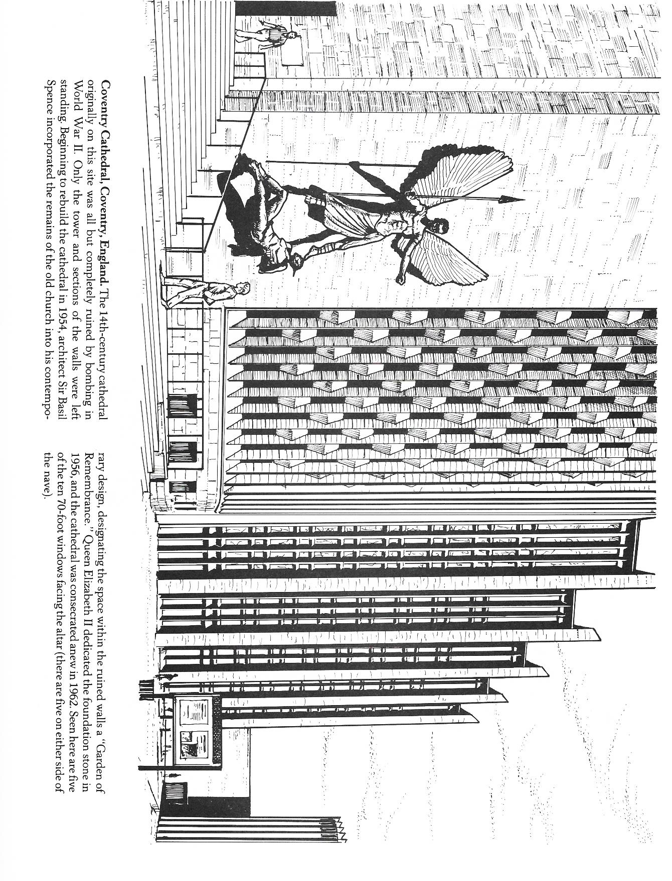
20th Century – Present day

MUSIC HISTORY: pg. 56

Maurice Duruflé

Maurice Duruflé (1902-1987), was a 20th century French composer. Many of Duruflé’s compositions, including his Requiem Mass, take lush French Romantic harmonies, often modal, and unify them with traditional Gregorian chant melodies, thus is style beautifully combines the old and the new. He composed his Requiem during World War II, which he completed in 1947 in memory of his father. Duruflé’s Requiem is filled with the familiar floating melodies, such as the Sanctus and Agnus Dei, which are still frequently sung at Mass in many churches today. A Requiem Mass is a Mass composed for the repose of the soul of the deceased, also called a funeral Mass. The Requiem Mass consists of the Kyrie, Sanctus and Agnus Dei from the Ordinary Mass, combined with special prayers for the dead. Duruflé sought to contrast his Requiem Mass with those composed in a late Romantic style, such as the Requiem Masses by Berlioz and Verdi, which Duruflé felt were too loud, operatic, bombastic and even frightening! Instead, Duruflé’s music is known for its quiet peaceful and spiritual quality. His Requiem is scored for chorus, two soloists, and either organ or small orchestra. The “Ubi Caritas” prayer is another arrangement of a Gregorian chant, this time arranged for a cappella choir. The “Ubi Caritas” text is traditionally sung on Holy Thursday. Duruflé’s setting is especially expressive of the love and unity within the Body of Christ. For Duruflé, music is the ultimate expression of human prayer, leading the listener closer to unity with God. In addition to being a composer, Duruflé was a virtuoso organist, and a music teacher.

Style of Durufle’s chant based church music:
- melodies based on chant, or chant like
- greatly expressive flowing lines with rhythmic freedom (often written in changing meter to closely follow the chant)
- lush harmonies, often modal (to fit his use of modal chant melodies)
- express tranquility and spiritual optimism

Introit

Rest eternal grant unto them, O Lord, and let perpetual light shine upon them.
You shall be praised, Lord, in Sion, and paid tribute in Jerusalem.
Hear my prayer. All flesh shall some before you.

Kyrie

Lord have mercy. Christ have mercy. Lord have mercy.

Sanctus

Holy, holy, holy, Lord God of Hosts!
Heaven and earth are full of your glory. Hosanna in the highest.
Blessed is he who comes in the name of the Lord. Hosanna in the highest.
MUSIC HISTORY: pg. 57

Agnus Dei

Lamb of God, who takes away the sins of the world, grant them rest.
Lamb of God, who takes away the sins of the world, grant them rest.
Lamb of God, who takes away the sins of the world, grant them rest eternal.

In Paradisum

May the angels lead you into paradise;
at your coming may the martyrs receive you
and lead you into the holy city of Jerusalem.
May the chorus of angels receive you
and with Lazarus, once poor,
may you have eternal rest.

Ubi Caritas (Motet)

Where charity and love are, there God is.
The love of God has bound us together in one.
Let us rejoice and be glad in His love;
let us fear and adore the living God,
and let us love Him with a pure heart.
Where charity and love are, there God is. Amen

Maurice Duruflé playing the organ
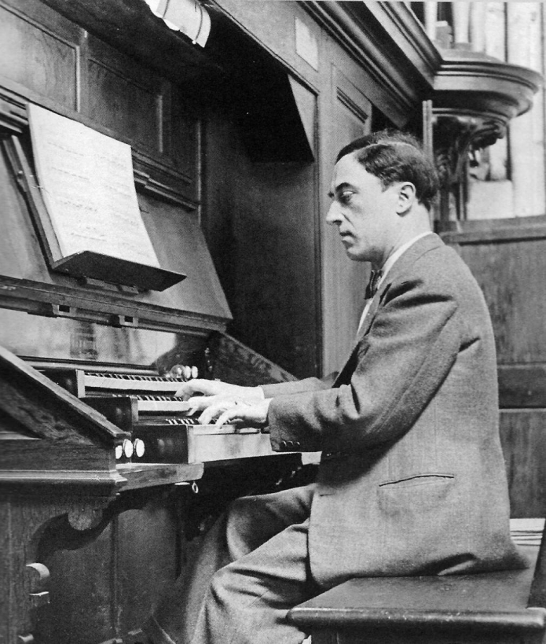

MUSIC HISTORY: pg. 58
MUSIC HISTORY: pg. 58

Duruflé Questions

- What country is Duruflé from?

- What instrument did Duruflé play?

- What qualities did Duruflé try to express in his church music?

- What did Duruflé use for the melodies in much of his church music, including his Requiem Mass?

- What is a Requiem Mass?

MUSIC HISTORY: pg. 59
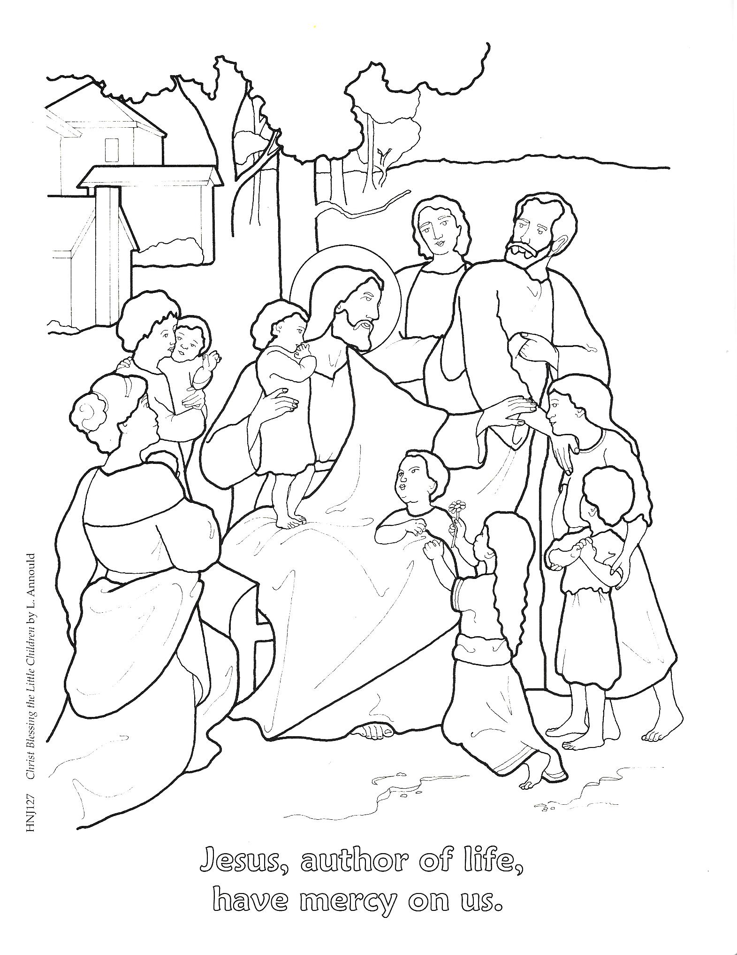

MUSIC HISTORY: pg. 60
