Fourth, Fifth, Sixth, Seventh, and Eighth Grade Summer Math

- Go to https://www.ixl.com

- Enter your Username (firstlast252) and Password (stmikes) on the top right of the website, and click “Sign in”

- To find the list of skills, click the “IXL” logo in the top left of the screen.

- Find your grade (the one you just completed), and click the blue link to the right of Math in your grade box.

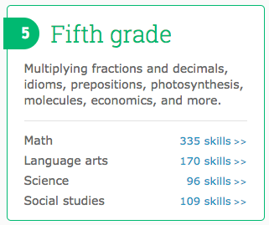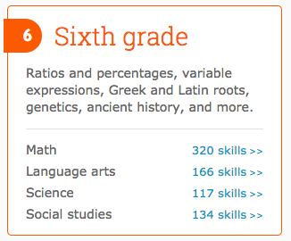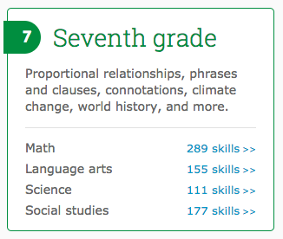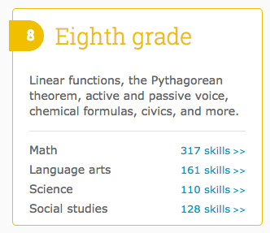

- This link will take you to the index page of all the skills for your grade level.

- Now find the skills you are required to work on over the summer (listed on handout). They are in alpha-numeric order.

  - Below are instructions for Honors Students:
    - Honors 2nd grade completes the Third to Fourth Grade Handout
    - Honors 3rd grade completes the Fourth to Fifth Grade Handout
    - Honors 4th grade completes the Fifth to Sixth Grade Handout
    - Honors 5th grade completes the Sixth to Seventh Grade Handout
    - Honors 6th grade completes the Seventh to Eighth Grade Handout
    - Honors 7th Grade Completes the Eighth Grade Handout

- Click the skill text, and start completing the problems. 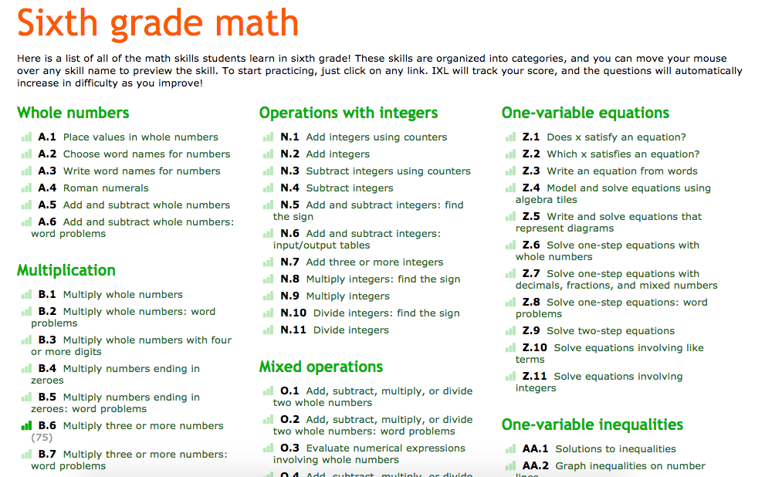

- You have adequately completed a skill when you:
  - A. Get a SmartScore of at least 70
  - Or
  - B. Spend 10 minutes on a skill and get a SmartScore of at least 50
  - Or
  - C. Spend 15 Active Minutes on the skill (don’t work too long on a skill if it is too hard).
    - IXL checks Active Time working and logs it for the teacher, so if you just click a problem, and leave it open for 15 minutes, it will not log any time. You need to actively click and try to solve the problems for the Active Time to pass.

- If a skill is proving too difficult, type in the skill name (not including the letter and number) into Google. There are many educational websites and YouTube videos that give instruction on how to solve these problems. Be sure to ask your parents permission before going to any other sites at home.
  - For Example, Sixth grade skill E.8 Least common multiple. Type in “Least common multiple” in Google, and the first video is from Khan Academy, and the second is from Mathisfun.com. Both are useful in learning this skill.

- Once you have completed all the skills, you are done! Your teacher will check these when you return and it will be worth a test grade in the first quarter.

- If you have any questions, feel free to email or call the school. The username and passwords are automatically assigned by IXL, and available on our school website.

