MUSIC HISTORY: pg. 39
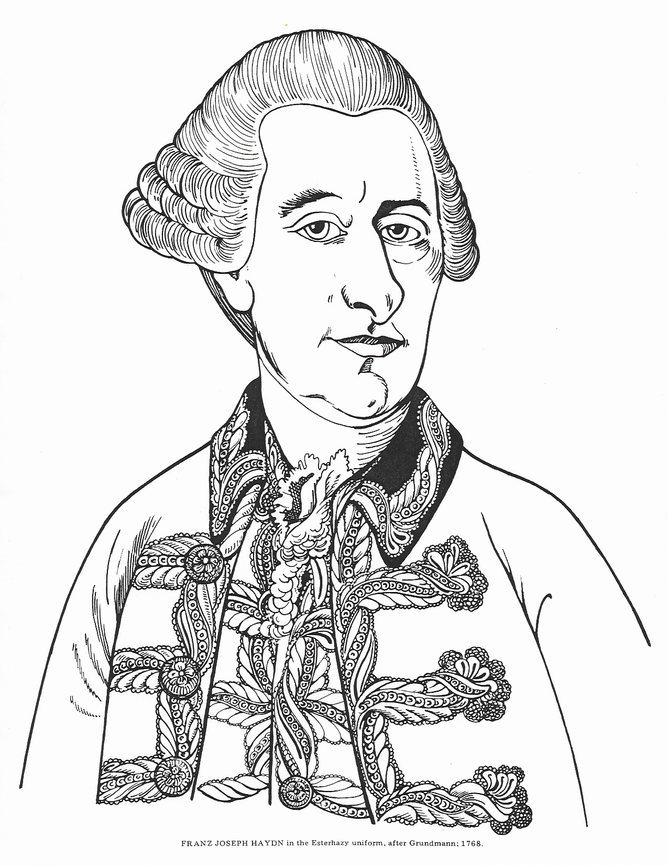
Classical Period: 1750-1800

MUSIC HISTORY: pg. 40
Franz Joseph Haydn

Franz Joseph Haydn (1732-1809) was the Austrian composer who formalized the Classical style. Haydn left his rural home to begin his studies in music at age eight as a choir boy at St. Stephen’s Cathedral in Vienna, Austria. He spent most of his life working at the court of the wealthy Esterhazy family. Later in life, Haydn returned to Vienna, and then travelled to England where his music was very popular. In all, Haydn composed over 100 symphonies and numerous Masses, several oratorios and other religious music as well.

Classical music is characterized by balanced musical structure. Melodies are usually in question-answer form, like a call and response, in which the second part of the phrase completes or “answers” the first part of the melodic phrase. Harmonies are generally clear and tonal. Throughout his long and productive career, Haydn was known for his cheerfulness and sense of humor. His music is often playful and always very inventive. Some of his compositions even contain musical “jokes” or “surprises”. He often uses sudden changes in dynamics, loud or soft, to surprise us. Loud dynamics are called forte (f); and soft dynamics are called piano (p).

His oratorio, “Die Schöpfung”, was popular in England and was translated as “The Creation”. The oratorio tells the story of the creation of the world using Biblical and poetic passages set to music. The story is narrated by three soloists, the archangels, Gabriel (soprano), Uriel (tenor) and Raphael (bass). The parts of Adam and Eve are also sung by soloists, while the choir plays the part of the heavenly chorus of angels. The soloist sing both recitatives, which are more speak-like to tell the story, and arias, which are more florid solo passages which reflect on the story. The orchestra does more than simply accompany the singers, but also plays an important role in setting the mood for the different parts of the story. At the beginning of the oratorio, Haydn dramatically uses the orchestra to represent the primordial chaos of the abyss.

Style of Haydn’s Church Music:
- balance and clarity
- spirited and lively, inventive and often cheerful or playful in nature
- use of orchestra, soloists and chorus, and alteration between these groups
- tuneful expressive melodies, balanced structure – often question answer form
- use of pictorial devices, ornamentation, dynamics (loud = forte; soft= piano) and
“surprises” for dramatic effect
- use of balanced forms that repeat, such as ternary (ABA) or rondo (ABACA)
- mostly homophonic (one melody with accompaniment); polyphonic sections are usually a fugue (one melody, usually with a countermelody, travels through all the parts in turn)
- tonal harmonies, restricted use of dissonance (dissonance always resolved)

MUSIC HISTORY: pg. 41

“Representation of Chaos” (orchestra)

“In the Beginning” (Raphael)
In the beginning, God made Heaven and Earth; and the Earth was without form and void;
and darkness was upon the face of the deep.
“In the Spirit” (Chorus)
In the spirit, God moved upon the face of the waters; and God said:
Let there be light. And there was light.
“And God saw the light” (Uriel)
And God saw the light, that it was good; and God divided the light from the darkness.

“Awake the Harp” (Chorus)
Awake the harp, ye choirs awaken. Loud let the praise of God be sounded. Rejoice in the Lord, the mighty God. Surely the heavens and earth has He girded with splendor and light.

“The Heavens are Telling the Gory of God” (Chorus and Soloists)
(Chorus) The heavens are telling the glory of God; with wonders of His work the firmament.
(Trio) Revealed are His ways by day unto day, by night that is gone to following night.
(Chorus) The heavens are telling the glory of God; with wonders of His work the firmament.
(Trio) In every land abounds the word. Every ear will hearken; never tongue be dumb.
(Chorus) The heavens are telling the glory of God; with wonders of His work the firmament.

“And God said… On Mighty Wings” (Gabriel)
And God said, Let the waters bring forth abundantly every moving creature that hath life,
and fowl that fly above the earth in the open firmament.
On mighty wings now circling soars the eagle proud and cleaves the air
with swift exulting flight to greet the sun. At morn the lark his cheerful welcome sings;
adoring coos the tender turtle dove. From every bush and grove pours the nightingale
her sweetest carol; no grief has ruffled yet her breast,
nor yet to sorrow been tuned her charming roundelay.

“Sing to God” (Chorus)
Sing to God, ye hosts unnumbered! Thanks, all thanks for wonders new created!
Praise His name in song unending, loud in festival rejoicing!
The Lord is great; He reigns for evermore. Amen.

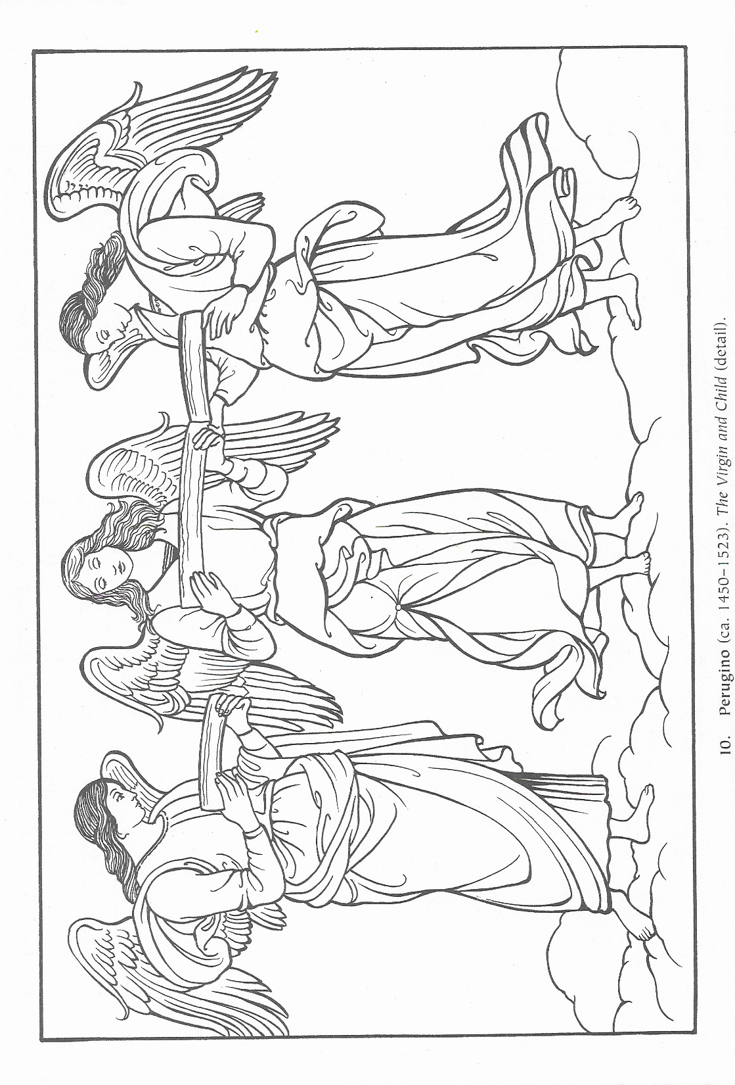
MUSIC HISTORY: pg. 42

MUSIC HISTORY: pg. 43

Haydn Questions

- What country is Haydn from?

- How old was Haydn when he began his musical training?

- Who did he work for most of his life?

- What are some of the things Haydn is best known for?

- What are dynamics?

- What does forte (f) mean?

- What does piano (p) mean?

- What is a recitative?

- What is an aria?

- What is ternary form?

- What is rondo form?

- What is question-answer form?

