MUSIC HISTORY: pg. 30

Baroque Music 1600 - 1750

“If it’s not Baroque, don’t fix it!” – Cogsworth (Beauty and the Beast)
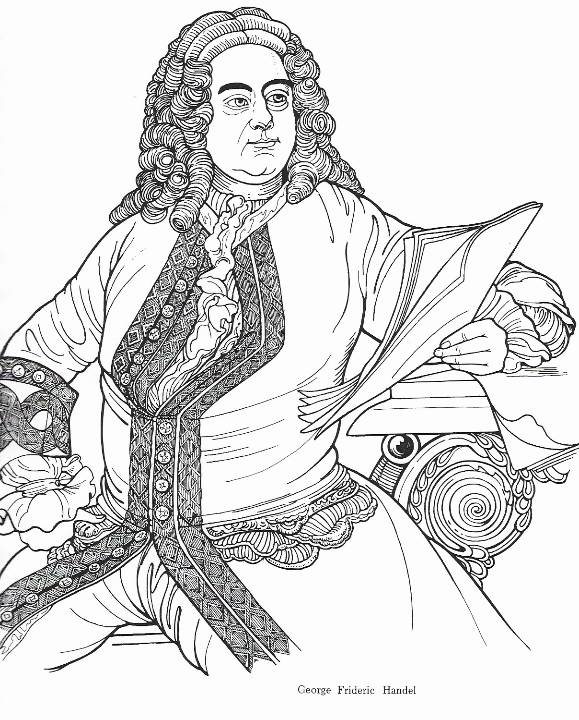

MUSIC HISTORY: pg. 31

George Friederic Handel

George Friederic Handel (1685-1759) was one of the two "giants" of the Baroque era (the other being J. S. Bach). Handel was born in Germany, but he moved to Italy where he composed mostly operas. Handel then moved to England in 1710. While in England, Handel began to compose oratorios. An oratorio is a large multi-movement work; with chorus, orchestra and soloists, that tells a biblical story. Handel's most famous and by far the most popular of his oratorios is "The Messiah”, written in 1741, which tells the story of the life of Jesus, the Messiah. Unlike many of Handel’s oratorios, “Messiah” is much less operatic and the chorus, not the soloists, plays the major role in telling the story. Handel drew on several of his earlier works when composing the music for “Messiah”; even so, he remarkably composed the entire oratorio, which is over two hours long, in just a little over three weeks; a truly amazing achievement.

Style of Handel's oratorios:
- massive multi-movement works with a large chorus, orchestra and soloists
- use of musical symbolism, word painting, and descriptive figures to express the text
- use of coloratura: swift passages with many notes sung on one syllable, often patterned
- use of steady, driving rhythmic pulse; or lyrical passages with a steady gentle pulse
- contrasts between homophonic (one melody with chords) and polyphonic writing (lots of melodies woven together) or fugal writing: a fugue is special a type of polyphonic writing in which a melodic subject, usually with a countersubject, is repeated in turn by each part, in a slightly varied form, similar to a round
- contrasts between dynamics (loud/soft), and tempo (fast/slow) for dramatic affect

For Unto Us a Child is Born (Is. 9: 6)

For unto us a Child is born, unto us a Son is given, and the government shall be upon His shoulder, and His name shall be called: Wonderful, Counsellor,
the Mighty God, the Everlasting Father, the Prince of Peace!

Pastoral Symphony

There Were Shepherds… Glory to God (Luke 2: 8-14)

There were shepherds abiding in the field, keeping watch over their flocks by night. And lo, the angel of the Lord came upon them and the glory of the Lord shone round about them, and they were sore afraid. And the angel said unto them: “Fear not; for behold, I bring you good tidings of great joy, which shall be to all people. For unto you a child is born this day, in the city of David, a Saviour, which is Christ the Lord. And suddenly there was with the angel a multitude of the heav’nly Host praising God , and saying:

Glory to God in the highest, and peace on earth, good will towards men!
MUSIC HISTORY: pg. 32

Surely He Hath Borne…And With His Stripes… All We Like Sheep (Is. 53: 4-6)

Surely, He hath borne our griefs and carried our sorrows;
He was wounded for our transgressions,
He was bruised for our iniquities;
the chastisement of our peace was upon Him.

And with His stripes we are healed.

All we like sheep have gone astray, we have turned ev’ry one to his own way;
and the Lord hath laid on Him the iniquity of us all.

Hallelujah Chorus (Rev. 19: 6, 11: 15, 19: 16)

Hallelujah, for the Lord God omnipotent reigneth.
The Kingdom of this world is become the Kingdom of our Lord
And of His Christ, and He shall reign forever and ever.

I Know that My Redeemer Liveth (Job 19: 25-26, 1 Cor. 15: 20)

I know that my Redeemer liveth, and that He shall stand at the latter day upon the earth,
and tho’ worms destroy this body, yet in my flesh shall I see God.
For now is Christ risen from the dead, the first fruits of them that sleep.

The Trumpet Shall Sound (1 Cor. 15: 52-53)

The trumpet shall sound, and the dead shall be rais’d incorruptible,
and we shall be changed. For this corruptible must put on incorruption
and this mortal must put on immortality.

O Death, Where is Thy Sting?... But thanks Be to God (1 Cor. 15: 55-57)

O death, where is thy string? O grave, where is thy victory?
The sting of death is sin and the strength of sin is the law.

But thanks be to God who giveth us the victory through our Lord Jesus Christ

Worthy is the Lamb… Amen (Rev. 5: 9, 12-13

Worthy is the Lamb that was slain, and hath redeemed us to God by His blood, to receive power, and riches, and wisdom, and strength, and honour, and glory, and blessing.
Blessing and honour, glory and pow’r be unto Him that sitteth upon the throne,
and unto the Lamb, forever and ever. Amen.
MUSIC HISTORY: pg. 33

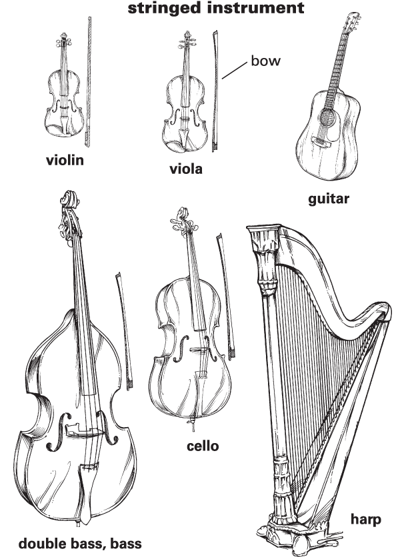

MUSIC HISTORY: pg. 34

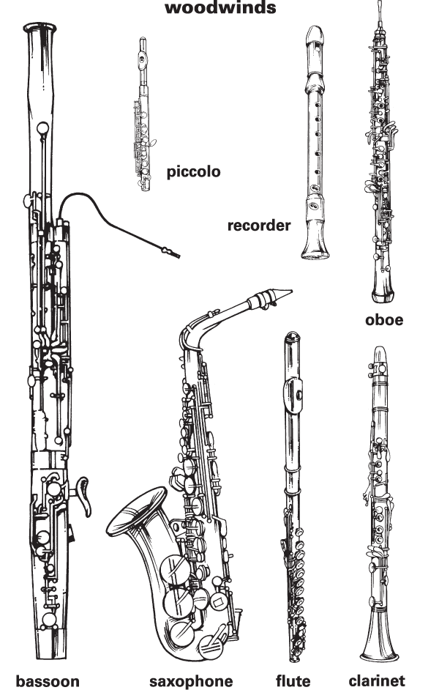

MUSIC HISTORY: pg. 35

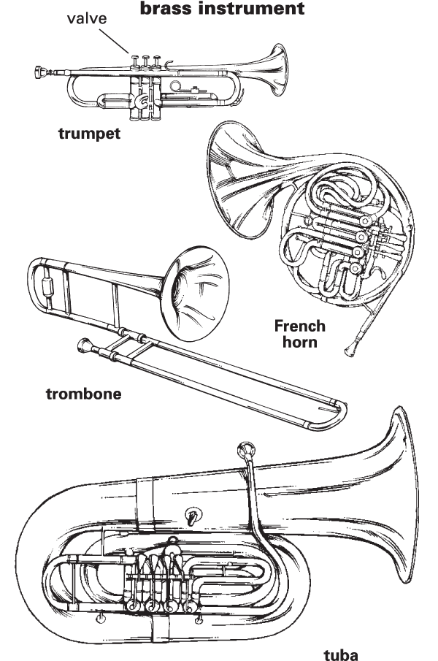

MUSIC HISTORY: pg. 36

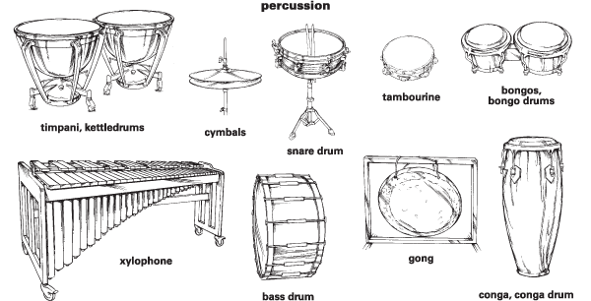

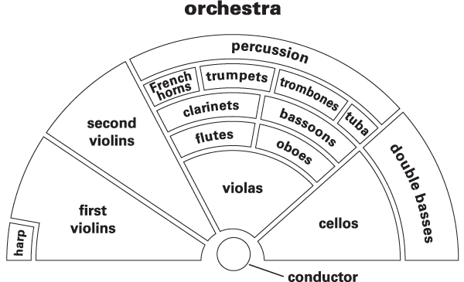

MUSIC HISTORY: pg. 37
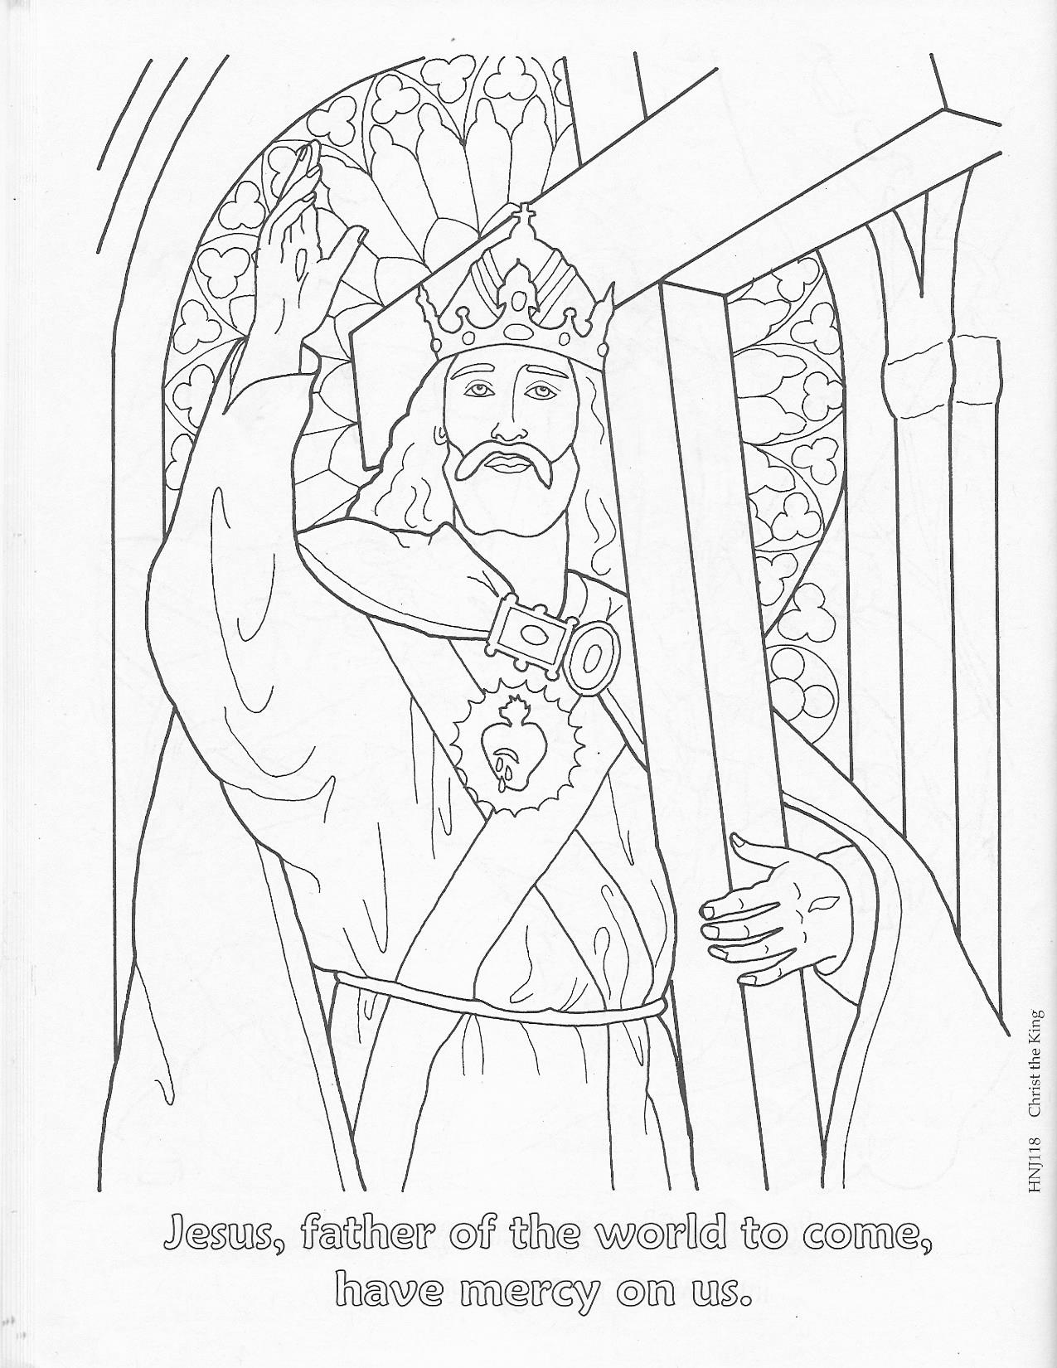

MUSIC HISTORY: pg. 38

Handel Questions

- What is an oratorio?

- What is Handel’s most famous oratorio?

- What is this oratorio about?

- How long did it take Handel to write this oratorio?

- In what country did Handel compose his oratorios?

- What are the four families of musical instruments?

- What is coloratura?

- What is a fugue?

