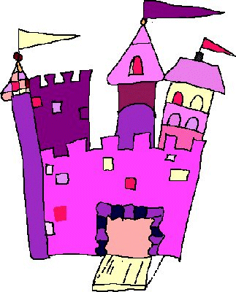
Name: ___________________________________ Date: _________________
Fairy Tale/Folk Tale/
Tall Tale/Fable
T-Shirt
Materials: t-shirt, decorating materials
Directions:
- Find a fairy tale or folk tale that interests you and is at an appropriate reading level for you. Have your book approved by your teacher.
Book Title: ___________________________________________________
Author: _____________________________________________________
Approval: Parent’s Initials: ___________ Teacher’s Initials: ____________
- Write at least two sentences about the setting, main characters, problem, plot, and favorite part of the story on the lines below. Use this paper as your draft/outline.
Setting:__________________________________________________________________________________________________________________________________________________________________________________________________
______________________________________________________________________________________________________________________________________
______________________________________________________________________________________________________________________________________

Characters:______________________________________________________________________________________________________________________________________________________________________________________________
______________________________________________________________________________________________________________________________________

Problem:_________________________________________________________________________________________________________________________________________________________________________________________________
______________________________________________________________________________________________________________________________________

Plot:
Beginning:_____________________________________________________________________________________________________________________________
___________________________________________________________________
___________________________________________________________________

Middle:______________________________________________________________________________________________________________________________
__________________________________________________________________
______________________________________________________________________________________________________________________________________

End:__________________________________________________________________________________________________________________________________
______________________________________________________________________________________________________________________________________
__________________________________________________________________
Favorite Part: ___________________________________________________________________
______________________________________________________________________________________________________________________________________
___________________________________________________________________
___________________________________________________________________

- Push up your sleeves and get creative with this fun book project! Decorate the front and back with pictures and words that represent your book.

MUST INCLUDE...
- Front of Shirt- book title, author, and a descriptive illustration (could be of the main conflict).
- Back of the Shirt- an illustration of the solution to a problem in the story, which does not have to be the main conflict (label it solution).
- The rest is up to you :)

- Check the rubric to make sure you have completed the assignment.

- Be sure to bring this worksheet and your good copy to school. They are part of your project grade.

- Oral presentation: introduce your book, present your Prezi, and share your opinion of the book.

Rubric Fairy Tale/Folk Tale/ Tall Tale/ Fable – T-Shirt
Name: ____________________________________ Date: _________________
Book Title: ______________________________________________________
 | Possible  Points 50 | Points Earned
- Was your book approved on time? | 5
- Did you hand in your project on time?  (-1 pts. for each day late) | 5
- Did you write a draft with at least two sentences about each story element: setting, main characters, problem, plot, and favorite part? | 10
- Are the spelling, punctuation, and grammar correct? | 5
- Did you create a t-shirt with the title, setting, characters, problem, plot, and favorite part? Are all required elements included and is the task correctly complete and has additional features? | 10
- Is your t-shirt creative and organized? | 10
- Oral presentation: did you speak clearly and with good volume? | 5

Comments: ________________________________________________________________

