MUSIC HISTORY: pg. 44

Romantic Era (1800-1900)
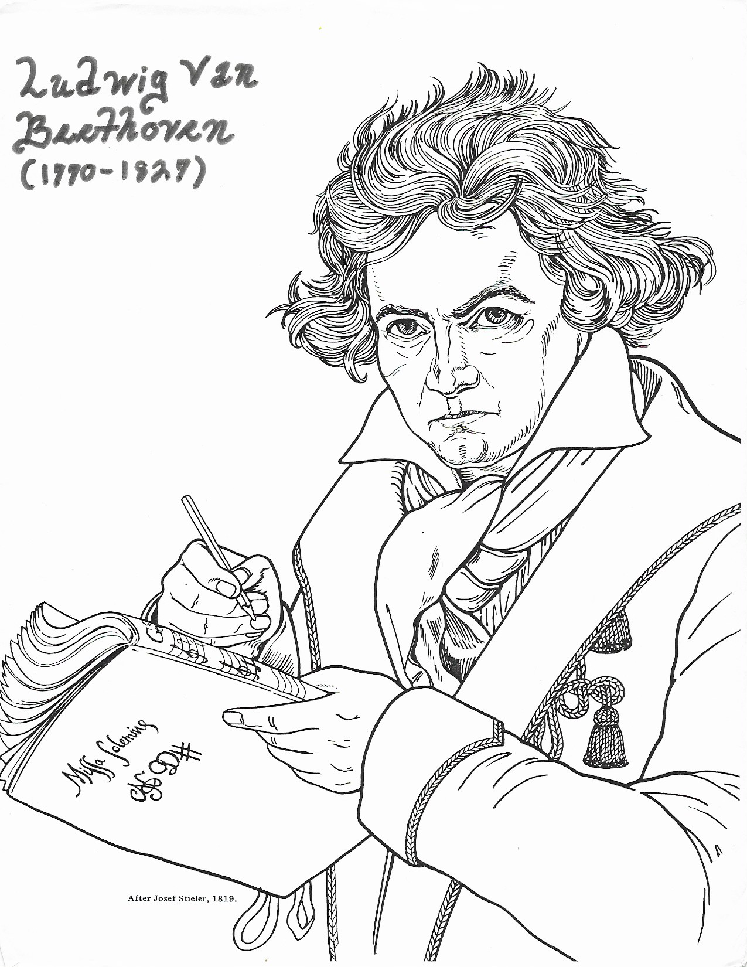

MUSIC HISTORY: pg. 44
MUSIC HISTORY: pg. 45
Beethoven

The German composer, Ludwig Van Beethoven (1770 – 1872), composed two Mass settings, as well as 9 symphonies, numerous piano pieces, and one opera. His style bridges the gap from the elegant Classical style of Haydn and Mozart, to the lush and emotionally expressive Romantic style, which pushes the limits of major/minor tonality. From a small town in Germany, Beethoven went to study music in Vienna, Austria, at age 17. He met Mozart and even took some lessons with him, but after only two weeks in Vienna, Beethoven’s mother passed away and he had to return home. His father was so crushed by her death that he was unable to work, and Beethoven found himself responsible for caring for his younger siblings, financially and otherwise. He was able to return to Vienna a few years later, where he spent most of his career. His talent as a virtuoso pianist was quickly recognized, and he later began to establish himself as a composer. Haydn recommended Beethoven for several jobs. Another tragedy struck when Beethoven began to lose his hearing at age 28. He later went completely deaf, but his spirit could not be silenced, and he continued to compose, hearing his music only in his mind.

Beethoven’s first Mass setting, the Great Mass in C (1807), was composed for Prince Esterhazy, Haydn’s former employer. This Mass, while still in the early Romantic style, holds to Classical conventions. Sadly, the first performance of his Mass in C did not go well. The Chorus had refused to rehearse under Beethoven, because he was deaf, and they were thus unprepared, giving a mediocre performance. Beethoven’s Mass in C is now considered one of his greatest works. The sung parts of the Mass are the Kyrie, Gloria, Credo, Sanctus and Agnus Dei.

Beethoven’s second and final setting of the Mass, his “Missa Solemnis” is considered by many to be his greatest work. Always a painstakingly slow composer, it took Beethoven five years to write the “Missa Solemnis”, which was for him a deeply personal expression of faith. Completed in 1822, Beethoven’s “Missa Solemnis” was first performed in 1824, and was published a few days after his death in 1827. The lengthy Mass setting is like a choral symphony filled with liturgical symbolism. In the Benedictus, a violin solo, played in the highest register, floats serenely above the soloists and chorus, representing the descent of the Holy Spirit to the earth, in some of the most lushly beautiful writing ever composed. In speaking of his “Missa Solemnis”, Beethoven said that he wanted to come closer to the Divinity, and to spread the rays of the Divinity among all mankind. Beethoven expressed this thought in the heading to the Kyrie, which reads; “from the heart – may it in turn go to the heart”.

Style of Beethoven’s Masses:
- Full use of orchestra with chorus and soloists, in which the orchestra plays an important
role, sometimes beginning or continuing the theme
- Choral writing strongly influenced by Handel
- Use of traditional forms within each movement to create balance and symmetry
- Often simple melodic material undergoes complex development
- Lush harmonies pushing the limits of major/minor tonality, use of chromaticism and dissonance
- Deeply personal and often poignantly emotional expression of the text
- Sudden contrasts in mood, dynamics, tempo etc. for dramatic effect
MUSIC HISTORY: pg. 46

Kyrie

"Have mercy on me, O God, according to your steadfast love;
according to your abundant mercy blot out my transgressions" (Ps 51:1)

Saint Pope John Paul II spoke about our need for what he calls the ‘unfathomable mystery of God’s mercy’ when he dedicated the Polish Shrine of Divine Mercy on Aug. 17, 2002. He states: “Like Saint Faustina, we wish to proclaim that apart from the mercy of God there is no other source of hope for mankind. We desire to repeat with faith: Jesus I trust in you! This proclamation, this confession of trust in the all-powerful love of God, is especially needed in our own time, when mankind is experiencing bewilderment in the face of many manifestations of evil. The invocation of God’s mercy needs to rise up from the depth of hearts filled with suffering, apprehension and uncertainty, and at the same time yearning for an infallible source of hope… With the eyes of our soul, we long to look into the eyes of the merciful Jesus, in order to find deep within His gaze the reflection of His inner life, as well as the light of grace which we already have received so often, which God holds out to us anew each day and on the last day.”

The Kyrie is part of the Penitential Rite. After confessing our sins in the Confiteor, we ask God to have mercy on us in singing the Kyrie. Asking God for mercy reflects a long tradition of asking God to mercifully forgive us of our sins, as in Psalm 51; as well as the tradition of asking God to be merciful to us and come to our aid in our struggles, ailments, and trials, such as the blind beggar who cried out to Jesus to have mercy on him. The Kyrie is made up of three invocations, often seen as addressed to the Father, to the Son, and to the Holy Spirit. The Kyrie is the only part of the modern liturgy that is in Greek. The Kyrie was adopted into the liturgy of the Roman church in the 5th century.

Father George Kosicki states that mercy is, “God’s love poured out upon us; it is when God, who is love itself, loves us. This flowing quality of mercy is most dramatically represented by Christ on the Cross as, through the Blood and Water gushing forth from His pierced Heart, He pours His very life out as a fountain of mercy for us… And we find it also in the great chant of the Church, the Kyrie Eleison (Lord have mercy), which for centuries has resounded throughout the world at every celebration of the Eucharist and the Liturgy of the Hours. The word ‘eleison’, which in Greek means ‘have mercy’, has the root meaning of ‘oil being poured out’, so whenever we say, ‘Lord have mercy,’ we are really saying, ‘Lord, pour your love out upon us’ (“Now Is the Time for Mercy”, Marian Press, 1993).

Cantor/choir All
V. Kyrie, eleison. R. Kyrie, eleison. Lord have mercy.
V. Christe, eleison. R. Christe, eleison. Christ have mercy.
V. Kyrie, eleison. R. Kyrie, eleison. Lord have mercy.
MUSIC HISTORY: pg. 47

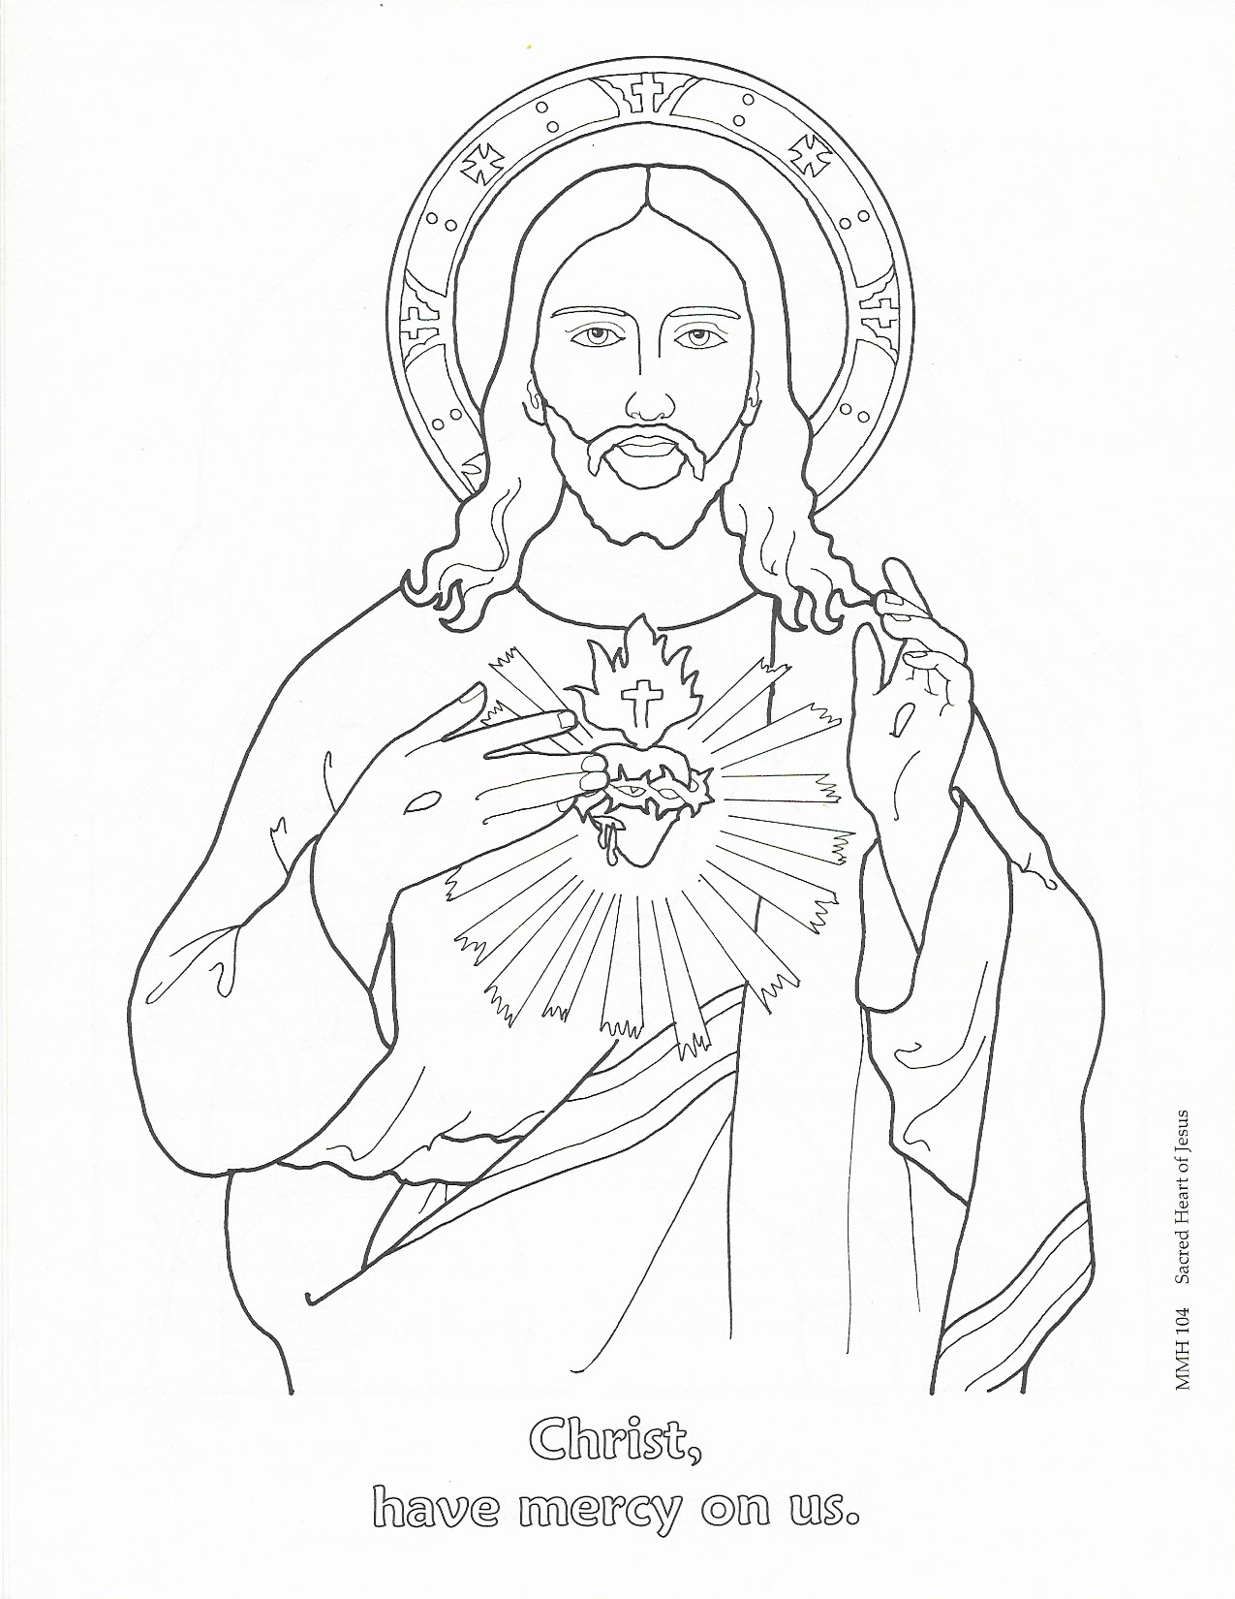

MUSIC HISTORY: pg. 48

Gloria

"And suddenly there was with the angel a multitude of the heavenly host,
praising God and saying ,'Glory to God in the highest heaven,
and on earth peace, good will to all people' (Luke 2:13-14)

The Gloria is a hymn of praise and thanksgiving raised up to the Father, Son and Holy Spirit. The text of the Gloria is an expanded version of the angels' hymn found in the gospel of Luke. Humankind joins in the angels' hymn on earth, with the hope of joining the hymn in heaven. The Gloria also echos many Old Testament titles of praise for God, by addressing him as Almighty, Heavenly King, and the Holy One throughout the hymn.

The Gloria tells the story of our salvation, as we are first reminded of Christ’s coming as God’s only Begotten Son; then we look to Christ’s redemptive work as the Lamb of God who takes away the sins of the world; and finally see Him seated at the right hand of the Father as the Most High with the Holy Spirit in the Glory of God the Father.

According to tradition, the Gloria was translated from Greek into Latin by St. Hilary (d.366). The Gloria was first used only at Christmas masses. Now, the Gloria is sung on all Sundays and Feast Days, except during times of penance.

Glory to God in the highest,
And on earth peace to people of good will.

We praise you, we bless you,
We adore you, we glorify you,
We give you thanks for your great glory,
Lord God, heavenly King, O God, almighty Father.

Lord Jesus Christ, Only Begotten Son,
Lord God, Lamb of God, Son of the Father,
You take away the sins of the world, have mercy on us;
You take away the sins of the world, receive our prayer;
You are seated at the right hand of the Father, have mercy on us.

For you alone are the Holy One,
You alone are the Lord,
You alone are the Most High, Jesus Christ,
With the Holy Spirit, in the glory of God the Father. Amen.
MUSIC HISTORY: pg. 49

Credo

After hearing the word of God and his teachings through sacred scripture and the homily, we rise to profess our faith in God by saying the Creed, which was composed at the council of Nicea in 325 AD. The Creed gives a summary of our Catholic faith, in which we state our beliefs concerning the creation of the world, the incarnation of Christ, His work of redemption, His glorification, the giving of the Holy Spirit, and look forward to Christ’s return. Confessing our faith publicly is an opportunity for us to stand on what we believe, to dedicate our lives more and more to God, and to place our trust in Him alone.

I believe in one God, the Father almighty,
maker of heaven and earth, of all things visible and invisible.

I believe in one Lord Jesus Christ, the Only Begotten Son of God,
born of the Father before all ages.
God from God, Light from Light, true God from true God,
begotten, not made, consubstantial with the Father;
through him all things were made.
For us men and for our salvation he came down from heaven,

And by the Holy Spirit was incarnate of the Virgin Mary, and became man.

For our sake he was crucified under Pontius Pilate, he suffered death and was buried,
and rose again on the third day in accordance with the Scriptures.
He ascended into heaven and is seated at the right hand of the Father.
He will come again in glory to judge the living and the dead
and his kingdom will have no end.

I believe in the Holy Spirit, the Lord, the giver of life,
who proceeds from the Father and the Son,
who with the Father and the Son is adored and glorified,
who has spoken through the prophets.

I believe in one, holy, catholic, and apostolic Church.
I confess one Baptism for the forgiveness of sins
and I look forward to the resurrection of the dead
and the life of the world to come. Amen.

MUSIC HISTORY: pg. 50

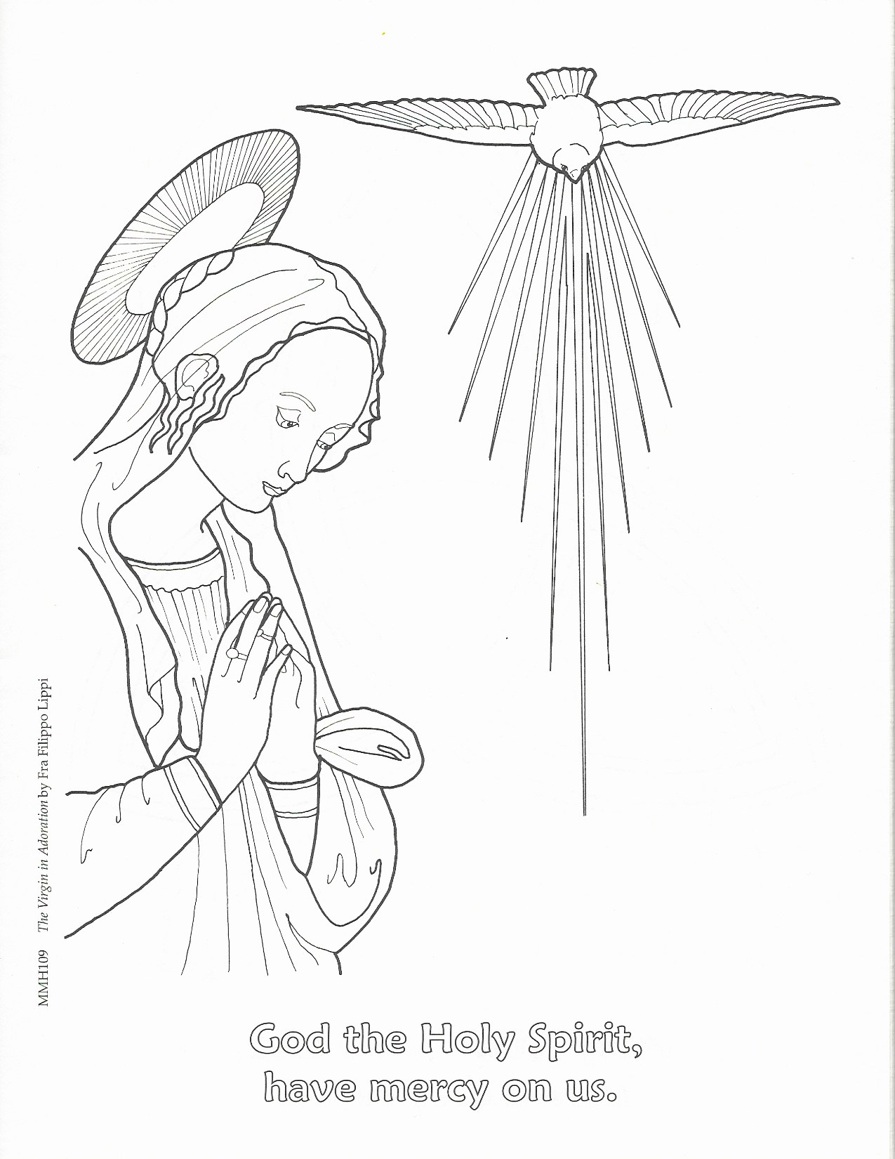

MUSIC HISTORY: pg. 51

Sanctus

"I saw the Lord sitting on a throne, high and lofty;
and the hem of his robe filled the temple.
Seraphs were in attendance above him; each had six wings:
with two they covered their faces,
and with two they covered their feet, and with two they flew.
And one called to another and said:
'Holy, holy, holy is the Lord of hosts;
the whole earth is full of his glory.'"
(Is. 6:1b-3)

"The crowds that went ahead of him and that followed were shouting,
'Hosanna to the Son of David!
Blessed is he who comes in the name of the Lord!
Hosanna in the highest heaven!'"
(Matt. 21:9)

The Sanctus is our response to the Preface sung by the priest in the Eucharistic Prayer. The people of God respond with the angels in praising God and offering thanks. The text of the Sanctus is a combination of Isaiah's vision, and the Palm Sunday acclamation.

Sanctus, Sanctus, Sanctus Holy, holy, holy
Dominus Deus Sabaoth. Lord, God of hosts,
Pleni sunt caeli et terra gloria tua. heaven and earth are full of your glory.
Hosanna in excelsis. Hosanna in the highest.

Benedictus qui venit Blessed is he
in nomine Domini. who comes in the name of the Lord.
Hosanna in excelsis. Hosanna in the highest.

MUSIC HISTORY: pg. 52

Agnus Dei

"The next day John the Baptist saw Jesus coming toward him and declared,
'Here is the lamb of God who takes away the sin of the world!'" (John 1:29)

"He was oppressed, and he was afflicted, yet he did not open his mouth;
like a lamb that is led to the slaughter, and like a sheep that before its shearers is silent.
By a perversion of justice he was taken away. Who could have imagined his future?
For he was cut off from the land of the living, stricken for the transgression of my people.
Yet it was the will of the Lord to crush him with pain.
When you make his life an offering for sin, he shall see his offspring,
and shall prolong his days; through him the will of the Lord shall prosper." (Is. 53:7,8,10)

The Angus Dei is sung at the time of the breaking of the bread. The text for the Angus Dei is taken from the Gloria text. In the Angus Dei, the people of God confess John the Baptist's declaration, that Jesus is the Lamb of God who takes away the sin of the world.

Angus Dei, qui tollis peccata mundi: Lamb of God, you take away the sin of the world:
miserere nobis. have mercy on us.
Angus Dei, qui tollis peccata mundi: Lamb of God, you take away the sin of the world:
miserere nobis. have mercy on us.
Angus Dei, qui tollis peccata mundi: Lamb of God, you take away the sin of the world:
dona nobis pacem. grant us peace.

MUSIC HISTORY: pg. 53

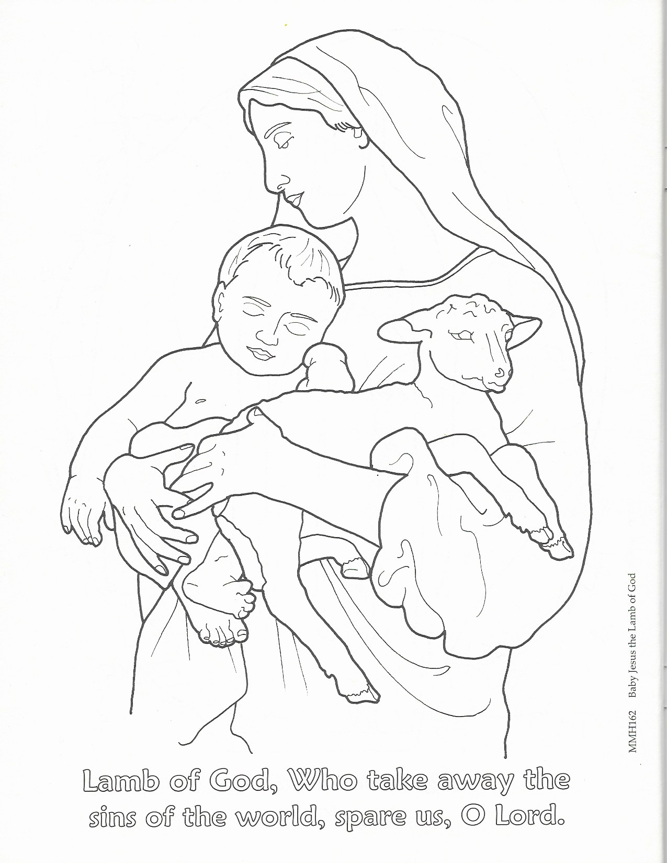

MUSIC HISTORY: pg. 54

Beethoven Mass Questions

- What country is Beethoven from?

- What city did he go to study music in and later spent most of his career?

- Who did Beethoven take a few music lessons with in this city?

- What tragedy caused him to return home after only two weeks of study in this city?

- What was the second tragedy in Beethoven’s life, which was a special challenge to him as a musician?

- How did Beethoven respond to this challenge?

- Who recommended Beethoven for jobs?

- What are the 5 sung parts of the Mass?

