April 4, 2019
8th Grade Sound Waves and Pressure Review
Vocab
- Sound is the kinetic energy of air molecules vibrating and interacting
- Vibration: The repeated back and forth movement of an object or substance
  - Sound is caused by vibrations
  - Vibration is a motion, so sound is an example of kinetic energy
  - Kinetic energy is transferred from air molecule to air molecule, creating a sound wave
  - Vocal cords vibrate and transfer kinetic energy to nearby air molecules, creating sound
- Longitudinal wave: vibrations occur in the same direction as the sound is moving
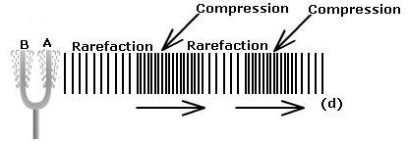
  - Sound travels as a longitudinal wave
  - Compression: part of a longitudinal wave where air molecules are close together
  - Rarefaction: part of a longitudinal wave where the air molecules are farther apart
  - Each tiny peep of sound creates its own wave
  - If not directed, sound waves travel (or spread out) in all directions
  - Kinetic energy moves through air in a wave, air molecules do not move along the wave
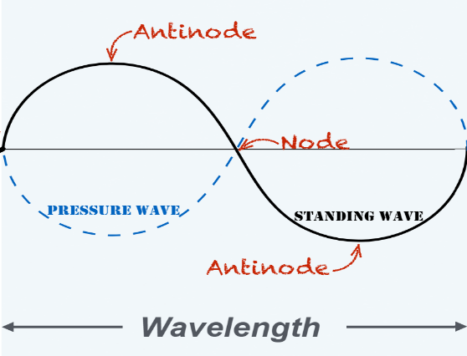
- Standing wave: A wave that forms in a vibrating object.
  - A standing wave does not move through space
  - Ex. vocal cords vibrate, but they do not move away from your throat!
- Pressure wave: The moving wave that is produced by a standing wave, moves through space
  - The back and forth movement of a standing wave’s vibrations cause the compression and rarefaction of a pressure wave that travels away
  - Caused by the transfer of kinetic energy
  - Moves in the opposite direction of a standing wave
  - Sound waves are audible pressure waves
- Node: The point at which a standing wave has NO displacement from equilibrium
- Antinode: The point at which a standing wave has its maximum displacement, or distance from equilibrium
  - The upper and lower peaks of a sound wave
- Frequency: number of vibrations per second, measured in Hertz
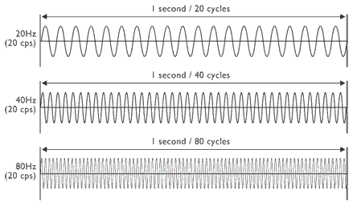
  - The number of times a standing wave moves back and forth every second
  - The faster the vibrations, the higher the frequency
  - The higher the frequency, the shorter the wavelength
    - When wavelengths are short, a lot more of them are able to fit into one second higher frequency of vibrations/sound waves
- Wavelength: The distance between two end nodes, measured in meters
  - Shorter wavelengths = more waves that fit into one second = higher frequencies
- Pitch: how high or low a note is
  - Ex. a soprano sings in a higher pitch than a baritone
  - More vibrations per second = higher frequency high pitch
  - Fewer vibrations per second = lower frequency low pitch
- Speed: (in this case) how fast the pressure waves of a sound travel in meters per second
  - Speed = frequency x wavelength
  - Sound travels 340 meters per second through air
- Hertz: The unit of frequency in vibrations per second
  - For example, a wave vibrating 880 times per second has a frequency of 880 Hz
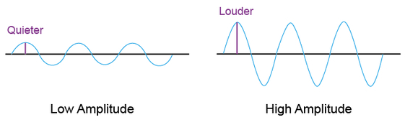
  - We hear from around 20-20,000 Hz
- Amplitude: determines how loudly we hear a sound
  - The maximum extent of a vibration, measured from node to antinode (the height of a wave)
  - Measured in decibels (dB)
- Decibel: the unit of measure for amplitude
- Transducer: converts one type of energy into another type of energy
  - Ex. a microphone converts mechanical energy caused by vibrations into electrical energy
  - Ex. an electromagnetic speaker converts electrical energy into mechanical energy, creating sound waves
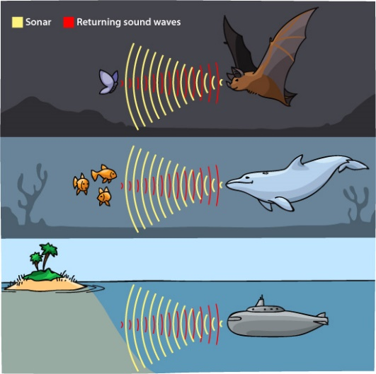
    - Reminder: sound is a form of mechanical energy because objects have mechanical energy if they are in motion
- SONAR: SOund Navigation And Ranging
  - Technology that is often used in water to determine distances between ships and other objects
  - Sound waves are emitted into water and travel as pressure waves
    - These pressure waves encounter an object, such as a whale, shipwreck, cliff, etc.
    - The waves are then reflected back to the sender/receiver
    - SONAR calculates the time lapse between emitting the original signal and receiving the echo to determine distance to the object
- Echolocation: bio-SONAR
  - Animals using sound waves to locate objects or prey
  - Works the same way as SONAR, but used by animals, such as Orca whales and bats

Focus Questions
How do humans hear sound?
- Sound waves reach the ear and cause the eardrum (tympanic membrane) to vibrate at the same frequency as the sound waves
- The eardrum transfers these vibrations to the cochlea (the snail-shaped structure in the inner ear)
- In the cochlea, these vibrations are converted into nerve signals
- These nerve signals are then sent to the brain, where they are interpreted as sound
  - The BRAIN tells us what different sounds mean!

How are sounds produced?
- Sounds are produced when matter in the form of a solid, liquid or gas vibrates.
- Air molecules do not move along with the wave
  - Instead, they vibrate and transfer their kinetic energy to nearby air molecules

How is sound transferred from one object or substance to another?
- The vibrations of one object or substance cause pressure waves to impact a neighboring object or substance. These pressure waves cause the second object or substance to start vibrating.

What is the relationship between the wavelength and frequency of a standing wave and the sound it produces?
- There is an inverse relationship between wavelength and frequency.
- As frequency increases, wavelength decreases

What is the speed of sound in air? The speed of sound in air is approximately 340 meters per second.

In the same type of matter, is the speed of sound different for different frequencies and wavelengths?
- In the same type of matter, the speed of sound does not change if two sounds have different frequencies or different wavelengths.

How do different types of matter affect the speed, the wavelength and the frequency of sound?
- The speed of sound increases from gas to liquid to solid
  - This is because molecules in liquids and solids are closer together, allowing vibrations to transfer more easily
  - The distance between molecules relates to how fast sound can move through a medium
- In a vacuum, there are no molecules to transfer vibrations to no sound
  - Sound cannot travel in space because there are essentially no molecules in space
- In a gas, the molecules are spaced relatively far apart sound moves more slowly
- In a liquid, the molecules are spaced relatively close together sound moves faster than in a gas
- In a solid, the molecules are very close together sound moves the fastest
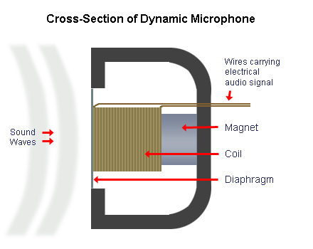
How does a dynamic microphone work?
- Sound waves cause the diaphragm in the microphone to vibrate
- Vibrations in the diaphragm cause a wire coil inside a magnet to vibrate
- The movement of the coil in the magnet produces an electric current
- This current, or “audio signal”, is sent through wires to a speaker

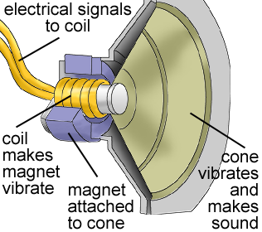
How does an electromagnetic speaker work?
- Electric current (or an audio signal) enters a wire coil in a magnet and causes the coil to vibrate
- The coil’s vibrations cause the speaker cone to vibrate
- This large vibrating cone transfers vibrations to nearby air molecules, creating sound waves!

How do Orcas hunt with echolocation?
- Orcas use nasal passages to send out sound through the fat-filled melon structure
  - Melon – specifically helps orcas focus and adjust sound waves
- Sound bounces back as an echo
- The whale absorbs the returning sound vibrations through the jawbone
- Vibrations are passed on to the inner ear
- Nerves send sound signals to the brain for processing

