May 21, 2018

8th Photosynthesis Review

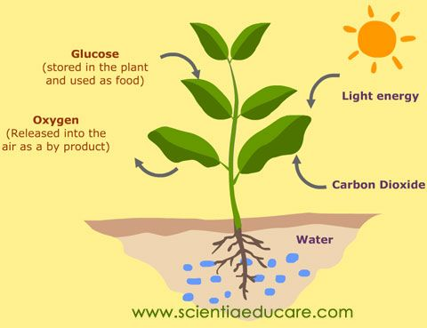
Vocab
- Photosynthesis: the process by which plants, algae, and some bacteria convert light energy into chemical energy for growth
  - Plants use the light energy from photons, carbon dioxide from the air, and water from the soul to produce oxygen and the sugar glucose
  - 6CO₂ + 6H₂O C₆H₁₂O₆ + 6O₂
- Glucose: a sugar produced by plants during photosynthesis
  - C₆H₁₂O₆
  - Hundreds of glucose molecules bind together to form large starch molecules
  - Starch is a form of stored chemical energy
- Photons: particles of light energy
  - Photons from nuclear fusion in the center of the sun provide energy for photosynthesis
- Chloroplast: organelles found in the cytoplasm of plant cells which are responsible for photosynthesis
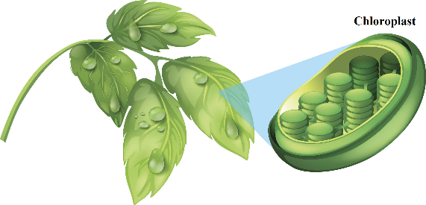
  - Located in both the leaves and stems of plants
- Chlorophyll: a green pigment concentrated in the chloroplasts of plant cells
  - Chlorophyll is necessary for photosynthesis
  - Chlorophyll absorbs mostly red and blue/violet wavelengths
- Carotene: a yellow pigment in plants
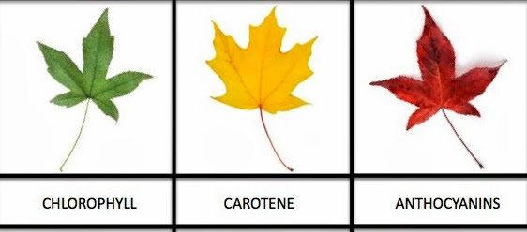
  - Carotene is present in plants all summer, but the yellow color is masked by huge amounts of chlorophyll
  - Protects plant cells from harmful photosynthesis byproducts
- Anthocyanin: a red/orange pigment in plants
  - Produced in stems and flowers
  - Produced mostly in autumn
- Carbon dioxide: a gas that is necessary for photosynthetic reactions (CO₂)
  - Most of a plant’s mass comes from carbon, which is harvested from the carbon dioxide plants take in
  - Adding carbon dioxide to water produces carbonic acid, which makes water more acidic
    - Testing the pH of water can help us tell whether there is carbon dioxide being produced by plants in the water
- Oxygen: a gas that is a product of photosynthetic reactions and is necessary for the life of animals and other living organisms (O₂)
  - Plants are the main source of oxygen on Earth
- Absorption spectrum: the types of wavelengths that a substance is able to absorb
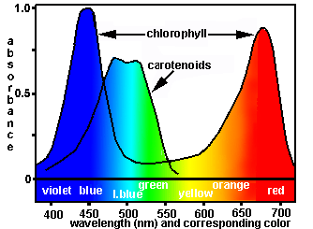
  - Ex. the absorption spectrum of chlorophyll shows that chlorophyll absorbs red and blue/violet wavelengths readily, but reflects yellow and green wavelengths
- pH: a property of matter which describes whether a substance is acidic or basic.
  - A pH of 7 indicates a neutral substance
  - A pH lower than 7 indicates that the substance has acidic properties
  - A pH greater than 7 indicates that the substance has basic properties

Focus Questions
- What do plants need to live?
  - Plants need water, sunlight, and carbon dioxide.

- Which pigments or colors are present in spinach leaves? Investigation #1
  - The leaves contain yellow and yellow-green pigments.

- How do light and photosynthesis affect carbon dioxide levels? Investigation #2
  - In the presence of light, carbon dioxide levels decreased in water containing Elodea but not in water alone. This is because the presence of light increased the ability of Elodea to perform photosynthesis, so the Elodea consumed more carbon dioxide.

- How do light and photosynthesis affect oxygen levels? Investigation #2
  - In the presence of light, oxygen levels increased in water containing Elodea but not in water alone. This is because the presence of light increased the ability of Elodea to perform photosynthesis, so the Elodea produced more oxygen and released it into the water.

- What is the importance of light in photosynthesis? Investigation #2
  - Light is necessary for photosynthesis to take place.

- In which parts of the plant does photosynthesis occur? Investigation #3
  - Both the Elodea stem and the Elodea leaf contain chloroplasts; therefore, photosynthesis occurs in both the stem and the leaf.

- In which parts of a Coleus leaf does photosynthesis occur? Investigation #4
  - Photosynthesis takes place in the chloroplasts, which are the parts of the leaves which contain chlorophyll. This is often indicated by the green color of the chlorophyll.

- Which pigment is required for photosynthesis?
  - The green pigment chlorophyll is required for photosynthesis.

- Why do leaves change color in the fall?
  - As the length of nighttime increases and the days shorten, chlorophyll production slows down and eventually stops.
  - Chlorophyll eventually disappears from leaves, and the yellow carotene can be seen more clearly.
  - As chlorophyll production decreases, anthocyanin production increases, causing leaves to turn red.
    - The amount of anthocyanin produced depends on the weather and soil moisture.
    - Good weather and water conditions lead to bright, vibrant reds
    - Poor weather and water conditions lead to duller, less vibrant reds
      - This partially explains why not all autumn leaves have the same mix of colors

- How does energy from the sun fuel photosynthetic processes on Earth?
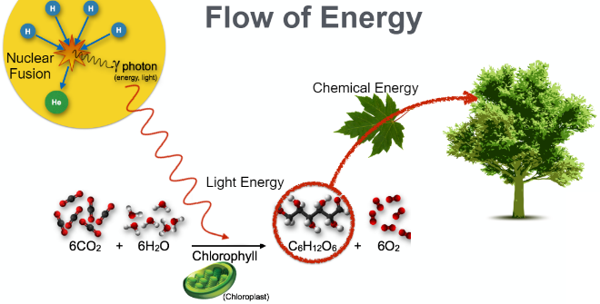
  - Nuclear fusion in the center of the sun releases energy in the form of photons.
  - Photons reach the surface of the sun and travel approximately 8 minutes to Earth.
  - On Earth, photons strike plant cells and cause photosynthesis to occur.
    - Plants convert the photon’s energy into stored chemical energy in the form of glucose
  - Glucose is stored and later used by the plant to grow and reproduce.

