May 13, 2019

8th Light Review
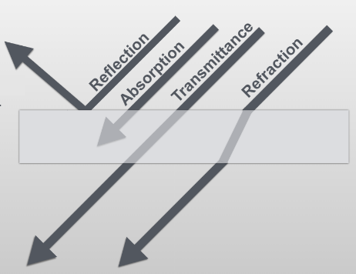
Vocab
- Transmittance: the ability of light to pass through a medium
- Reflection: the bouncing of light off an object
- Absorbance: to take light in and not transmit or reflect it
- Refraction: when light waves bend as they travel from one medium to another, for example from air to water
- Angle of incidence: the angle at which light hits a substance
- Angle of reflection: the angle at which light is reflected off a substance
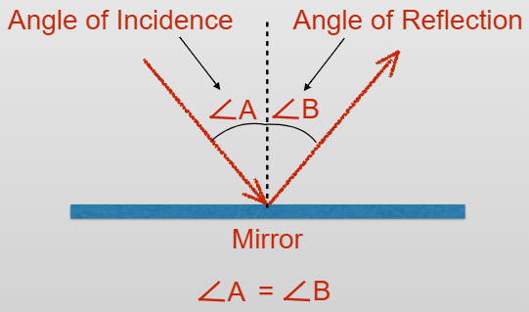
- Law of Reflection: the angle of incidence equals the angle of reflection
  - The angle at which light hits an object equals the angle at which light is reflected from that object
- Transparent: allows the transmittance of almost all light, ex. windows
- Translucent: allows the transmittance of some light, ex. frosted glass
  - Semitransparent
- Opaque: prevents the transmittance of light, ex. oak doors or brick walls
- Color filter: absorbs all visible light except for a few select wavelengths
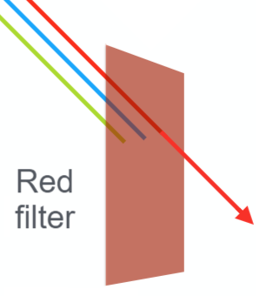
  - A red color filter absorbs all color wavelengths except for red
    - Red wavelengths are transmitted by a red color filter
- Spectrophotometer: instrument used to measure the amount of light transmitted or absorbed by a solution
  - Useful in determining solute concentration

Light is composed of small moving particles called “photons”
- Photons move, so light is a form of kinetic energy
- Light travels as a wave
All the color we perceive is reflected light!
- We are seeing specific color wavelengths reflected into our eyes
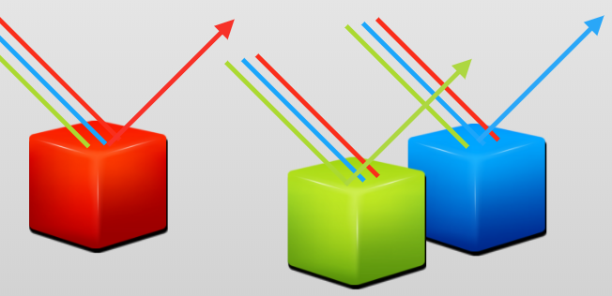
As absorbance increases, transmittance decreases (inverse relationship)
- As more light is absorbed by a substance, less light passes through that substance
Electromagnetic spectrum: the entire range of wavelengths or frequencies of electromagnetic radiation, ranging from radio waves to gamma rays
- Visible light is on the electromagnetic spectrum, and ranges from 700 nanometers (red) to 400 nanometers (violet)
- As wavelength decreases, energy increases (inverse relationship)
  - Ex. gamma rays have the shortest wavelength and the highest amount of energy
- Wavelength is measured in meters
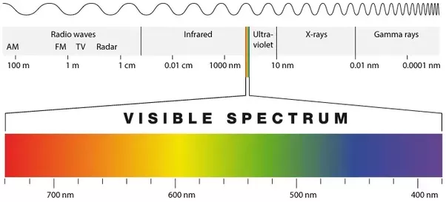
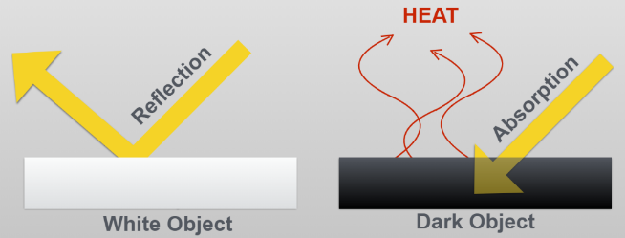
White light – composed of all wavelengths of visible light
- White objects reflect almost all light
- Prisms separate white light into all other colors
  - The order of colors is always the same because it is based on the colors’ wavelengths
    - ROY G. BIV
Black – absorbs almost all light
- We see the color black when very little light is reflected
- As light is absorbed by a black object, light energy is also absorbed
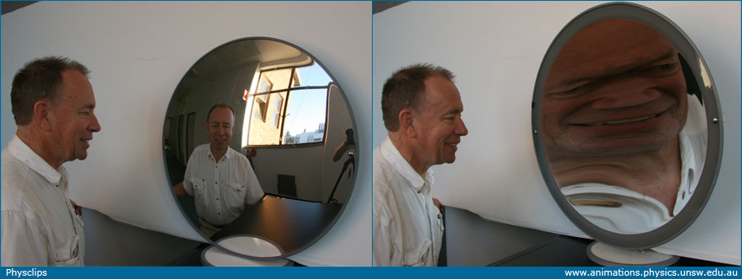
  - This energy is transferred to the molecules in the black object, causing those molecules to move and vibrate this creates HEAT!!
Mirrors
- Plane: flat mirror
- Concave: the mirror bends inward
  - The mirror “caves” in
  - This makes an image bigger, ex. a dentist mirror
- Convex: the mirror bends outward
  - This makes an image smaller so you can see more convex mirror concave mirror
    - Ex. a road mirror or drugstore mirror
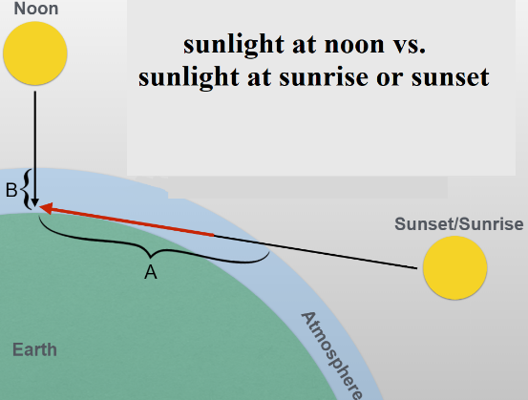
Sunset and sunrise
- Earth’s atmosphere absorbs blue and green wavelengths better than red and orange
- At sunrise and sunset, light travels through more of our atmosphere, so more blue and green wavelengths are absorbed
- Only the red and orange wavelengths can move through the atmosphere without being absorbed, so we see red and orange at sunrise and sunset – the atmosphere acts like a red filter!
Nuclear fusion: when 4 hydrogen atoms come together with such force that their nuclei fuse
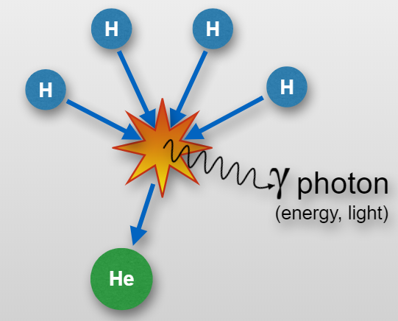
- The sun is our closest star
  - Earth is about 8 light-minutes from the sun
  - The sun’s core temperature is 27,000,000º F
  - The sun is composed of 75% hydrogen and 25% helium
- Where does (most) of our light come from? NUCLEAR FUSION!
  - This only occurs near the center of a star, where temperature and pressure are very high
- 4 hydrogen atoms combine to create 1 helium atom and release energy in the form of a photon
- In a nuclear fusion reaction, mass is converted into energy
  - Stars convert matter into energy!!!
    - Energy is released as light in the form of a photon
- The sun converts approximately 9 billion pounds of matter into energy every second
  - The sun is our only source of energy for life on Earth!
The relationship between energy, mass, and light is represented as E = mc²
- E = energy
- M = mass
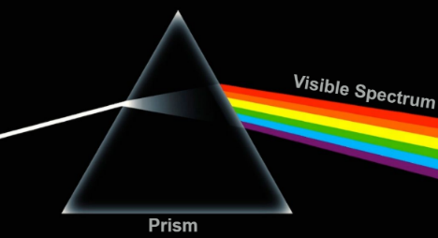
- C = speed of light
How does a prism work?
- Prisms work by refracting light!
- White light contains a mixture of all wavelengths of visible light
- Different wavelengths of light are refracted to a different extent by the same medium
Focus Questions
What is the relationship between the absorption and transmission of light through transparent substances?
- There is an inverse relationship between the amount of light that is transmitted and the amount of light that is absorbed when light interacts with a transparent liquid.
  - As absorption increases, transmittance decreases.
- The color of a transparent substance is determined by the wavelength of light that is transmitted through the object.
  - For example, a blue filter is blue, but it is still transparent because you can see objects through the filter. We see the filter as blue because blue wavelengths are able to pass through the filter. All other color wavelengths are absorbed.
  - Another example: water that has been colored with green food dye is green. When you look through the green-colored water, you know that green wavelengths are being transmitted through the water and the other color wavelengths are being absorbed.

How do light waves interact with objects that reflect light?
- When a light wave interacts with an object that reflects light, the angle at which the wave is reflected off the object (the angle of reflection) is equal to the angle at which it encounters the object (the angle of incidence).

How does wavelength affect the perception of light?
- We perceive an object or medium as being a certain color because those wavelengths are the ones reflected into our eyes.
  - For example, we see a lemon as yellow because yellow wavelengths are being reflected by the lemon.
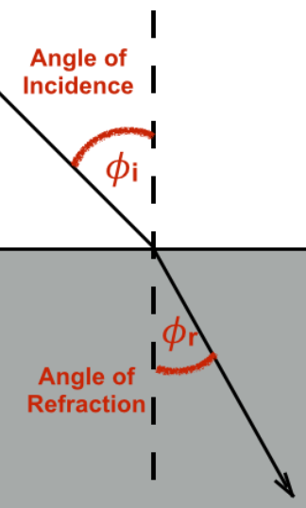
How does a change in mediums affect the wavelength of light?
- When light passes from one medium to another, the speed of the wavelengths changes. This causes the light waves to change direction (the light is bent). This process is called refraction.
- Said another way: refraction occurs because when light passes from one medium to another (such as from air to water), the speed of the wavelengths changes, causing the light to change direction (or bend).
- Every medium changes the speed of light in a particular way. This characteristic of a medium is called its “refractive index.”

