October 24, 2017

8th Grade Heat and Heat Transfer Review

Vocab
- Heat: thermal energy
  - The total of all energy within a substance
  - Total energy of all molecular movement within a substance
  - It can also be described as the transfer of thermal energy
- Kinetic energy: the energy of motion
  - Kinetic energy ALWAYS moves from areas of high energy to low energy
- Temperature: measure of the average kinetic energy of matter within a given substance
  - Measure of average heat
  - The higher the kinetic energy, the greater the rate of molecular motion, and the higher the temperature.
- Freezing point: the temperature at which a liquid becomes a solid
  - At the freezing point, there are equal amounts of liquid and solid molecules
  - Above the freezing point, there is more liquid matter
  - Below the freezing point, there is more solid matter
- Boiling point: the temperature at which a liquid becomes a gas
  - Above the boiling point, there is more gaseous matter
  - Below the boiling point, there is more liquid matter
- Equilibrium: a stable situation in which opposing forces cancel each other out
  - No net energy transfer
- Law of Conservation of Energy: energy can be converted from one form to another, but can neither be created nor destroyed.
- Heat transfer: the transfer of thermal energy
  - Heat transfer ALWAYS moves from areas of high temperature (high kinetic energy) to low temperature (low kinetic energy)
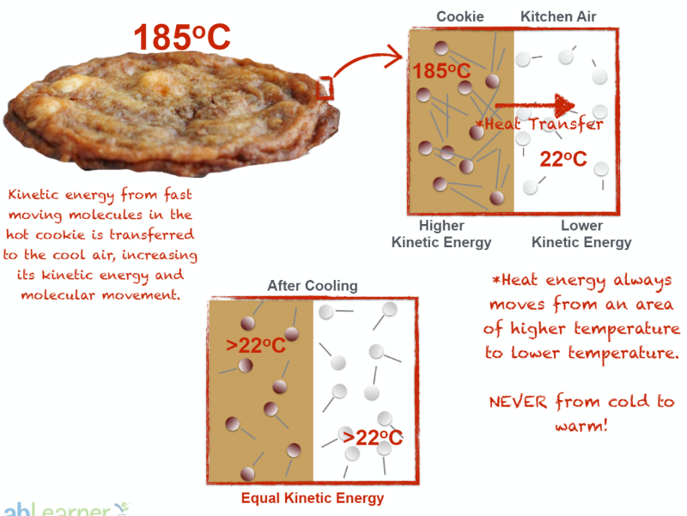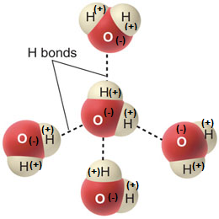

- Hydrogen bond: weak interaction between the positively-charged hydrogen atom on one water molecule and the negatively-charged oxygen atom of another water molecule
  - These weak bonds are the cause of surface tension, which allows water bugs to walk on water and dew drops to form as little beads of water
- Freezing point depression: the lowering of the freezing point of a liquid
  - Adding a solute to a liquid decreases the freezing point
  - The liquid freezes at a lower temperature
- Boiling point elevation: the raising of the boiling point of a liquid
  - Adding a solute to a liquid increases the boiling point
  - The liquid boils at a higher temperature.
- Specific Heat Capacity: the amount of heat (joules) that is required to raise the temperature of 1 gram of a substance by 1 degree Celsius
  - Higher specific heat capacity = it takes more heat to raise a substance’s temperature
  - Ex. it takes more heat to change the temperature of water than to change the temperature of sand
  - Higher heat capacity better insulator
- Joules: unit of energy

Focus Questions
What is the relationship between heat, kinetic energy and temperature?
- Heat is the transfer of thermal energy
- As heat increases, kinetic energy increases and temperature increases

What changes in matter accompany changes in heat?
- In general, matter expands when heated and contracts when cooled because of changes in the kinetic energy of molecules.
- As heat increases, substances change from solids to liquids to gases
- As heat decreases, substances change from gases to liquids to solids

How do changes in thermal energy relate to freezing and boiling point of water?
- Freezing point: when a solid becomes a liquid
  - The lower kinetic energy in colder substances slows molecular movement and compacts the substances, forming a solid
  - Tightly packed molecules
- Boiling point: when a liquid becomes a gas
  - The higher kinetic energy in hotter substances increases molecular movement and breaks the bonds between liquid molecules, resulting in the liquid becoming a gas
  - Molecules spread out

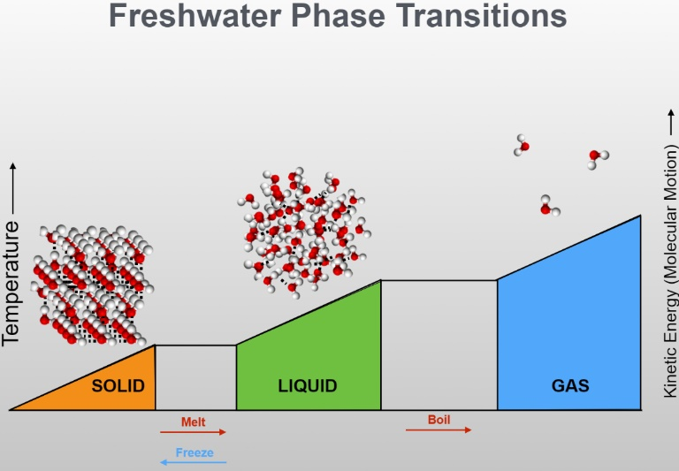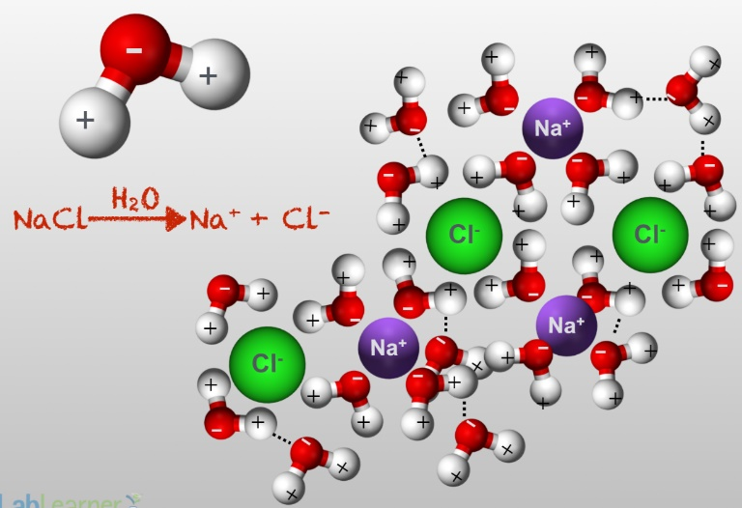

How does addition of a solute change the freezing and boiling point of water?
- Adding a solute to water decreases the freezing point of water and increases its boiling point
- Example: table salt, NaCl
  - The positively-charged hydrogen atom pulls on the negatively-charged chlorine atom, while the negatively-charged oxygen atom pulls on the positively-charged sodium atom
  - These interactions between all the atoms cause the table salt to dissolve into Na and Cl
  - The Na and Cl get in the way of the water molecules and make it hard for the water to come back together and form a tightly-packed arrangement of molecules (ice)
  - To get water to boil, extra heat is needed to break the bonds between the O and the Na as well as between the H and the Cl
- Salt must be removed before freezing or boiling water – extra energy is needed to do this

How can the ability to absorb heat be measured as a physical property of matter?
- Specific heat capacity is a measure of the amount of heat energy (joules) required to raise the temperature of 1 gram of a substance by 1 degree Celsius.

How does a thermometer work?
- As air temperature changes around a thermometer, the kinetic energy of the air molecules changes
- The change in the kinetic energy of the air molecules is transferred to the liquid molecules inside a thermometer
- As kinetic energy increases in the liquid, the molecules begin moving faster and the liquid expands, rising up the tube inside the thermometer
- Rising kinetic energy of air molecules rising liquid = rising temperature

