March 1, 2019

8th Grade Electricity and Magnetism Review

- Circuit: an uninterrupted path between the terminals (ends) of a power source
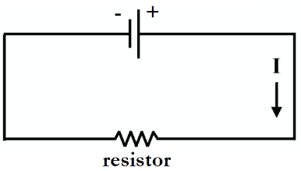
  - Electrons (e-) move from a negative terminal to a positive terminal
  - Electricity only flows through closed circuits
- Voltage: measure of electrical potential between two points in a circuit
  - Measured in volts (V)
  - How much electricity is the device capable of producing?
  - In our labs, we increased voltage by increasing the number of batteries in the circuit
- Current: the amount of electric charge that actually passes a given point in a specified time period
  - Measured in amperes (amps, A)
  - Represented by a capital I
  - The direction of current flow is opposite from the direction of electron flow in a circuit
    - Current flows from the positive terminal to the negative terminal of the battery

What is the charge of electrons and in which direction do they move in a circuit?
- Electrons are negative, and they move from negative to positive

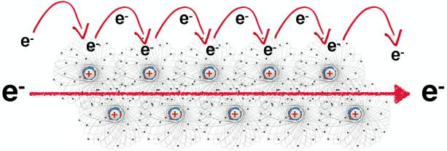
How does current move through a wire?
- Metals like copper are very conductive due to the outer electrons around their atoms
- One electron from a copper atom jumps to a nearby copper atom and knocks into one of its outer e-
- This electron that was knocked into then jumps to another nearby copper atom and knocks into another e-
- This pattern of electrons knocking each other out of place continues down the wire
- The movement of electrons from atom to atom creates the electron flow that is electricity

- Amperage: amount of charge that passes a given point in the circuit in a specific period of time
  - Used to measure current
- Multimeter: an instrument used to measure current, voltage, and resistance
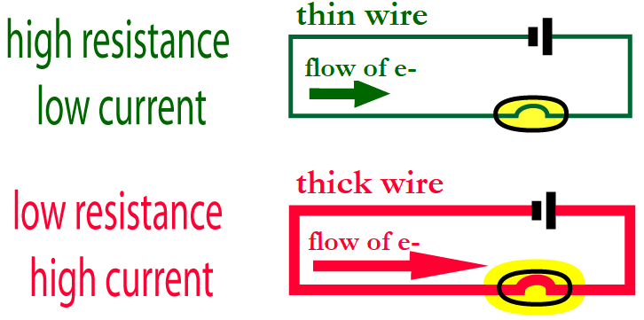
- Resistance: decreasing the flow of electrons and current by changing the diameter or material of a wire
  - As resistance increases, current decreases
  - Thin wires (smaller diameter) cause more resistance than thick wires (large diameter)
    - Similarly, it is more difficult to drink a milkshake through a skinny straw than through a wider straw
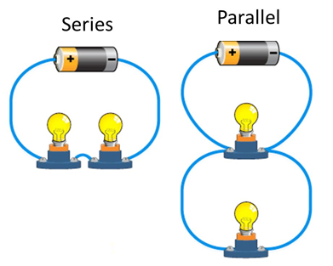
  - Resistance is measured in Ohms (Ω)
- Resistor: any wire in a circuit which decreases the flow of current
- Series vs. Parallel Circuits
  - Series: more than one resistor arranged on one path
    - Increasing the length of a resistor (increasing the number of resistors in a series circuit) increases resistance and decreases current
      - Current struggles to move through several resistors in a row, making bulbs dimmer
    - If one bulb goes out, they all go out
  - Parallel: more than one resistor arranged on many paths
    - Increasing the cross section of a resistor (increasing the number of resistors in parallel, or making the resistor “wider”) decreases resistance and increases current
      - There are several paths for the current to move through, keeping bulbs bright
    - If one bulb goes out, the other bulbs stay lit
- Ohm’s Law: V = IR
  - Voltage (V) = Current (I) x Resistance (R)
  - As resistance increases, current decreases
  - As voltage increases, current increases
- Useful resistance: if a circuit has high resistance, then electricity will struggle to flow through it
  - The more electricity struggles, the more energy is wasted
  - We often experience this wasted energy as heat
    - Phones and laptops frequently get hot, which we do not want – this energy is being wasted as heat rather than used as electricity
  - “Wasted” energy can be used to our advantage in some appliances, such as ovens, irons, toasters, and toasters
    - For instance, when you turn on a toaster, you are sending electricity through a series of long, thin wires on either side of the bread slots
      - These wires create a LOT of resistance, so they get VERY hot – we use this heat to toast our bread!

How does an incandescent bulb work?
- When you turn on a light switch, electricity begins to flow through the tungsten wire in the lightbulb
- The tungsten wire is thin and super long, which creates a lot of resistance
- This resistance produces light, which we use! But the resistance also produces heat, which is wasted
- 90% of electrical energy used by incandescent bulbs is lost as heat

- Battery: a source of power in which chemical energy is converted into electricity
  - chemical potential energy is converted into kinetic energy (electrons are moving) when introduced into a circuit, causing a flow of electrons
  - electrons are concentrated in the negative terminal, “waiting” for a completed circuit
- Reduction reaction: takes or gains electrons
- Oxidation reaction: gives away or loses electrons
  - OIL RIG – oxidation is losing, reduction is gaining

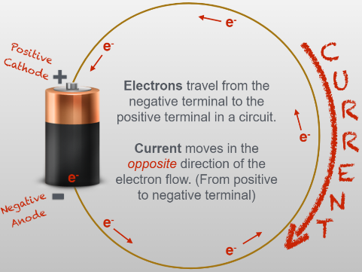
How does a battery work?
- In a battery, electrons are all crowded near the negative end, or anode
  - In a typical battery, the anode is the outer zinc case
- These crowded electrons are desperate to move away from each other and towards the positive end of the battery, but an electrolyte paste separates electrons from the positive end
- When plugged into a closed circuit, electrons escape the anode
- The electrons flow through a wire, usually copper, towards the positive end of the battery, or cathode
  - In a typical battery, the cathode is the inner carbon rod
  - You can tell where the cathode is by the bump on one end of a battery
- SUMMARY: Electrons leave the anode of the battery and move through the copper wire in the direction of the cathode, while current moves in the opposite direction of the electron flow
- Electromagnet: a metal object made into a magnet by surrounding the object with a coil and passing an electric current through the coil
  - A magnetic field is produced by a strong electric current
  - More coils, more current → more magnetism
  - In Inv. #3, we made an electromagnet by surrounding a nail with a coil and sending a current through the coil
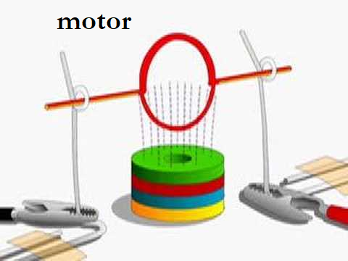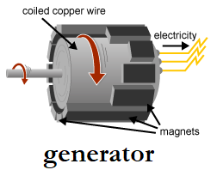
- Electric motor: when an electric current is sent through a coil of wires surrounded by a magnet, the coil will turn
  - Electricity causes this motor to run and do work
- Electric generator: when a coil is surrounded by fixed magnets and the coil is mechanically turned (NO current is applied!), an electrical current is produced
    - The coil could be turned by hand, by steam from coal, by water flow from a dam or river, by wind, etc.
  - The electricity produced is then purchased by consumers to use in their homes
- MRI: Magnetic Resonance Imaging
  - Takes images of soft tissue, such as muscles and organs

What is the relationship between voltage, current, and resistance?
- As voltage increases, current increases but the resistance remains the same
- As resistance increases, current decreases but voltage remains the same
- The relationship among voltage, current, and resistance is described by Ohm’s law, V= IR

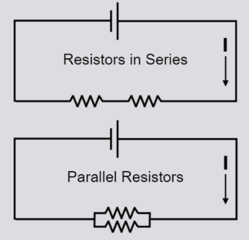
How do the dimensions of a resistor affect current?
- Increasing the length of a resistor increases the amount of resistance and decreases current
  - In Inv. #2, putting two resistors in series (in a row) increased resistance
- Increasing the diameter of a resistor decreases the amount of resistance and increases current
  - In Inv. #2, putting two resistors in parallel (next to each other) decreased resistance because it gave the current more area to move through

What factors affect the strength of an electromagnet?
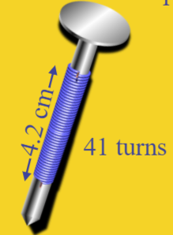
- The number of turns of wire in the coil over a specific length
  - (Number of turns over a specific length)
- The amount of current flowing through the wire

In what ways can we produce electricity?
- Solar power, wind power
- Fossil fuels (natural gas and coal)
- Hydroelectric (water, ex. dams, water wheels)
- Nuclear

