November 20, 2019

8th Grade Electricity and Magnetism Review

- Circuit: an uninterrupted path between the terminals (ends) of a power source
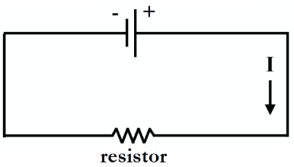
  - Electrons (e-) move from a negative terminal to a positive terminal
  - Electricity only flows through closed circuits
- Voltage: measure of electrical potential between two points in a circuit
  - Measured in volts (V)
  - How much electricity is the device capable of producing?
  - In our labs, we increased voltage by increasing the number of batteries in the circuit
- Current: the amount of electric charge that actually passes a given point in a specified time period
  - Measured in amperes (amps, A)
  - Represented by a capital I
  - The direction of current flow is opposite from the direction of electron flow in a circuit
    - Current flows from the positive terminal to the negative terminal of the battery

What is the charge of electrons and in which direction do they move in a circuit?
- Electrons are negative, and they move from negative to positive

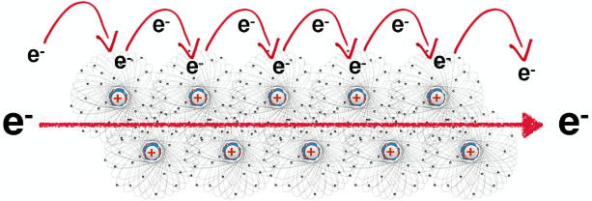
How does current move through a wire?
- Metals like copper are very conductive due to the outer electrons around their atoms
- One electron from a copper atom jumps to a nearby copper atom and knocks into one of its outer e-
- This electron that was knocked into then jumps to another nearby copper atom and knocks into another e-
- This pattern of electrons knocking each other out of place continues down the wire
- The movement of electrons from atom to atom creates the electron flow that is electricity

- Amperage: amount of charge that passes a given point in the circuit in a specific period of time
  - Used to measure current
- Multimeter: an instrument used to measure current, voltage, and resistance
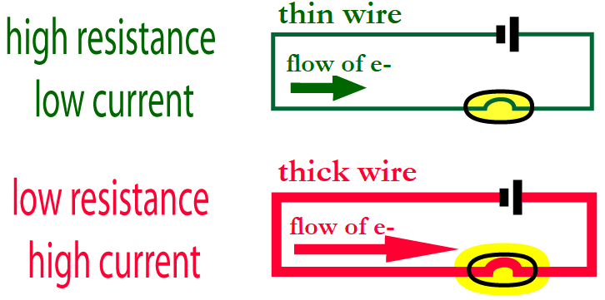
- Resistance: decreasing the flow of electrons and current by changing the diameter or material of a wire
  - As resistance increases, current decreases
  - Thin wires (smaller diameter) cause more resistance than thick wires (large diameter)
    - Similarly, it is more difficult to drink a milkshake through a skinny straw than through a wider straw
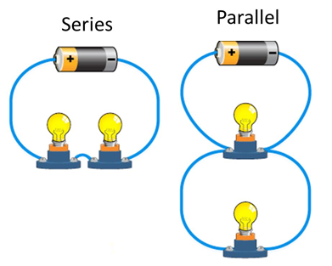
  - Resistance is measured in Ohms (Ω)
- Resistor: wire or component in a circuit that resists electron flow
- Series vs. Parallel Circuits
  - Series: more than one resistor arranged on one path
    - Increasing the length of a resistor (increasing the number of resistors in a series circuit) increases resistance and decreases current
      - Current struggles to move through several resistors in a row, making bulbs dimmer
    - If one bulb goes out, they all go out
  - Parallel: more than one resistor arranged on many paths
    - Increasing the cross section of a resistor (increasing the number of resistors in parallel, or making the resistor “wider”) decreases resistance and increases current
      - There are several paths for the current to move through, keeping bulbs bright
    - If one bulb goes out, the other bulbs stay lit
- Ohm’s Law: V = IR
  - Voltage (V) = Current (I) x Resistance (R)
  - As resistance increases, current decreases
  - As voltage increases, current increases
- Useful resistance: if a circuit has high resistance, then electricity will struggle to flow through it
  - The more electricity struggles, the more energy is wasted
  - We often experience this wasted energy as heat or light
    - Phones and laptops frequently get hot, which we do not want – this energy is being wasted as heat rather than used as electricity
  - “Wasted” energy can be used to our advantage in some appliances, such as ovens, irons, toasters, and hair dryers
    - For instance, when you turn on a toaster, you are sending electricity through a series of long, thin wires on either side of the bread slots
      - These wires create a LOT of resistance, so they get VERY hot – we use this heat to toast our bread!

How does an incandescent bulb work?
- When you turn on a light switch, electricity begins to flow through the tungsten wire in the lightbulb
- The tungsten wire is thin and super long, which creates a lot of resistance
- This resistance produces light, which we use! But the resistance also produces heat, which is wasted
- 90% of electrical energy used by incandescent bulbs is lost as heat

- Battery: a source of power in which chemical energy is converted into electricity
  - chemical potential energy is converted into electrical kinetic energy when introduced into a circuit, causing a flow of electrons
  - electrons are concentrated in the negative terminal, “waiting” for a completed circuit
- Reduction reaction: takes or gains electrons
- Oxidation reaction: gives away or loses electrons
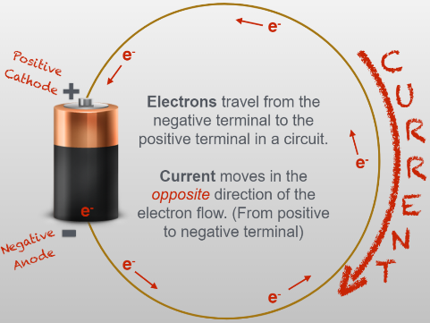
  - OIL RIG – oxidation is losing, reduction is gaining

How does a battery work?
- In a battery, electrons are all crowded near the negative end, or anode
  - In a typical battery, the anode is the outer zinc case
- These crowded electrons are desperate to move away from each other and towards the positive end of the battery, but an electrolyte paste separates electrons from the positive end
- When plugged into a closed circuit, electrons escape the anode
- The electrons flow through a wire, usually copper, towards the positive end of the battery, or cathode
  - In a typical battery, the cathode is the inner carbon rod
  - You can tell where the cathode is by the bump on one end of a battery
- SUMMARY: Electrons leave the anode of the battery and move through the copper wire in the direction of the cathode, while current moves in the opposite direction of the electron flow. The anode loses electrons and is oxidized, while the cathode gains electrons and is reduced.
- Electromagnet: a metal object made into a magnet by surrounding the object with a coil and passing an electric current through the coil
  - A magnetic field is produced by a strong electric current
  - More coils, more current → more magnetism
  - In Inv. #3, we made an electromagnet by surrounding a nail with a coil and sending a current through the coil
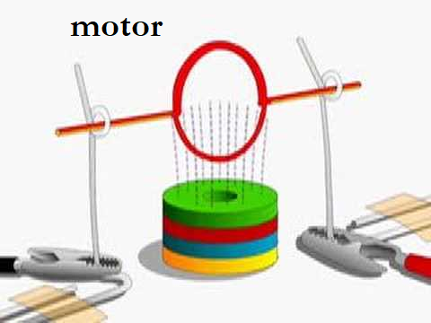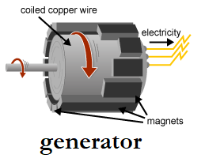
- Electric motor: when an electric current is sent through a coil of wires surrounded by a magnet, the coil will turn
  - Electricity causes this motor to run and do work
- Electric generator: when a coil is surrounded by fixed magnets and the coil is mechanically turned (NO current is applied!), an electrical current is produced
    - The coil could be turned by hand, by steam from coal, by water flow from a dam or river, by wind, etc.
  - The electricity produced is then purchased by consumers to use in their homes
- MRI: Magnetic Resonance Imaging
  - Takes images of soft tissue, such as muscles and organs

What is the relationship between voltage, current, and resistance?
- As voltage increases, current increases but the resistance remains the same
- As resistance increases, current decreases but voltage remains the same
- The relationship among voltage, current, and resistance is described by Ohm’s law, V= IR

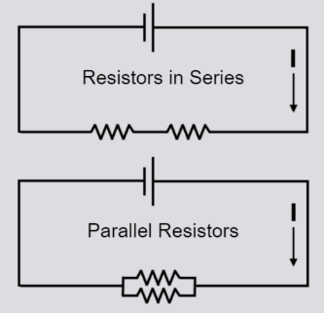
How do the dimensions of a resistor affect current?
- Increasing the length of a resistor increases the amount of resistance and decreases current
  - In Inv. #2, putting two resistors in series (in a row) increased resistance
- Increasing the diameter (width) of a resistor decreases the amount of resistance and increases current
  - In Inv. #2, putting two resistors in parallel (next to each other) decreased resistance because it gave the current more area to move through

What factors affect the strength of an electromagnet?
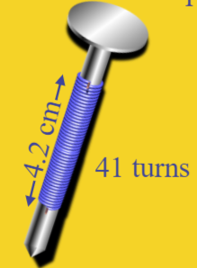
- The number of turns of wire in the coil over a specific length
  - (Number of turns over a specific length)
- The amount of current flowing through the wire

In what ways can we produce electricity?
- Solar power, wind power
- Fossil fuels (natural gas and coal)
- Hydroelectric (water, ex. dams, water wheels)
- Nuclear

