October 15, 2017
7th Grade Atomic Structure Review

Vocab
- Matter: anything that takes up space and has mass
- Element: a type of matter that cannot be broken down into another substance through chemical reactions
  - Elements consist of atoms
- Atom: the smallest particle of an element that still has all the properties of that element
- Subatomic particles: particles that make up an atom
  - Protons, neutrons and electrons are subatomic particles
- Nucleus: the center mass of an atom, containing protons and neutrons
- Proton: a subatomic particle with a positive charge
- Neutron: a subatomic particle with no charge
- Electron: a subatomic particle with a negative charge that orbits the nucleus
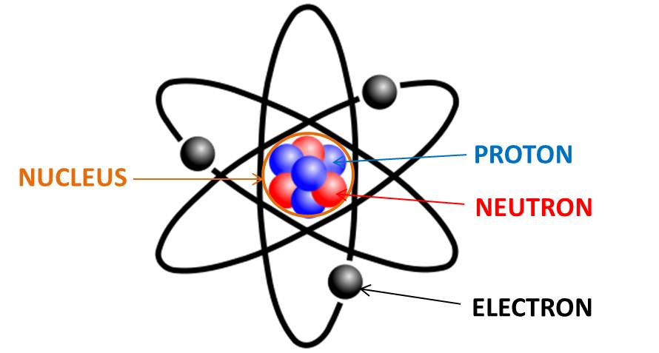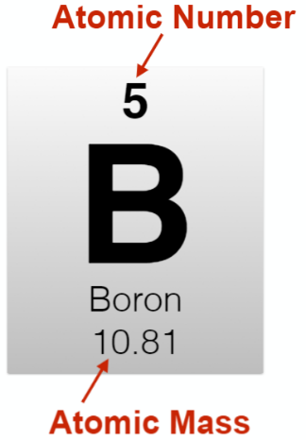
- Periodic Table of the Elements: a table that organizes the elements according to their physical and chemical properties
- Group: the vertical columns in the Periodic Table
- Period: the horizontal rows in the Periodic Table
- Atomic Number: the number of protons and the number of electrons found in an element’s atom
  - Atomic number = # protons = # electrons
- Atomic Mass: the mass of an atom’s protons and neutrons
  - Atomic mass – # protons = # neutrons
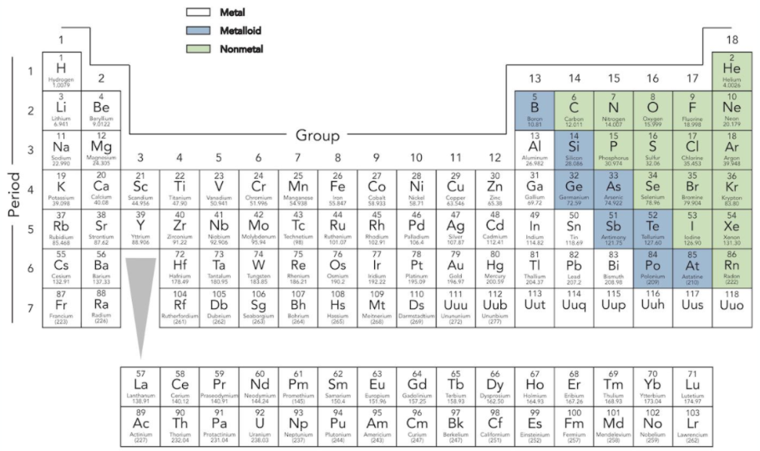
- Metals: elements that are lustrous, shiny, hard and malleable and good conductors of electricity and heat
- Nonmetals: elements that are soft, brittle, dull, and poor conductors of electricity and heat
- Metalloid: an element that can possess properties of both metals and nonmetals
  - Semi-conductors and electrical insulators
- Physical Property: a property of a substance that can be observed without changing the substance’s identity
  - Ex. color, texture, smell, taste, density, freezing point, melting point
- Chemical property: characteristics that can be observed or measured during a chemical reaction
  - Ex. reactivity to acids, combustion, pH
- Electricity: the steady flow of electrons

Focus Questions
How is the Periodic Table of the Elements Arranged?
- Elements with similar physical and chemical properties are grouped together on the table.
- The Periodic Table separates elements into metals, nonmetals, and metalloids.

How do the elements from the metal and nonmetal groups differ?
- Metals and nonmetals have different physical and chemical properties from each other.

What information about an element can be determined by using the Periodic Table of the Elements?
- An element’s atomic mass equals the number of protons in its atoms’ nucleus and the number of electrons normally orbiting the nucleus
- The number of neutrons found in the nucleus of an atom is equal to the element’s atomic mass minus its atomic number.

What is a metalloid?
- A metalloid is an element that can have the properties of both metals and nonmetals.

Where are metalloids found on the Periodic Table of the Elements?
- Metalloids can be found on the border of the metals and nonmetals of the Periodic Table of the Elements.

