March 31, 2019
7th Grade Cells Review
Vocab
- Cell: the basic unit of all living things
  - The smallest structural and functional unit of an organism
- Specimen: a sample of a substance or material
  - A specimen is placed onto a slide and then you look at the slide using a microscope

Light Microscopy vs. Transmission Electron vs. Scanning Electron
- Light microscope: uses light to view specimens
  - Up to 1000x magnification
  - Specimen placed between lens and light source, so light passes through slide
  - Stains can be used to make certain parts of a cell easier to see, or to increase contrast
  - Can be used to view living cells
- Transmission electron microscope (TEM): uses beam of electrons to view specimens
  - Up to 1,000,000x magnification
  - Specimen is placed between lens and electron source, so the beam passes through specimen
  - Can be used to see detailed cell structures and molecules
  - Black and white pictures, non-living specimens
- Scanning electron microscope (SEM): uses beam of electrons
  - Usually use around 30,000x magnification, up to 500,000x
  - Specimen is placed at the very bottom of the microscope, so electrons bounce off the surface and do NOT pass through the specimen
  - SEM creates 3-D images of the surface of a specimen
  - Black and white pictures, non-living specimens
  - Smaller than TEM
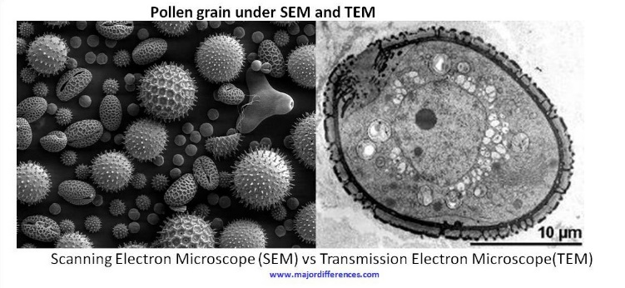
- Sectioning: a method of specimen preparation involving the way in which the specimen was cut. Two examples are longitudinal sectioning and cross sectioning.
- Staining: a method of specimen preparation involving a substance placed on the specimen to stain various parts of the cells to make them easier to observe
- Wet mount: method of preparing a slide so that the specimen is suspended in a liquid, usually water

Prokaryotes vs. Eukaryotes
- Some cells can exist independently, such as bacteria
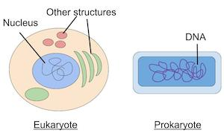
- Some cells exist as part of a tissue, such as muscle cells
- Prokaryotes
  - Unicellular (single-celled)
  - No distinct nucleus has DNA, but it is loose in the cytoplasm
  - NO membrane-bound organelles
  - Generally smaller than eukaryotes
  - Bacteria are prokaryotes
    - Rods, spheres, spirals
- Eukaryotes:
  - Generally multicellular
  - Distinct nucleus DNA inside membrane-bound nucleus
  - Distinct, membrane-bound organelles
  - Plant and animal cells are eukaryotes
  - Typically bigger than prokaryotes

Animal Cell Plant Cell
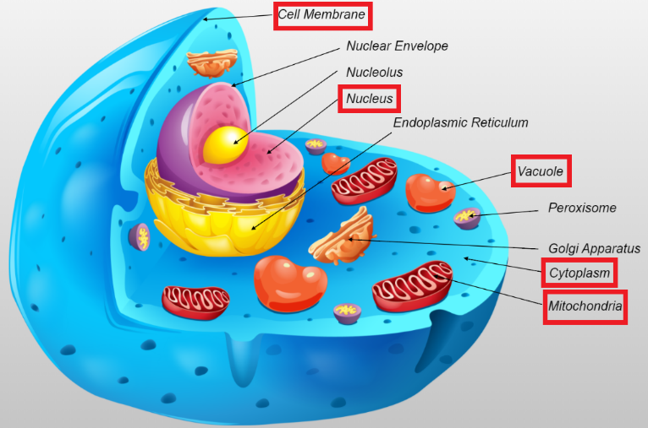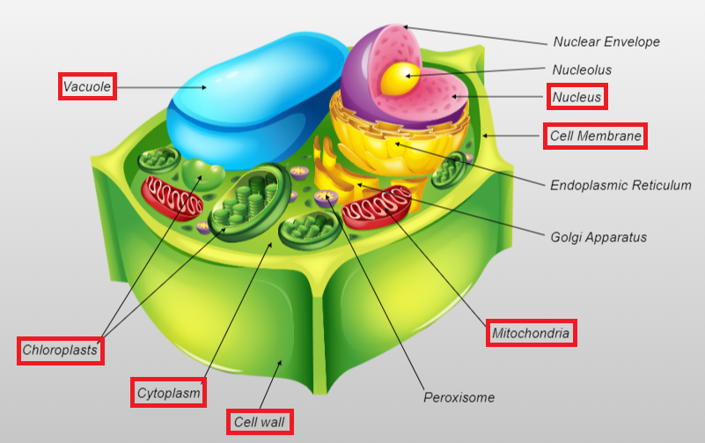
Parts of a Cell
- Organelle: a cellular structure which has a specific function, such as the nucleus
- Cell membrane: the semi-permeable outer border of the cell that separates the cytoplasm from the external environment surrounding the cell
- Nucleus: the cellular organelle that contains DNA and RNA and is responsible for controlling many of the activities of the cell
- Vacuole: water-filled organelle.
  - There are usually many small vacuoles in animal cells and one large vacuole in plant cells
- Mitochondria: organelle that produces energy for the cell
  - “Powerhouse of the cell”
- Cytoplasm: jelly-like substance which surrounds cellular organelles
- Chloroplast: the organelles present in plant cells that are responsible for photosynthesis
- Cell wall: the rigid and permeable cellular structure which surrounds the cell membrane in a plant cell

Tonicity
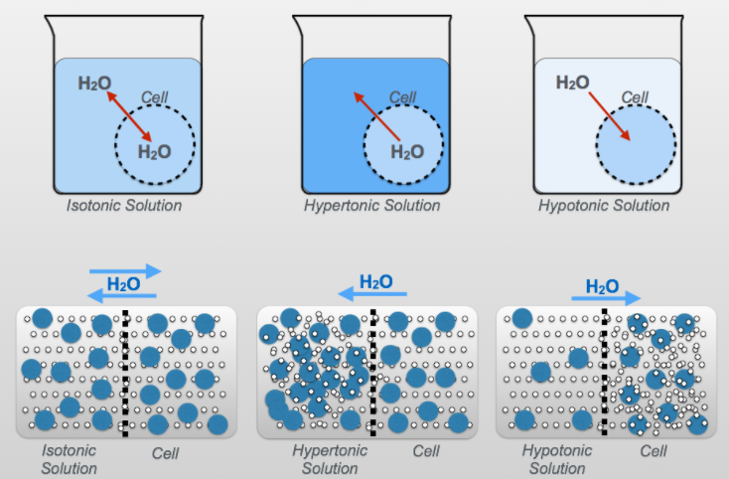
- Semi-permeable membrane: membrane that allows water to freely pass through it but not solute molecules
  - Salt does NOT pass through a semi-permeable membrane
  - Water flow depends on the amount of solute (or salt) in the environment
  - The cell membrane of plant and animal cells are “semi-permeable membranes”
- Osmosis: causes water to move into or out of a cell depending on the type of solution the cell is surrounded by
  - Water will always move toward a higher solute concentration across a semi-permeable membrane
- Hypertonic: when the outside solution has more solute
  - Water leaves the cell
  - Causes plant and animal cells to shrivel up as cell volume decreases
- Hypotonic: when the outside solution has less solute
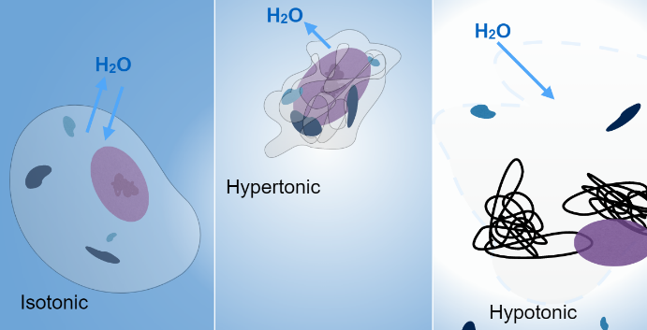
  - Water enters the cell
  - In plant cells, rigid cell wall prevents too much expansion
  - In animal cells, too much water entering the cell causes it to burst called cell lysis
- Isotonic: when the outside solution has the same amount of solute as the cell
  - No net movement of water in or out of the cell
- System always moving towards equilibrium

Parts of a Light Microscope
- Ocular lens: the eyepiece. The ocular lens typically has a magnification of 10x
- Objective lenses: four different lenses that are used to magnify a specimen on a slide
  - The four magnifications are 4x, 10x, 40x, and 100x
  - Multiplying the magnification of the objective lens and the ocular lens gives the total magnification you are using
- Nosepiece: the rotating disk to which the four objective lenses are attached
- Stage: the flat, solid surface where you put a slide
- Diaphragm: controls the amount of light that reaches the slide
  - A lever is used to open or close a hole which let light through
- Translation knobs: used to move the slide on the stage
  - Allows us to look at different parts of a specimen
- Coarse focus knob: moves the stage up and down a lot at a time to bring a slide into focus
  - The larger, outer knob on the side of the microscope
- Fine focus knob: moves the stage up and down a little at a time to bring a slide into focus
  - The smaller, inner knob on the side of the microscope
- Light intensity knob: used to control the amount of light coming from a light source by controlling the electricity flowing into the microscope
- Oil immersion lens: 100x objective lens
  - Oil is used with this lens to ensure enough light enters the microscope to see the specimen

Focus Questions
How does staining affect the appearance of a specimen?
- Staining of specimens may add artificial color to the cells to allow various structures to be more easily viewed.
- We only do this with light microscopes

How does sectioning affect the appearance of a specimen?
- Observations of the size, shape, and arrangement of cells can be affected by the sectioning of the specimen.

How are the structures in plant and animal cells similar to and different from each other?
- Plant cells generally contain a nucleus, a cell wall, a cell membrane, mitochondria, chloroplasts, cytoplasm, and one large vacuole. Animal cells generally contain a nucleus, a cell membrane, mitochondria, cytoplasm, and several smaller vacuoles.
- Animal cells DO NOT have chloroplasts or cell walls, and they have many water vacuoles instead of just one big one.

Are all cells from the same organism the same?
- No! For example, lung cells are different from heart cells, which are different from blood cells, etc.

Is the cell membrane of a plant cell permeable to salt?
- No, the cell membrane of a plant cell is not permeable to salt.

Are the cell wall and the cell membrane of a plant cell permeable to water?
- The cell wall and cell membrane are permeable to water.

How does an oil immersion lens work?
- As we increase magnification, the lens collects less and less light
  - You can see as we switch from 4x to 10x to 40x that the specimen keeps getting darker
- To make sure we have enough light to see the specimen at high magnifications, we use oil
- As light travels from one medium to another (in our case from a gas, air, to a solid, the microscope lens), light is refracted
  - This means the light is bent in different directions and does not travel in a perfectly straight line
- Immersion oil helps limit this refraction and sends more light up into the objective lens, producing a brighter image
