April 22, 2018

7th Grade Cells Review

*Vocab*

* **Cell**: the basic unit of all living things
  + The smallest structural and functional unit of an organism
* **Specimen**: a sample of a substance or material
  + A specimen is placed onto a slide and then you look at the slide using a microscope

*Light Microscopy vs. Transmission Electron vs. Scanning Electron*

* **Light microscope**:uses light to view specimens
  + Up to 1000x magnification
  + Specimen placed between lens and light source, so light passes through slide
  + Stains can be used to make certain parts of a cell easier to see, or to increase contrast
  + *Can be used to view living cells*
* **Transmission electron microscope (TEM)**: uses beam of electrons to view specimens
  + Up to 1,000,000x magnification
  + Specimen is placed between lens and electron source, so the beam passes through specimen
  + *Can be used to see detailed cell structures and molecules*
  + Black and white pictures, non-living specimens
* **Scanning electron microscope (SEM)**: uses beam of electrons
  + Usually use around 30,000x magnification, up to 500,000x
  + Specimen is placed at the very bottom of the microscope, so electrons bounce off the surface and do NOT pass through the specimen
  + *SEM creates 3-D images of the surface of a specimen*
  + Black and white pictures, non-living specimens
  + Smaller than TEM

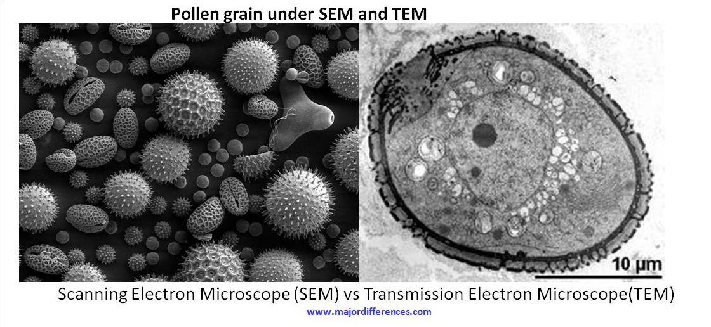

* **Sectioning:** a method of specimen preparation involving the way in which the specimen was cut. Two examples are longitudinal sectioning and cross sectioning.
* **Staining:** a method of specimen preparation involving a substance placed on the specimen to stain various parts of the cells to make them easier to observe

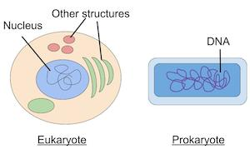

*Prokaryotes vs. Eukaryotes*

* Some cells can exist independently, such as bacteria
* Some cells exist as part of a tissue, such as muscle cells
* **Prokaryotes**
  + Unicellular (single-celled)
  + No distinct nucleus **🡪** has DNA, but it is loose in the cytoplasm
  + NO membrane-bound organelles
  + Generally smaller than eukaryotes
  + **Bacteria** are prokaryotes
    - Rods, spheres, spirals
* **Eukaryotes:**
  + Generally multicellular
  + Distinct nucleus 🡪 DNA inside membrane-bound nucleus
  + Distinct, membrane-bound organelles
  + Plant and animal cells are eukaryotes
  + Typically bigger than prokaryotes

***Animal Cell Plant Cell***

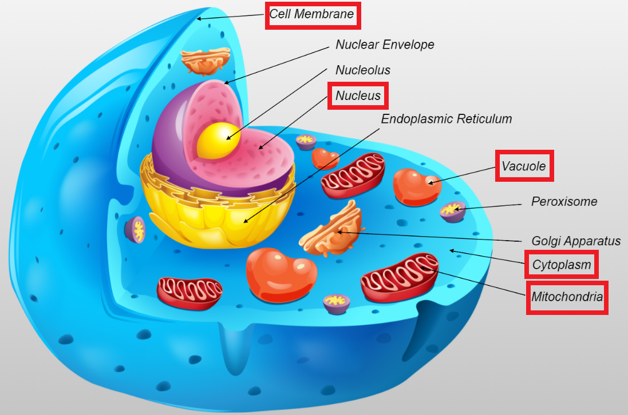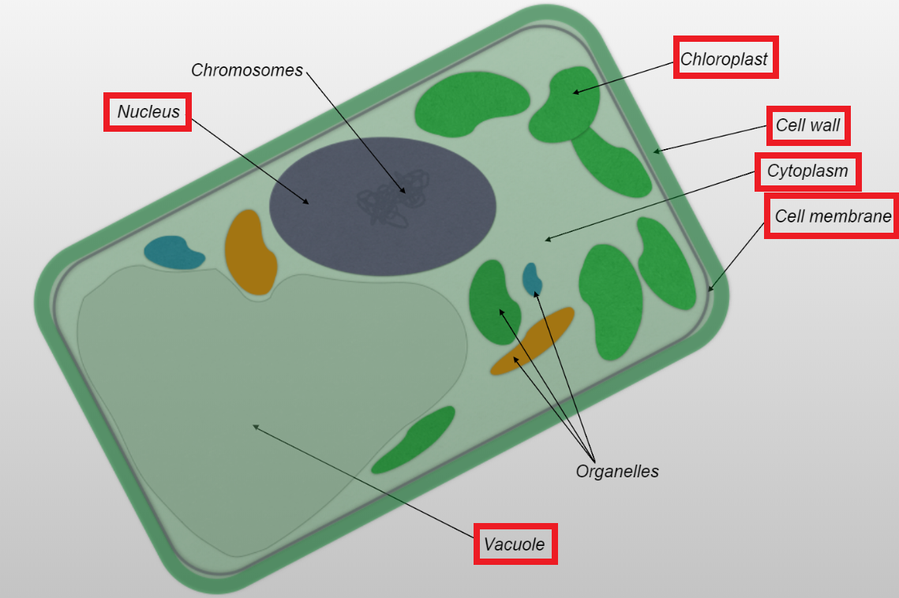

*Parts of a Cell*

* **Organelle:** a cellular structure which has a specific function, such as the nucleus
* **Cell membrane:** the semi-permeable outer border of the cell that separates the cytoplasm from the external environment surrounding the cell
* **Nucleus:** the cellular organelle that contains DNA and RNA and is responsible for controlling many of the activities of the cell
* **Vacuole:** water-filled organelle.
  + There are usually many small vacuoles in animal cells and one large vacuole in plant cells
* **Mitochondria:** organelle that produces energy for the cell
  + “Powerhouse of the cell”
* **Cytoplasm:** jelly-like substance which surrounds cellular organelles
* **Chloroplast:** the organelles present in *plant cells* that are responsible for photosynthesis
* **Cell wall:** the rigid and permeable cellular structure which surrounds the cell membrane in a *plant cell*

*Tonicity*

* **Semi-permeable membrane**: membrane that allows water to freely pass through it but not solute molecules

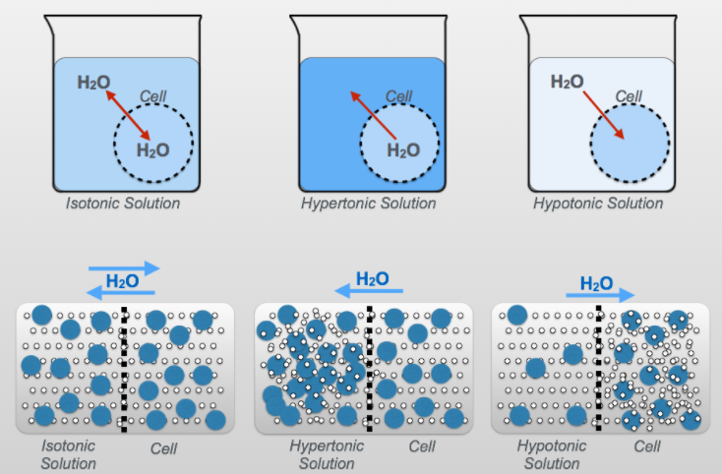

* + Salt does NOT pass through a semi-permeable membrane
  + Water flow depends on the amount of solute (or salt) in the environment
  + The cell membrane of plant and animal cells are “semi-permeable membranes”
* **Osmosis:** causes water to move into or out of a cell depending on the type of solution the cell is surrounded by
  + Water moves from areas of high concentration to low concentration
* **Hypertonic**: when the outside solution has more solute and less water
  + Water leaves the cell
  + Causes plant and animal cells to shrivel up as cell volume decreases
* **Hypotonic**: when the outside solution has less solute and more water
  + Water enters the cell

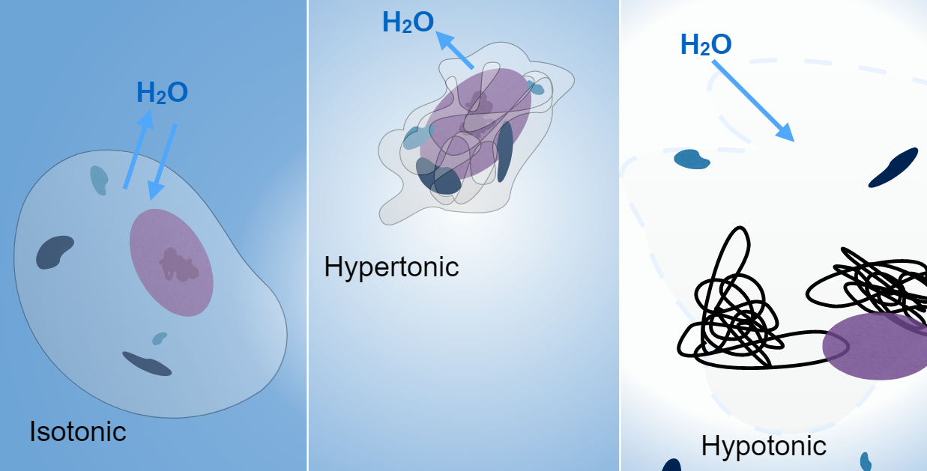

* + In plant cells, rigid cell wall prevents too much expansion
  + In animal cells, too much water entering the cell causes it to burst 🡪 called **cell lysis**
* **Isotonic**: when the outside solution has the same amount of solute as the cell
  + No net movement of water in or out of the cell
* System always moving towards equilibrium

*Parts of a Light Microscope*

* **Ocular lens**: the eyepiece. The ocular lens typically has a magnification of 10x
* **Objective lenses**: four different lenses that are used to magnify a specimen on a slide
  + The four magnifications are **4x, 10x, 40x, and 100x**
  + *Multiplying the magnification of the objective lens and the ocular lens gives the total magnification you are using*
* **Nosepiece**: the rotating disk to which the four objective lenses are attached
* **Stage**: the flat, solid surface where you put a slide
* **Diaphragm**: controls the amount of light that reaches the slide
  + A lever is used to open or close a hole which let light through
* **Translation knobs**: used to move the slide on the stage
  + Allows us to look at different parts of a specimen
* **Coarse focus knob**: moves the stage up and down a lot at a time to bring a slide into focus
  + The larger, outer knob on the side of the microscope
* **Fine focus knob**: moves the stage up and down a little at a time to bring a slide into focus
  + The smaller, inner knob on the side of the microscope
* **Light intensity knob**: used to control the amount of light coming from a light source by controlling the *electricity* flowing into the microscope
* **Oil immersion lens**: 100x objective lens
  + Oil is used with this lens to ensure enough light enters the microscope to see the specimen

*Focus Questions*

**How does staining affect the appearance of a specimen?**

* Staining of specimens may add artificial color to the cells to allow various structures to be more easily viewed.
* We only do this with *light* microscopes

**How does sectioning affect the appearance of a specimen?**

* Observations of the size, shape, and arrangement of cells can be affected by the sectioning of the specimen.

**How are the structures in plant and animal cells similar to and different from each other?**

* Plant cells generally contain a nucleus, a cell wall, a cell membrane, mitochondria, chloroplasts, cytoplasm, and one large vacuole. Animal cells generally contain a nucleus, a cell membrane, mitochondria, cytoplasm, and several smaller vacuoles.
* Animal cells DO NOT have chloroplasts or cell walls, and they have many water vacuoles instead of just one big one.

**Are all cells from the same organism the same?**

* No!

**Is the cell membrane of a plant cell permeable to salt?**

* No, the cell membrane of a plant cell is *not* permeable to salt.

**Are the cell wall and the cell membrane of a plant cell permeable to water?**

* The cell wall and cell membrane are permeable to water.

**How does an oil immersion lens work?**

* As we increase magnification, the lens collects less and less light
  + You can see as we switch from 4x to 10x to 40x that the specimen keeps getting darker
* To make sure we have enough light to see the specimen at high magnifications, we use oil
* As light travels from one medium to another (in our case from a gas, air, to a solid, the microscope lens), light is refracted
  + This means the *light is bent* in different directions and does not travel in a perfectly straight line
* Immersion oil helps limit this refraction and sends more light up into the objective lens, producing a brighter image

