March 8, 2018

7th Grade Acids and Bases Study Guide

Vocabulary
Solution: a mixture of two or more substances

Solute: the substance that is present in the smallest amount when a solution is prepared
- This substance is typically a solid, but not always
  - When we did the dilutions in lab #2, the HCl was the solute because we mixed 1 little milliliter of HCl into 9 mL of water

Solvent: the substance that is present in the largest amount when a solution is prepared
- This substance is typically a liquid
  - In the lab #2 dilutions, the solvent was water
  - Ex. in salt water (a solution), salt is the solute and water is the solvent

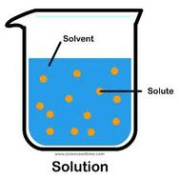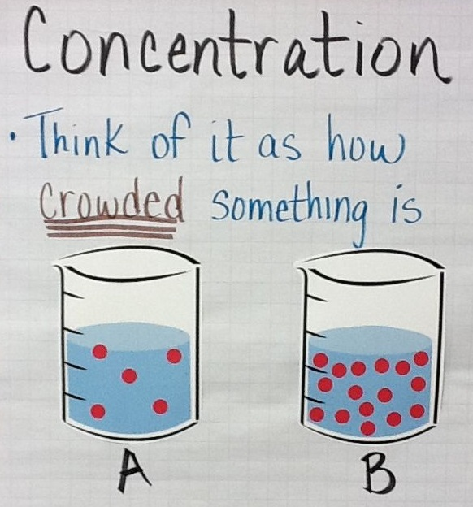

Concentration: the amount of solute compared to the volume of solvent
  - Concentration = solute ÷ solvent
  - Usually expressed as a certain mass of solute that is dissolved in milliliters of solvent
  - Ex. concentration of H+ = how many H+ ions are dissolved into water

Dissociate: when a chemical compound is dissolved in a solvent and separates into two or more ions
- A compound breaks down into ions
- Ex. HCl → H⁺ + Cl⁻ HCl dissociates into H+ and Cl-

Ion: a chemical compound that has a negative or a positive charge
  - A cation is positively charged, and an anion is negatively charged
  - Ex. H⁺ and OH⁻

Hydrogen ion: H+
- A hydrogen atom that has lost 1 electron, so that only the nucleus and a single proton remain
  - When an acid is mixed with water, the acid breaks down into a negatively charged ion and H+
    - Ex. HCl H⁺ + Cl⁻
    - The presence of H+ makes acids acidic
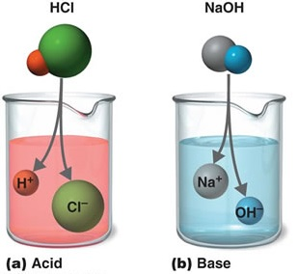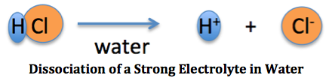

Acid: a chemical compound that dissociates into an H+ and a negatively charged ion when mixed with water
  - Acids turn litmus paper (pH paper) RED

Hydroxide ion: OH-
- A water molecule that has lost a hydrogen ion, H+
  - When a base is mixed with water, it dissociates into a positively charged ion and an OH–
    - NaOH Na⁺ + OH⁻
    - The presence of OH- makes bases basic

Base: a compound that dissociates into an OH- and a positively charged ion when mixed with water
  - Bases turn litmus paper BLUE

pH scale: a scale from 0 to 14 that is a measure of the hydrogen ion concentration
- A higher pH means there is LESS H+
  - Lower pH = more H+
- A higher pH means there is MORE OH-
  - Lower pH = less OH-
- pH is measured on a logarithmic scale (“log” scale)
- A pH of 7 has 10x more H+ than a pH of 8
  - A pH of 7 is 10x more acidic than a pH of 8
- A pH of 9 has 100x more OH- than a pH of 7
  - A pH of 9 is 100x more basic than a pH of 7
- A pH of 7 is neutral
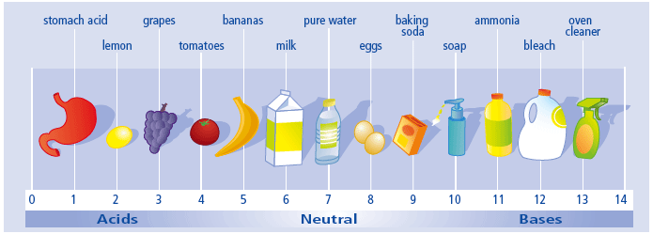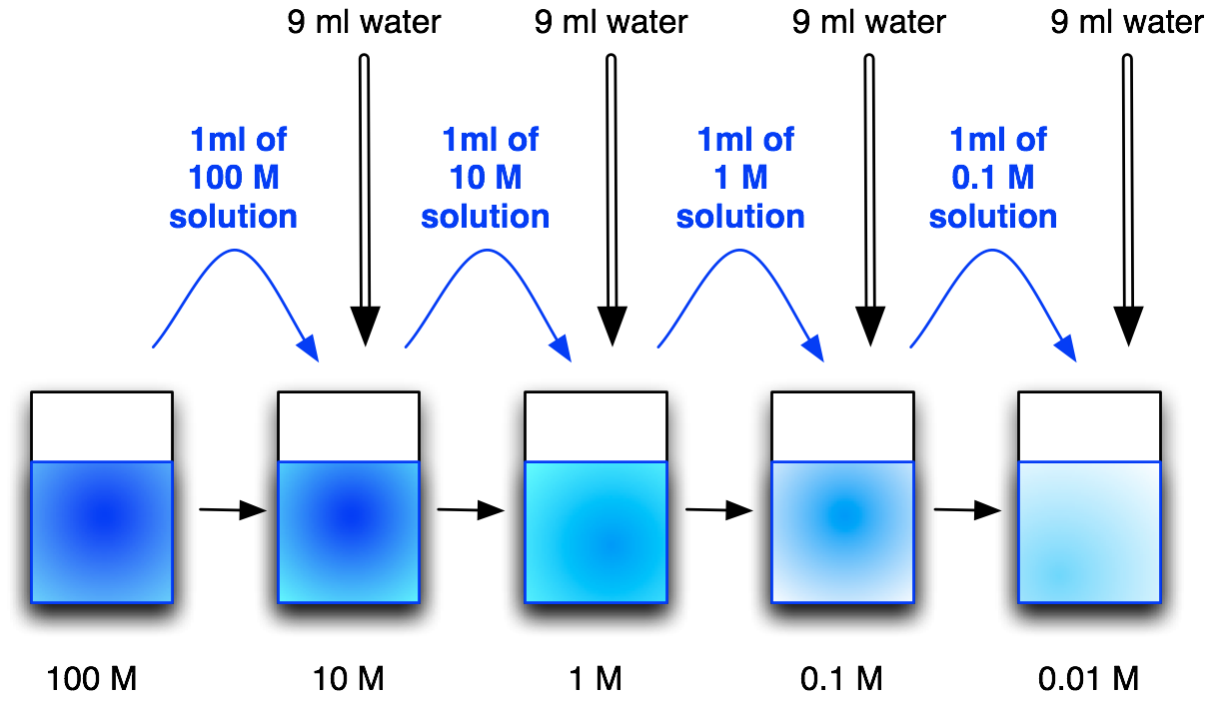

Dilution: when a concentrated solution is prepared by adding more solvent
- In our labs, we diluted HCl by adding more water

Neutralization: when an acid and a base react to form a water molecule and a salt
- Acid + Base → H₂O and a salt
  - The OH- binds to the free H+
  - This reduces the amount of free H+ ions, which decreases acidity and raises pH, making the solution a more neutral pH
- Ex. HCl + NaOH H₂O + NaCl
Stomach acid: HCl
- Human stomachs are lined with cells that produce HCl (acid) to aid digestion
- Our stomachs also have cells that produce mucus to protect our stomachs from the HCl
- Excessive stomach acid can cause acid reflux or ulcers

Focus Questions
What properties make acids and bases chemically reactive?
- Acids release H+ ions when they are mixed with water
- Bases release OH- and combine with H+ ions when they are mixed with water.

What is the relationship between the concentration of H+ ions in a solution and the chemical reactivity of strong and weak acids?
- Strong acids release more H+ ions when mixed with water, resulting in a higher concentration of H+ ions
  - This yields a lower pH
- Weak acids release fewer H+ ions, resulting in a lower concentration of H+ ions
  - This yields a higher pH

What is the relationship between the concentration of H+ ions in a solution and the chemical reactivity of strong and weak bases?
- Strong bases release more OH- ions that can remove more H+ ions when mixed with water, resulting in a lower concentration of H+ ions
  - This results in a higher pH
- Weak bases remove fewer H+ ions resulting, in a higher concentration of H+ ions
  - This results in a lower pH

What is the relationship between the pH of a solution and the concentration of hydrogen ions (H+)?
- As the pH of a solution increases, the concentration of H+ ions decreases
  - An increase of 1 pH unit decreases the H+ concentration 10 times
- As the pH of a solution decreases, the concentration of H+ ions increases
  - A decrease of 1 pH unit increases the H+ concentration 10 times

What is the relationship between the pH of a solution and the concentration of hydrogen ions (OH-)?
- As the pH of a solution increases, the concentration of OH- ions increases
  - An increase of 1 pH unit increases the OH- concentration 10 times
- As the pH of a solution decreases, the concentration of OH- ions decreases
  - A decrease of 1 pH unit decreases the OH- concentration 10 times

What happens to the concentration of hydrogen ions (H+) when an acid and a base react?
- When an acid and a base are mixed, H+ ions and OH- ions react to produce water and a salt
  - Ex. HBr + KOH H₂O + KBr
- This decreases the concentration of free H+ and OH- ions, resulting in a more neutral solution
- Water is neutral!! Water has a pH of 7

Acids
- pH < 7
- taste sour
- neutralize bases
- release H+

Bases
- pH > 7
- taste bitter
- feel slippery
- neutralize acids
- release OH-

