December 11, 2018
7th Grade Acids and Bases Review

Vocabulary
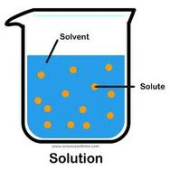
- Solution: a mixture of two or more substances
- Solute: the substance that is present in the smaller amount when a solution is prepared
  - This substance is typically a solid, but not always
  - This is the substance that is dissolved
  - When we did the dilutions in lab #2, the HCl was the solute because we mixed 1 little milliliter of HCl into 9 mL of water
- Solvent: the substance that is present in the larger amount when a solution is prepared
  - This substance is typically a liquid
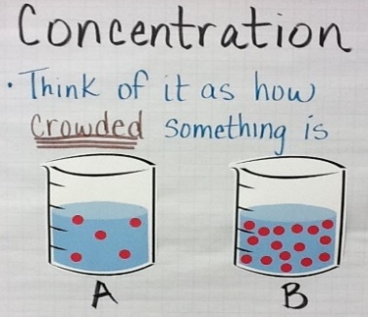
  - This is the substance that causes the dissolving
  - In lab #2, the solvent was water because we mixed only a little bit of HCl into a lot of water
    - Ex. in a salt water solution, salt is the solute and water is the solvent
- Concentration: the amount of solute compared to the volume of solvent
  - Concentration = solute/solvent OR grams/milliliters OR mass/volume
  - Ex. concentration of H+ = how many H+ ions are dissolved into water
- Dilution: when a concentrated solution is prepared by adding more solvent
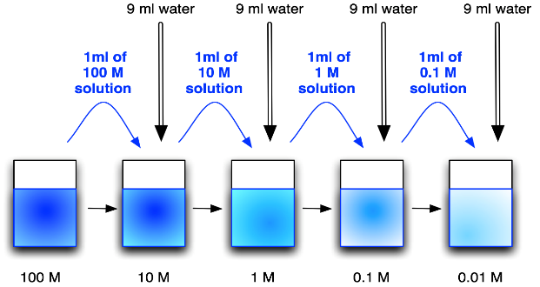
  - Adding more solvent, usually water, to lower the concentration or make the solution “weaker”
  - Ex. in our labs, we diluted HCl by adding more water
- Dissociate: when a chemical compound is dissolved in a solvent and separates into two or more ions
  - When a compound breaks down into ions
  - Ex. HCl → H⁺ + Cl⁻
    - HCl dissociates into H+ and Cl-
- Ion: a chemical compound that has a negative or a positive charge
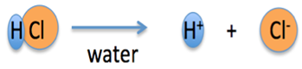
  - Ex. H⁺ and OH⁻ are both ions
- Hydrogen ion: H+
  - When an acid is mixed with water, the acid breaks down into a negatively charged ion and H⁺
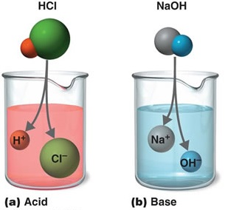
    - Ex. HCl H⁺ + Cl⁻
    - The presence of H+ makes acids acidic
- Acid: a chemical compound that produces H+ ions when mixed with water
  - Acids contain high H+ concentrations
  - Acids turn litmus paper (pH paper) RED
  - Acids are very chemically reactive
  - Strongest acids have the lowest pH
    - The greater the concentration of H+, the lower the pH and the more acidic
- Hydroxide ion: OH-
  - When a base is mixed with water, it dissociates into a positively charged ion and an OH–
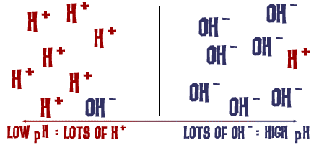
  - NaOH Na⁺ + OH⁻
  - The presence of OH- makes bases basic
- Base: a chemical compound that produces OH- ions when mixed with water
  - Bases contain low H+ concentrations and high OH- concentrations
  - Bases turn litmus paper BLUE
  - Strongest bases have the highest pH
    - The greater the concentration of OH-, the higher the pH and the more basic
  - Basic-ity = alkalinity
- pH scale: used to describe whether a compound is an acid or a base
  - A scale from 0 to 14 that measures the hydrogen ion (H+) concentration
  - A low pH means there is MORE H+, which means pH numbers below 7 are acids
  - A high pH means there is MORE OH-, which means pH numbers above 7 are bases
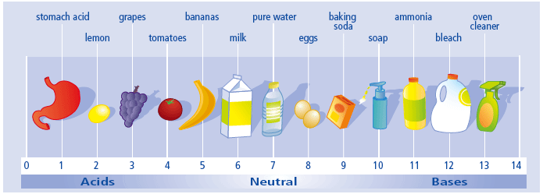
  - A pH of 7 is neutral
  - pH is a chemical property
- Logarithmic scale: each whole number on the scale is either 10 times greater or 10 times less than the numbers immediately around it
  - pH is measured on a logarithmic scale (“log” scale)
    - A pH of 7 is 10 times more acidic than a pH of 8
    - A pH of 9 is 100 times more basic than a pH of 7
- Neutralization: when an acid and a base react to form a water molecule and a salt
  - Acid + Base → H₂O and a salt
  - OH- binds to H+ to create H₂O! Water is a neutral pH, thus neutralization reaction
    - The remaining + and – ions interact to make a salt
    - NaOH + HCl H₂O + NaCl
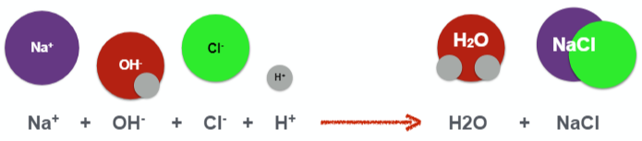
- Stomach acid: hydrochloric acid, or HCl
  - Human stomachs are lined with cells that produce HCl (acid) to aid digestion
  - Our stomachs also have cells that produce mucus to protect our stomachs from the HCl
  - Excessive stomach acid can cause acid reflux, heartburn, or ulcers
  - Antacids help with heartburn! “Anti-acid”

Focus Questions
What properties make acids and bases chemically reactive?
- Acids release H+ ions when they are mixed with water
- Bases release OH- ions and combine with H+ ions when they are mixed with water

What is the relationship between the concentration of H+ ions in a solution and the chemical reactivity of strong and weak acids?
- Strong acids release more H+ ions when mixed with water, resulting in a higher concentration of H+ ions
  - More H+ ions means the acid is more reactive
- Weak acids release fewer H+ ions, resulting in a lower concentration of H+ ions
  - Fewer H+ ions means the acid is less reactive

What is the relationship between the concentration of OH- ions in a solution and the chemical reactivity of strong and weak bases?
- Strong bases release more OH- ions when mixed with water, resulting in a higher concentration of OH- ions
  - More OH- ions means the base is more reactive
- Weak bases release fewer OH- ions, resulting in a lower concentration of OH- ions
  - Fewer OH- ions means the base is less reactive

What is the relationship between the pH of a solution and the concentration of hydrogen ions (H+)?
- As the pH of a solution increases, the concentration of H+ ions decreases
  - An increase of 1 pH unit decreases the H+ concentration 10 times
- As the pH of a solution decreases, the concentration of H+ ions increases
  - A decrease of 1 pH unit increases the H+ concentration 10 times

What is the relationship between the pH of a solution and the concentration of hydrogen ions (OH-)?
- As the pH of a solution increases, the concentration of OH- ions increases
  - An increase of 1 pH unit increases the OH- concentration 10 times
- As the pH of a solution decreases, the concentration of OH- ions decreases
  - A decrease of 1 pH unit decreases the OH- concentration 10 times

What happens to the concentration of hydrogen ions (H+) when an acid and a base react?
- When an acid and a base are mixed, H+ ions and OH- ions react to produce water and a salt
  - Ex. 2HCl + Mg(OH)₂ 2H₂O + MgCl₂ (MgCl₂ is the salt)
  - Ex. HBr + KOH H₂O + KBr (KBr is the salt)
- This decreases the concentration of free H+ and OH- ions, resulting in a more neutral solution
- Water is neutral!! Water has a pH of 7

Acids
- pH < 7
- taste sour
- neutralize bases
- release H+

Bases
- pH > 7
- taste bitter
- feel slippery
- neutralize acids
- release OH-

