May 22, 2018

6th Grade Simple Machines Review

Vocab
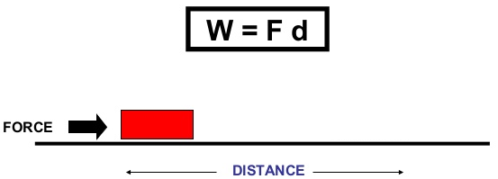
- Machine: any device that helps you do work
- Work: using a force to move an object a distance
  - Work = force x distance
- Force: a push or pull on an object
- Load force: the weight of the object being moved
  - Load force = mass x gravity
- Load distance: the distance over which a load is moved
- Effort force: the amount of force required to move a load
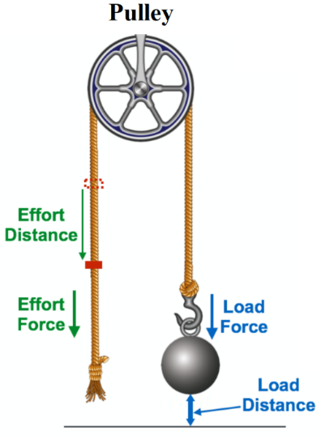
- Effort distance: the distance over which effort is applied
- Joule (J): the unit used to measure energy and work
- Mechanical advantage: describes the relationship between a load and the effort needed to move the load
  - Simple machines do not reduce the total amount of work done, but they make the same amount of work seem easier
  - Simple machines increase mechanical advantage by making work feel easier
- Simple machine: machines that do not do work on their own
  - Require input (force or effort) from a person
  - Do not use electricity
  - Have one or fewer moving parts
  - Change the force, direction, or speed of a movement
- Pulley: a grooved wheel with a rope in the groove that is used to raise, lower, or move a load
  - Pulleys change the direction of the force
  - Ex. elevators, flag poles, construction cranes
- Lever: a stiff bar that rests on a support called a fulcrum which lifts or moves loads
  - Ex. scissors, wheelbarrow, tongs
- Inclined plane: a flat surface tilted at an angle, with one end higher than the other, that is used for raising or lowering a load
  - Also known as a ramp
  - Gentler slopes increase mechanical advantage because less force will be needed to move an object up or down the slope
  - Inclined planes do not need to be straight to increase mechanical advantage
  - Ex. slide, spiral ramp in a parking garage
- Wedge: triangle-shaped tool that is made up of two inclined planes joined together
  - Used to separate two objects or portions of an object, to lift up an object, or to hold an object in place
  - Longer wedges with thinner tips have greater mechanical advantage
  - Ex. axe, doorstop, teeth
- Screw: long, narrow inclined plane wrapped around a cylinder
  - Used to hold things together or to move objects from lower to higher positions
  - The grooves around the shaft or cylinder is the thread
  - The closer the threads are, the greater the mechanical advantage
  - Ex. jar lid, faucet, drill, light bulb
- Wheel and axle: a large disc and a small cylinder, both joined at the center, that is used to move a load
  - The larger disc is called the wheel, and the smaller rod is referred to as the axle
  - A wheel alone or an axle alone is not a simple machine – they must be joined to be called a simple machine!
    - Ex. doorknob, screwdriver, ceiling fan, Ferris wheel

Focus Questions
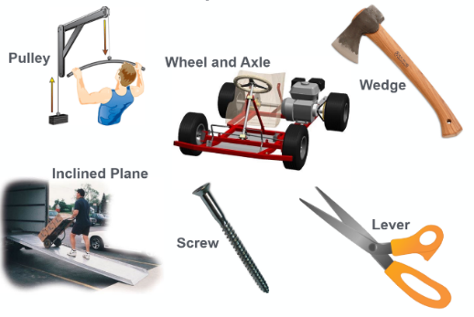
- What are the six simple machines?
  - The six simple machines are the wheel and axle, the pulley, the lever, the inclined plane, the wedge, and the screw.

- How can simple machines change the force needed to lift a load?
  - Simple machines can change the force needed to lift a load by offering a mechanical advantage.

- How does mechanical advantage relate to effort and load forces?
  - If the load force is much greater than the effort force, then there will be a mechanical advantage because less effort will be needed to move the heavy load.

- What are the three parts of a lever?
  - Fulcrum: point on a lever which turns, balances, or pivots
  - Effort: force used to do the work
    - A handle or bar of the lever that you push or pull on
  - Load: work needed to be done
    - The object to be moved or lifted

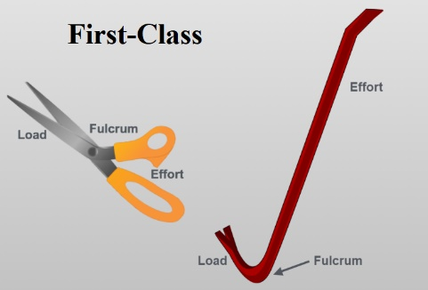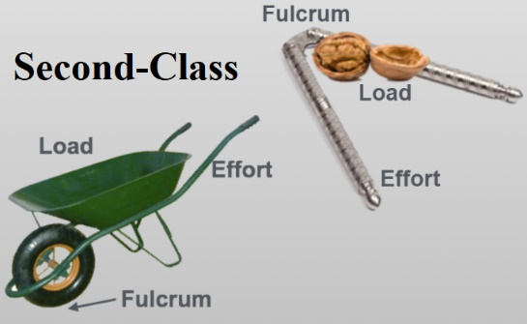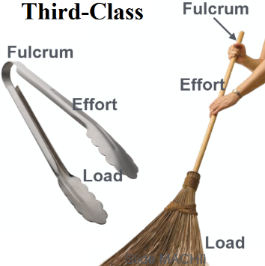
- What are the three classes of levers?
  - First-class: the fulcrum is located between the effort force and the load
    - Ex. crowbar, scissors, see-saw
  - Second-class: the load is located between the effort force and the fulcrum
    - Ex. nutcracker, wheelbarrow
  - Third-class: the effort force is applied between the load and the fulcrum
    - Ex. tweezers, tongs, broom, bicep

- How does the relationship between the fulcrum, effort, and load affect the force needed to lift a load?
  - Changing the position of the fulcrum, effort, and load in relation to one another changes how a lever works. This can affect the distance over which a load can be lifted, the distance over which effort must be applied, and/or the effort force needed to move the load.

