December 12, 2018

6th Kinetic Energy Review

Vocab
- Law of Conservation of Energy: energy cannot be created nor destroyed, it only changes form
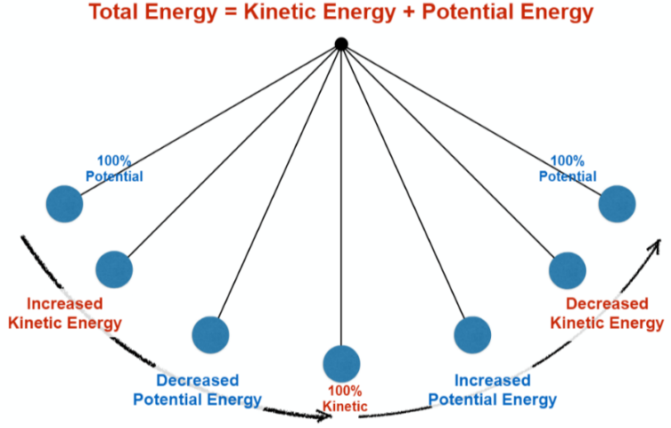
- Kinetic energy: the energy of motion
  - Think speed, heat, velocity, action, etc.
- Potential energy: the energy stored in an object or substance
  - Think storage, waiting, reserved, resting, etc.
- Thermal kinetic energy: the movement of molecules
  - The energy of heat
  - When molecules move faster, they have greater kinetic energy and more heat
- Light kinetic energy: the energy of moving photons
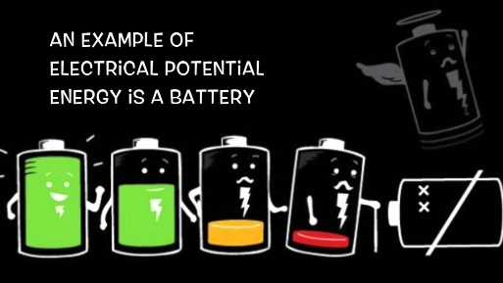
- Electrical kinetic energy: the movement of electrons
  - Electricity is moving electrons!
- Electrical potential energy: the potential energy that exists when comparing a region of high electrical charge to one of low electrical charge
  - Batteries are a storehouse of electrical potential energy
  - Source of electrons waiting to be plugged in
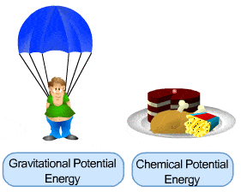
- Gravitational potential energy: the potential energy that exists between two objects that exert a gravitational pull on each other
  - Associated with falling objects
- Chemical potential energy: the potential energy stored in the chemical bonds of chemical compounds
  - Almost all of the Earth’s energy comes from the sun
  - Plants convert the sun’s energy into stored chemical potential energy, which is passed down the food chain
  - Fossil fuels contain stored chemical energy
- Watt: unit of power used to measure electrical energy
  - Ex. 75-watt lightbulb
- Lux: measure of the amount of illumination, or how bright a light is
- Combustion reaction: fuel + O₂ CO₂ + H₂O
  - Ex. CH₄ + 2O₂ CO₂ + 2H₂O (fuel + oxygen carbon dioxide + water)
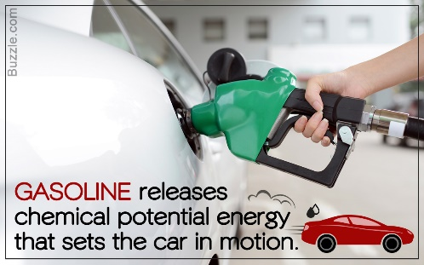
  - Converts stored chemical energy into kinetic energy
  - Exothermic reaction, which means it gives off heat
  - A kind of burning or explosion reaction
  - In a forest fire, combustion reactions convert stored chemical energy into the kinetic energy of heat, light, and sound
  - Combustion engines convert chemical potential energy into kinetic energy
    - Stored energy in gasoline is converted into the kinetic energy of a moving car
Focus Questions
How does the transfer of potential energy to kinetic energy relate to the Law of Conservation of Energy?
- All of the energy changes observed in our investigations were due to the conversion of energy from potential to kinetic or from kinetic to kinetic, not because energy disappeared or was created.
  - Investigation #1: we dropped the wood ball and knocked it into the plastic bear. The ball had potential energy when it was held in the air, and it increased in kinetic energy as it fell. The ball also transferred kinetic energy to the bear when it hit the bear and caused it to move. Energy was converted from potential into kinetic, but not created or destroyed.
  - Investigation #3: we observed the conversion of chemical potential energy to kinetic energy. Vinegar and baking soda are composed of lots of atoms that are held together by chemical bonds. These bonds store chemical potential energy. When we mixed the vinegar with baking soda, the chemical bonds were broken and reformed, converting the chemical potential energy into kinetic energy. We saw this conversion into kinetic energy as gas bubbles formed and the balloon inflated.

Can one form of energy be converted to another? Support your answer with data from the experiments.
- YES!! In Investigation #1, we converted potential energy into kinetic by dropping the pendulum ball. As it swung down, potential energy in the ball was converted into kinetic energy.
- In Investigation #2, we observed the conversion of electrical energy to light energy and the conversion of light energy to heat energy. As electricity flowed into the lightbulb, the moving electrons caused the wire in the lightbulb to glow, converting electrical energy into light energy. This light energy caused the molecules in the air around the bulb to move very fast, causing heat and thus converting light energy into heat energy.
- In Investigation #3… see the answer for the first Focus Question!

How does converting energy from one form to another relate to the conservation of energy?
- The Law of Conservation of Energy states that energy cannot be created or destroyed but can be converted from one form to another.
- Investigation #2 showed direct relationships between the conversion of electrical energy to light energy and light energy to heat.
- In Investigation #3, we observed a direct relationship between the amount of vinegar we used (chemical potential energy) and the circumference of the balloon (kinetic energy).

What kind of energy is lightning and what is it converted into?
- Lightning is a form of electrical energy and it is converted into light, heat, and sound energy.

What is the charge of electrons and in which direction do they move in a circuit?
- Electrons are negatively charged, and they move from negative to positive.

How does an incandescent lightbulb work?
- When you turn the light switch on, electricity begins to flow through the wire in the lightbulb
  - This flow of electrons through the bulb causes the bulb to glow and get hot
- A brighter light means that more electricity (and more electrons) is flowing through the bulb
- A dimmer light means that less electricity and fewer electrons are flowing through the bulb
- The more electrons flowing through the lightbulb, the brighter and hotter the bulb gets!

In what ways can we produce electricity?
- Solar power, wind power, hydroelectric (water power, ex. dams, water wheels)
- Nuclear, fossil fuels (natural gas and coal)

