October 3, 2017
6th Grade Properties of Matter Review

Vocab
- Matter: anything that takes up space and has mass
  - Everything in the universe is composed of matter!
- Element: a type of matter that cannot be broken down into another substance by
chemical reactions
  - 118 elements make up the Periodic Table
  - These elements combine in different ways to form all of the matter in the universe
- Atom: the smallest particle that an element can be broken down to and still have all the
characteristics and properties of that element
  - Atoms combine to form very different molecules and compounds
  - The type of atom in a compound and the amount of atoms in a compound determine the compound’s properties
    - Different atoms NaCl (table salt) is different from C₆H₈O₆ (vitamin C)
    - Different amounts of atoms C₆H₈O₆ (vitamin C) is different from C₁₂H₂₂O₁₁ (sugar)
- Subatomic Particles: the tiny particles that are in an atom and determine its properties
  - Protons, neutrons, and electrons
- Molecule: a type of matter that is made up of two or more atoms
- Compound: a type of matter that is made up of two or more different atoms
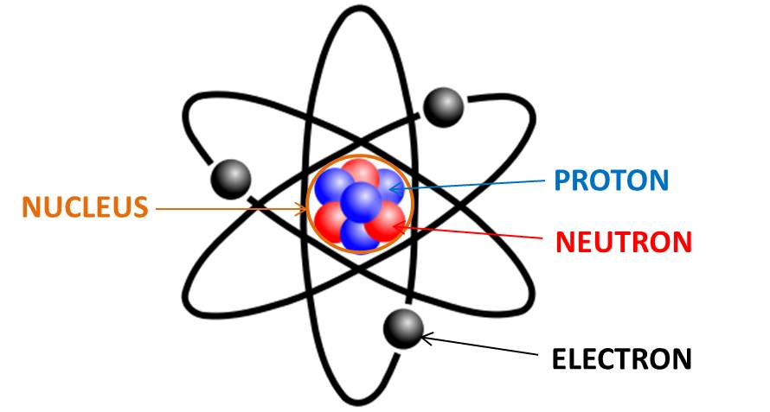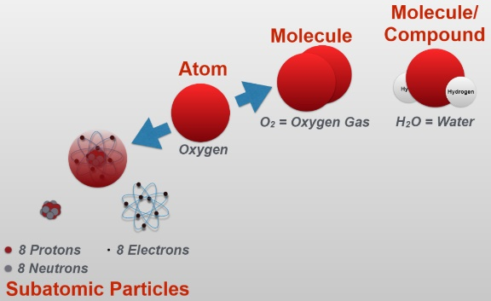
- Chemical formula: tells how many of each element is in a molecule or compound
  - Ex. H₂O, C₆H₈O₆, NaCl, H₂SO₄
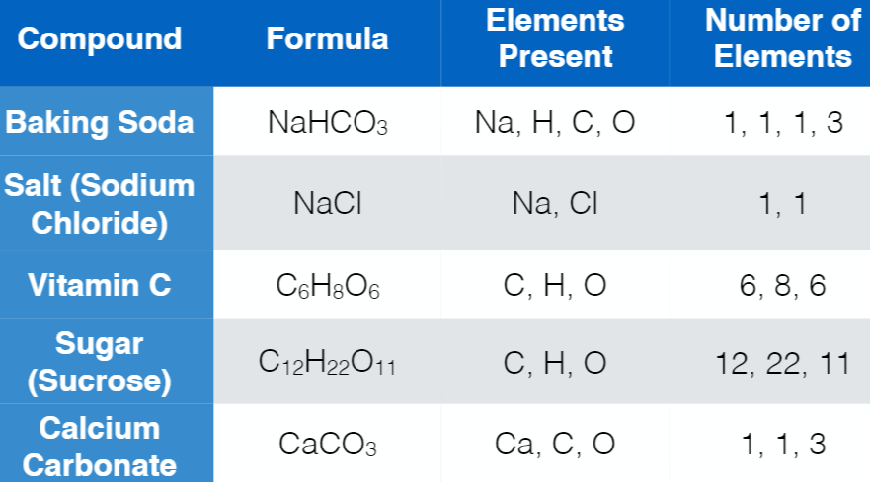
- Density: a property of matter that defines how much matter exists in a particular space
- Solubility: the ability of a solid to dissolve in a liquid
- Miscibility: the ability of a liquid to mix with another liquid
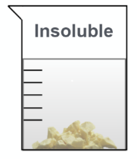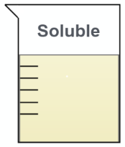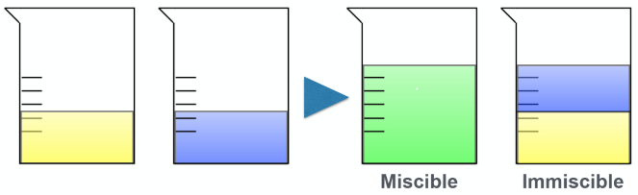
- Physical Property: a property of a substance that can be observed without changing the
substance’s identity
  - Ex. color, texture, smell, taste, density, freezing point, melting point
- Chemical Property: a characteristic that can be observed by changing the identity of the
substance in a chemical reaction
  - Ex. reactivity to acids, combustion
  - Evidence of a chemical reaction: temperature change, gas formation, color change
- pH: a property used to describe whether a compound is an acid, base, or neutral substance
  - A pH less than 7 is acidic, 7 is neutral, and a pH greater than 7 is basic
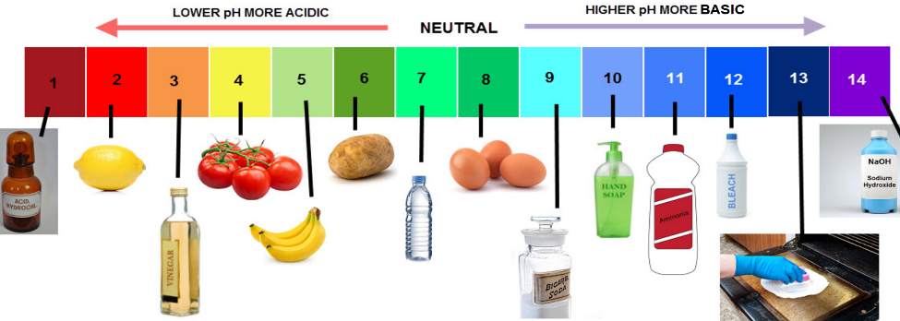

Focus Questions – review your LabLearner Investigations #1 and #4 for help with these questions!
Can you tell the difference between an element and a compound by measuring mass and volume?
- No, because properties such as color, texture, visual appearance, mass, and volume are similar for many elements and compounds.

Can you determine the identity of an unknown substance by observing its mass and volume?
- A definite identification using just mass and volume is not possible because mass and volume are similar for many elements and compounds.

Can you tell the difference between an element and a compound by calculating density and observing chemical reactions?
- No, because elements and compounds can have similar densities or react in similar ways during chemical reactions.

Can you determine the identity of an unknown substance by calculating its density and observing chemical reactions?
- No, because different substances can have similar densities or react in similar ways during chemical reactions.

Do compounds composed of the same elements have identical properties?
- Not necessarily
- Remember from Lab #4, Vitamin C, sugar, vinegar, rubbing alcohol and vegetable oil are all composed of the same elements (C, H, and O, or Carbon, Hydrogen, and Oxygen). However, vitamin C and sugar are solids and rubbing alcohol, vegetable oil and vinegar are liquids.

Can compounds composed of different elements have similar properties?
- Yes, compounds composed of different elements can have similar properties.
- Salt (NaCl), sugar (C₁₂H₂₂O₁₁), and calcium carbonate (CaCO₃) are composed of different elements but they are all white solids.
- Salt, sugar, and vitamin C are composed of different elements, but are all soluble in water.

Do compounds composed of the same elements have a similar or dissimilar pH?
- Compounds composed of the same elements may have a pH that is either similar or dissimilar to each other.
- For example, vinegar and vitamin C are composed of the same elements and have a similar pH in that they are both acidic.
- However, vinegar and vitamin C had very different pH’s compared to vegetable oil and sugar, which are also composed of the same elements.

