March 14, 2019

6th Atmosphere Test Review, New Material

Density: the amount of matter in a given volume or area
- Also described as a measure of how compact or condensed matter is

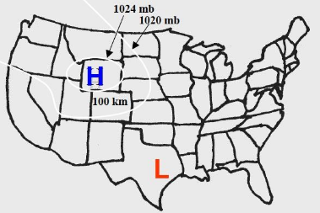
Atmospheric pressure and wind
- Wind is caused by changes in air pressure
  - Air moves from areas of high pressure to areas of low pressure
  - In our experiment with the tin foil and books, we saw that dropping the book created a high pressure area which created wind, pushing the foil away
  - When we picked the book up rapidly, we created a low pressure zone which created wind that pulled the tin foil in
- The bigger the difference between high pressure and low pressure zones, the stronger the wind
  - If a super high pressure zone hits a super low pressure zone, the wind will be intense
    - Ex. 1060 mb high pressure vs. 1000 mb low pressure (difference of 60 mb)
  - If a somewhat high pressure zone hits a relatively low pressure zone, the wind will be mild
    - Ex. 1024 mb high pressure vs. 1020 mb low pressure (difference of 4 mb)
- The closer the distance between high pressure and low pressure zones, the stronger the wind
- A blue “H” stands for high pressure/cold air, and a red “L” stands for low pressure/warm air

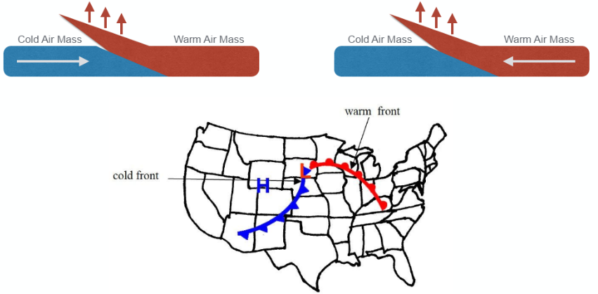
Cold and warm fronts
cold front warm front
- Front: the boundary between air masses of two different temperatures and densities
- Cold front: when cold air moves into a stationary mass of warm air
  - The cold air pushes underneath the warm air and forces the warm air to rise up
- Warm front: when warm air moves into a stationary mass of cold air
  - The warm air rolls over the cold air and rises up into the atmosphere
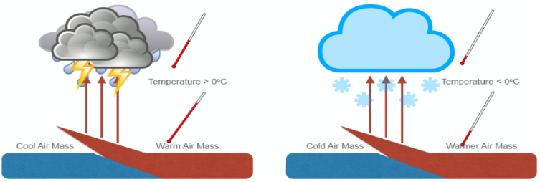
- Warm air rises in both cold and warm fronts – the main difference between a warm and a cold front is which temperature of air is moving faster

Precipitation
- Condensation: a change in phase from a gas to a liquid
  - Water vapor in the atmosphere cools and turns from a gas into precipitation
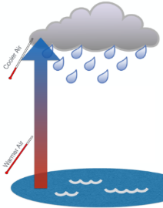
  - Water vapor must be present in the air for condensation to occur
- Precipitation: liquid or solid water that falls from the sky
  - Ex. rain, snow, hail, sleet, freezing rain
- Evaporation: change of phase from a liquid to a gas, ex. boiling water
- Condensation, precipitation, and evaporation in the atmosphere all depend on air temperature
- Storm front: as warm, moist air rises into the cold upper atmosphere, water vapor in the air cools and condenses out as precipitation
    - Water on Earth’s surface is warmed and evaporates to become water vapor in the air
    - Warm air containing water vapor rises into the cold upper atmosphere
    - As the warm air rises, the water vapor cools and condenses from water vapor back into a liquid
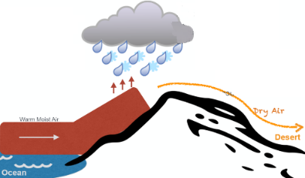
    - The liquid then precipitates out of the air as rain or snow
  - Both cold and warm fronts are often the site of severe weather events
- Mountains: mountains can force warm air up into the atmosphere by
acting like a ramp
  - As warm air reaches colder altitudes, precipitation can occur
  - Deserts can form on the other side of mountains because air
has no moisture left

How does our atmosphere help humans live on Earth?
- Greenhouse effect keeps Earth warm
- Ozone protects us from harmful UV radiation
- Burns up meteors
- Causes weather events, including rain
- Allows us to speak with each other, since we depend on air molecules to produce sound

Focus Questions
- What happens to the volume and density of air as it is heated and cooled?
  - The volume and density of air change with changes in temperature.
  - As the temperature of air increases, its volume increases and its density decreases.
  - As the temperature of air decreases, its volume decreases and its density increases.

- Why do changes in density cause air movement?
  - Air is a fluid. Fluids that are denser sink below those that are less dense.
  - The decrease in density as air is heated causes it to rise above cooler, denser air.
  - The increase in density as air is cooled causes it to sink below warmer, less dense air.

- How do differences in the temperature of the Earth’s atmosphere affect the movement of air?
  - The warmer air in the atmosphere rises and cooler air in the atmosphere sinks. This causes convection currents in the atmosphere.

- What types of air movements cause areas of high and low pressure?
  - Cold air sinking increases the pressure in an area, while warm air rising decreases the pressure in an area.

- Why do differences in pressure cause wind?
  - When there are pressure differences in the atmosphere, air moves from areas of high pressure to areas of low pressure. This movement of air creates wind.

- What factors are necessary for precipitation to form along fronts?
  - Three of the factors necessary for precipitation to occur include:
    - A difference in density between the warm and cold air masses
    - An upper atmosphere that has temperatures lower than the air in the rising warm air mass
    - A significant amount of water vapor in the rising warm air mass.

- What changes in atmospheric pressure occur with the passing of a cold or warm front?
  - In both cold and warm fronts, the rising of the warmer air mass is accompanied by a decrease in the atmospheric pressure.

