February 5, 2018

6th Atmosphere Quiz Review

Composition of Earth's atmosphere
- Nitrogen: 78%
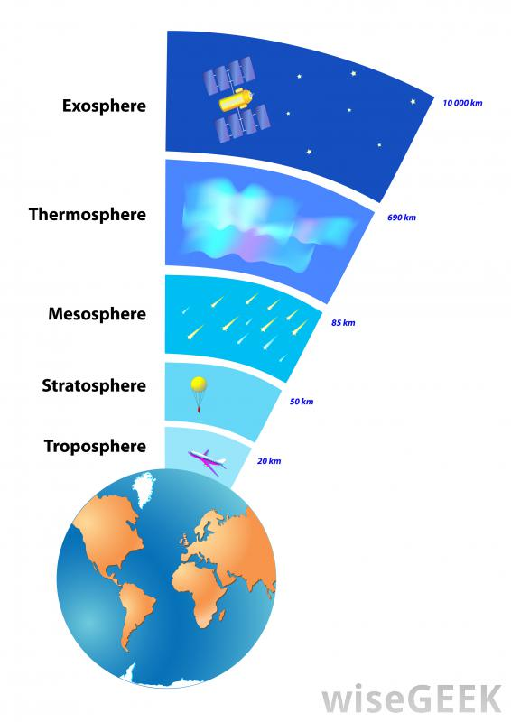
- Oxygen: 21%
- Argon, water vapor, carbon dioxide

Layers of the atmosphere
Troposphere – closest layer to Earth’s surface
- Weather events occur here
- Contains around 80% of the air in our atmosphere
- Most commercial air travel occurs here
Stratosphere – layer above the troposphere
- Jet planes sometimes fly through the stratosphere to avoid bad weather and turbulence
- Contains the ozone layer
  - Ozone layer: area where most of the ozone (O3) in our atmosphere resides
    - The ozone layer protects us by absorbing most of the sun's harmful UV radiation
Mesosphere – layer above the stratosphere
- Where most meteors that enter our atmosphere burn up
Thermosphere – layer above the mesosphere
- large distances between single molecules
- One molecule would need to travel about one kilometer to hit another molecule
- Can reach 2700 degrees Fahrenheit
Exosphere – farthest layer from Earth
- Thinnest layer (fewest air molecules)
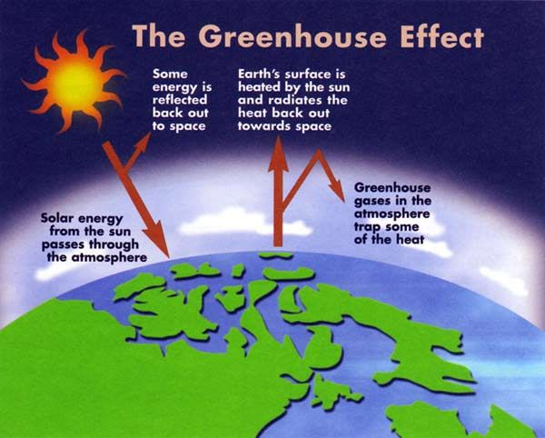
- Blends into outer space

Heating and cooling of Earth
- Heat and energy (radiation) from the sun enter Earth’s atmosphere
  - Around 30% of this radiation is reflected back into space
- Solar radiation heats Earth’s surface
- Earth absorbs heat from the sun and radiates it back through the atmosphere into space

Greenhouse effect + climate change
- Definition: gases in the atmosphere trap heat rising from Earth's surface and increase the temperature of the atmosphere
- The greenhouse effect helps to heat Earth and keep us alive
- BUT, the greenhouse effect contributes to climate change when excessive (too much) amounts of gases that trap heat are released into the atmosphere
  - Examples of “greenhouse gases” include: carbon dioxide, methane, and water vapor
Effects of climate change
- Increases in sea, land, and air temperatures
- Decreases in glaciers, snow cover, and sea ice (like ice in the North Pole and Antarctica)
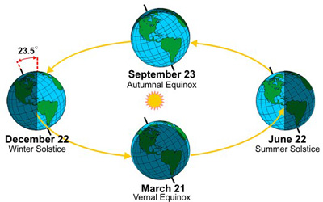
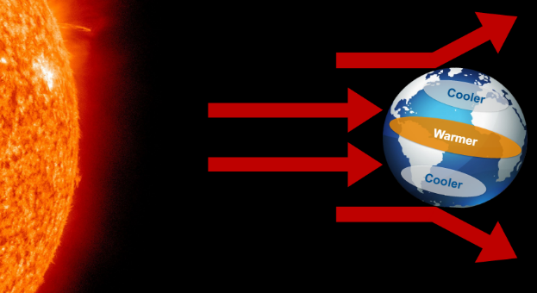
- Sea level rise
Earth’s seasons
- Earth is tilted at an angle of 23.5 degrees
- Earth is heated unevenly by the sun
- The sun’s rays hit the equator most directly equator is warm
- The sun's rays hit the north and south poles at a slight angle poles are cold because less heat reaches the poles
- In our summer, the northern hemisphere is tilted towards the sun and receives more direct sunlight → this makes the summer hot
- In our winter, the northern hemisphere is tilted away from the sun and received less direct sunlight → this makes the winter cold

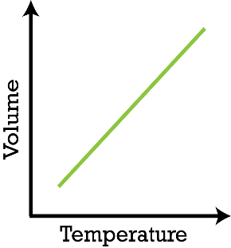
Charles's Law
- As temperature increases, volume increases
  - As temperature decreases, volume decreases
  - In the experiment we did using the flask and the balloon, we saw that when we put the flask into hot water, the balloon began to expand
  - The air in the flask was heated and caused the balloon to expand, showing how an increase in temperature causes an increase in volume

Temperature and density
- As temperature increases, density decreases
  - Hot air rises and cool air sinks because warm air is less dense than cool air
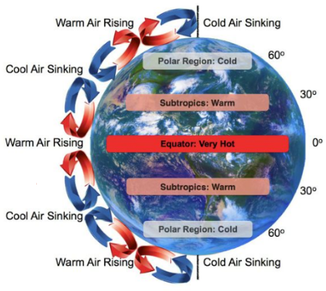
Convection currents
- Hot air at the equator rises into the atmosphere
  - (Hot air is less dense than cool air)
- This air then cools and sinks back down to Earth's surface
- As the air heats up again, it begins to rise back into the atmosphere → this creates a cycle of air that is rising, cooling, sinking, heating, and rising again
- This is a “convection current system”

Coriolis Effect
- The Earth’s rotation causes 2 large convection current systems to split into 6 smaller convection current systems

