February 9, 2020

6th Atmosphere Quiz Review

Composition of Earth's atmosphere
- Nitrogen: 78%
- Oxygen: 21%
- Argon, water vapor, carbon dioxide

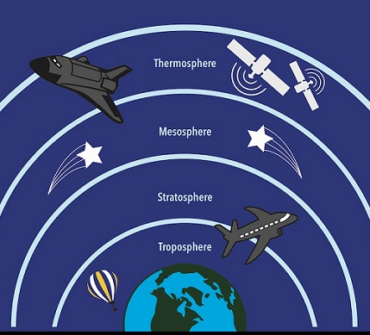
Layers of the atmosphere
The atmosphere is divided into layers based on temperature differences
Troposphere – closest layer to Earth’s surface
- Weather events occur here
- Contains around 80% of the air in our atmosphere
Stratosphere – layer above the troposphere
- Most long distance air travel occurs here to avoid bad weather and turbulence
- Contains the ozone layer
  - Ozone layer: area where most of the ozone (O3) in our atmosphere resides
    - The ozone layer protects us by absorbing most of the sun's harmful UV radiation
Mesosphere – layer above the stratosphere
- Where most meteors that enter our atmosphere burn up
Thermosphere – layer above the mesosphere
- Large distances between single molecules
- One molecule would need to travel about one kilometer to hit another molecule
- Can reach 2700 degrees Fahrenheit
Exosphere – farthest layer from Earth
- Thinnest layer (fewest air molecules)
- Blends into outer space

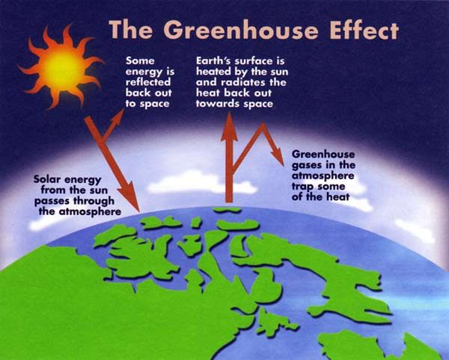
Heating and cooling of Earth
- Heat and energy (radiation) from the sun enter Earth’s atmosphere
  - Around 30% of this radiation is reflected back into space
- Solar radiation heats Earth’s surface
- Earth absorbs heat from the sun and radiates it back through the atmosphere into space

Greenhouse effect + climate change
- Definition: gases in the atmosphere trap heat rising from Earth's surface and increase the temperature of the atmosphere
- The greenhouse effect helps to heat Earth and keep us alive
- BUT, the greenhouse effect contributes to climate change when excessive (too much) amounts of gases that trap heat are released into the atmosphere
  - Examples of “greenhouse gases” include: carbon dioxide, methane, and water vapor

Effects of climate change
- Increases in sea, land, and air temperatures
- Decreases in glaciers, snow cover, and sea ice (like ice in the North Pole and Antarctica)
- Sea level rise
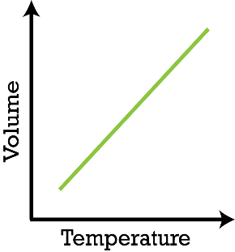
Charles's Law
- As temperature increases, volume increases
  - As temperature decreases, volume decreases
  - In the experiment we did using the flask and the balloon, we saw that when we put the flask into hot water, the balloon began to expand
  - The air in the flask was heated and caused the balloon to expand, showing how an increase in temperature causes an increase in volume

Temperature and density
- As temperature increases, density decreases
  - Hot air rises and cool air sinks because warm air is less dense than cool air
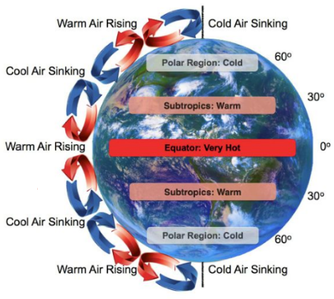
Convection currents
- Hot air on Earth’s surface rises into the atmosphere
  - (Hot air is less dense than cool air)
- This air then cools and sinks back down to Earth's surface
- As the air heats up again, it begins to rise back into the atmosphere → this creates a cycle of air that is heating, rising, cooling, sinking, heating, and rising again
- This is a “convection current system”

Coriolis Effect
- The Earth’s rotation causes one large convection current system to split into six smaller convection current systems
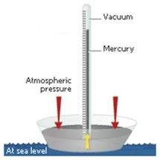
Atmospheric pressure
- The weight of air molecules presses down on Earth's surface, producing pressure
- Gravity causes the air molecules to press down on Earth
- Without air molecules or gravity, there can be no atmospheric pressure
- Barometers measure pressure
- P = F/A
  - P = atmospheric pressure
  - F = the force of the air molecules
  - A = area
Convection currents and atmospheric pressure
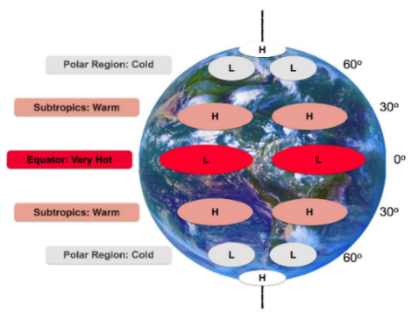
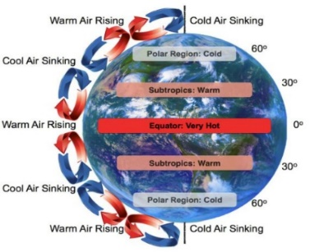
- As temperature increases, pressure decreases
- Warm air rising into the atmosphere creates a low pressure zone beneath it
  - The air molecules are not pressing down on Earth anymore
  - Warm air molecules act against gravity due to increased kinetic energy
- Cool air sinking down onto Earth's surface creates a high pressure zone beneath it
  - The air molecules are pressing down with greater force on Earth
- In the pictures above, you can see that the low pressure zones (where the L's are) are where the hot air is rising, and the high pressure zones (where the H's are) are where the cold air is sinking
- Convection systems create high and low pressure zones

